目录

环境配置 3

Groups 3

获取VIP 3

查看当前testbench 版本号 3

TB_1.6_HOTFIX 3

test command: 4

几个重要的文件夹 4

Spec 5

Doc 5

GCC 6

编译过程 6

参数详解 8

常用参数 8

预编译 -E 9

编译-S 11

汇编 -C 11

链接 12

arm-none-eabi交叉编译工具 13

help 13

arm-none-eabi-gcc 13

arm-none-eabi-ld 13

arm-none-eabi-objdump 14

arm-none-eabi-objcopy 14

arm-none-eabi-size 14

RT700用到的gcc command 14

查找log 关键词 14

RT700 15

Master ID 15

code 16

Boot 16

Linkfile 解析 16

C编译运行 17

Pre_main 、 post_main 18

CM33 NS boot 19

CM33_M boot 34

CM33_M_NS boot 35

HIFI4 boot 35

HIFI1 Boot 36

Zenv Boot 37

Dual core boot 38

可用的non-secure 地址 38

指定code到section中 38

DMA setup 38

原理 40

Testbench 40

Spec文档 40

Force 用法 40

Arg用法 41

Default tc 41

Makefile defines 42

Signals 42

# 环境配置

## TB

### test command:

* 当前项目根目录下下执行：

S200:

bsub -q interq -I soc verilog -irun -tc sentinel -bc rtl -vec s200 -collect_arg -test s200_debug__swd -sim_arg '-gui +MEMDUMP ' -keeptemps -shm -session s200 &

bsub -q interq -I soc verilog -irun -tc sentinel -bc rtl -vec s200 -collect_arg -test s200_scm_mbist_init_req__swd -seed -906201707 -sim_arg '-gui +MEMDUMP ' -keeptemps -shm -session rtl_eco_mbist &

no gui：

bsub -q interq -I soc verilog -irun -tc sentinel -bc rtl -vec s200 -collect_arg -test s200_mua_reg -keeptemps -shm -sim_arg "+MEMDUMP" -session s200 &

dma:

bsub -q interq -I soc verilog -irun -tc default -bc rtl -vec dma3 -collect_arg -test dma3_reg__inst0__pclk_cfg_on_run_mode -sim_arg '-gui' -keeptemps -shm -session dma-access &

sanity

bsub -q interq -I soc verilog -irun -block soc_tb -bc rtl -tc default -vectors sanity -test simple -shm -keeptemps -session default7 &

FSDB:

bsub -q interq -I soc vcsmx -block soc_tb -bc rtl -tc sentinel -vectors s200 -test s200_mua_reg -fsdb -keeptemps -collect_arg -session mua_reg_s200&

GLS

vgen -plan DMA.csv,S200.csv,ROMCP.csv -group P0

vrun -view postlayout -cond best -target gls&

vrun -view postlayout_1p0v -cond best -target gls&

vrun -view postlayout_1p0v -cond worst -target gls&

best：

bsub -q interq -I    soc verilog -irun -block soc_tb -bc postlayout -tc sentinel -vectors s200 -test s200_done_irq -sim_arg "-gui" -shm -keeptemps -collect_arg -cond best -session default_gls &

worst：

        bsub -q interq -I  soc verilog -irun -block soc_tb -bc postlayout -tc sentinel -vectors s200 -test s200_soc_sec_violation -sim_arg "-gui" -shm -keeptemps -collect_arg -cond worst -session  postlayout_worst_soc_vio &

worst 1.0V：

bsub -q interq -I soc verilog -irun -block soc_tb -bc postlayout_1p0v -tc sentinel -vectors s200 -test s200_otpc_pgm_uuid -sim_arg "-gui" -shm -keeptemps -collect_arg -cond worst -session postlayout_worst_1.0_otpc &

UPF

bsub -q interq -I soc vcsmx -block soc_tb -bc  postlayout_upf -tc sentinel -vectors s200 -test s200_done_irq -fsdb -sim_arg "-gui" -keeptemps -collect_arg -cond worst -session gls_upf_done_irq &

bsub -q interq -I soc vcsmx -block soc_tb -bc  postlayout_upf -tc sentinel -vectors s200 -test s200_done_irq -fsdb -sim_arg "-gui" -keeptemps -collect_arg -cond best -session gls_upf_done_irq &

bsub -q interq -I soc vcsmx -block soc_tb -bc postlayout_upf -tc default -vectors sanity -test simple -fsdb -keeptemps -collect_arg -cond best -session default_gls_upf &

bsub -q interq -I soc vcsmx -block soc_tb -bc  postlayout_upf -tc sentinel -vectors s200 -test s200_frc_ret__core_a__s200_frc_ret__pdown_wake_sleep__inst0__pclk_cfg_active__core_s3__s200_frc_ret.s3__pdown_wake_sleep__pclk_cfg_active -fsdb -sim_arg "-gui" -keeptemps -collect_arg -cond worst -session gls_upf_frc_ret &

./testbench/blocks/soc_tb/tool_data/vmanager/vrun_gls_upf.csh bcs_upf/wcs_upf/bcs_upf_1p0v/wcs_upf_1p0v/wcs_upf_io3p3v/bcs_upf_io3p3v/wcs_upf_1p0v_io3p3v/bcs_upf_1p0v_io3p3v

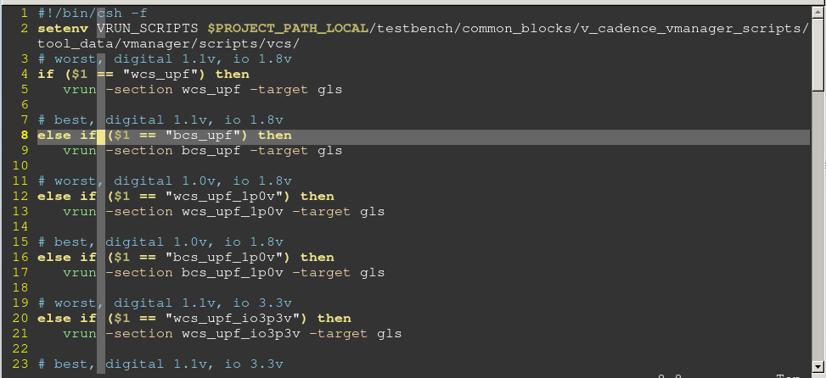

CLP

**dssc pop $PIWORKSPACE/settings/workspace_pg.md**

**dssc pop $PIWORKSPACE/settings/project_pg.md**

**setenv SOC_WORK $PIWORKSPACE/settings/workspace_pg.md**

bsub -q interq -I soc vcsmx -block soc_tb -seed -1776956120 -bc postlayout_clp -tc sentinel -vectors s200 -test_name s200_lpuart_basic_txrx -sim_arg "-gui" -fsdb -keeptemps -collect_arg -cond best -session postlayout_clp_lpuart &

* verdi 打开：

进入文件夹：

/home/kw47_verif_nobk1/richard_nxa28190/V_SS_KW47_SOC_TB_1.30/testbench/blocks/soc_tb/tool_data/verilog/verilog_FILENAMES_apcw401i-10-60-47-211.nxdi.kr-awsc1.nxp.com_68100

bsub -q interq verdi -f caf -sv -uvm

* 不编译.V

加上 -no_compile

* 允许跑出所有错误

最好在command line 上跑， 加-sim_arg "+MAX_ERROR=200 +UVM_ERROR=200"，这样把所有的error 都跑出来再 一次性加属性，速度快些

### Coverage

imc -load /home/kw47_verif_nobk2/kai_nxf55178/V_SS_KW47_SOC_TB_1.30_cov/testbench/blocks/soc_tb/tool_data/iccr/rtl.nxf55178.23_09_26_22_09_12_0089/all &

### Stingray tc

Tc控制哪些VIP需要编译， 对应的tc文件路径：

/home/kw47_verif_nobk1/richard_nxa28190/V_SS_KW47_SOC_TB_1.6/testbench/blocks/soc_tb/global/ sentinel.tc

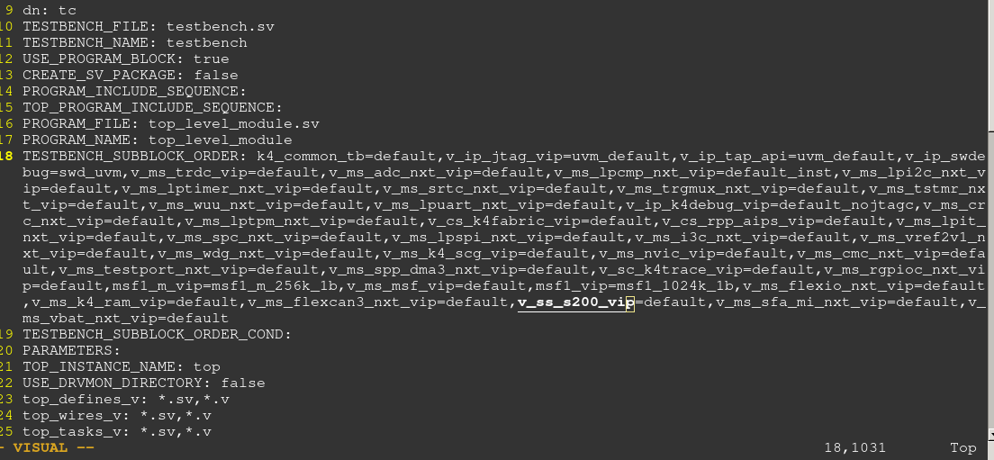

命令跑S200 case的时候，tc需要指定为sentinel

soc verilog -irun -tc sentinel -bc rtl

vplan中tc的配置：

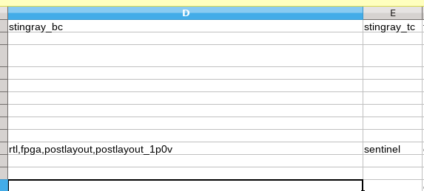

### 查看波形

verdi -f xx -ssf xxx.fsdb

## 关键字

Compiling stimulus

Compiling stimulus for CORE_A

GLOBAL_OBJS=

CORE_A_STIM CORE_S3_STIM

/pkg/fs-stingray-/2019.04/free_software/make/linux26_64bit/make -f

Generating required files

Generating sray_mem_map for CORE_S3

arm-none-eabi-ld

Load S3 image into S3 ROM

# ROM test

## 环境配置

4. Get rom vip in testbench/common_blocks

pi pop v_ss_rom_verif_vip

5. Go into rom vip and dssc pop all the files

cd v_ss_rom_verif_vip

dssc pop -recursive

6. Update Sentinel ROM hex (I can’t check in Sentinel ROM hex) to latest:

pi pop v_ss_s200_vip

put s3.rom.hex in v_ss_s200_vip/tool_data/compiler/include

7. Pop ROM tc and following sv file to the latest:

cd testbench/blocks/soc_tb/global/

dssc pop default_rom.tc (v1.4)

work

cd testbench/blocks/soc_tb/testbench/top_instances_v

dssc pop ram_data_initial_for_rom_code.sv (v1.2)

8. Pop rom vplans under testbench/blocks/soc_tb/tool_data/vplanner/rom_regression

9. Pop all the files under testbench/blocks/soc_tb/vectors/rom_bootloader,

Put latest bootloader.hex under testbench/blocks/soc_tb/vectors/rom_bootloader/stimulus/rom_hex

(A very initial version of ROM is checked in as v1.2 (removed S200 related things and can make following ROM sanity pass))

Feel free to update bootloader.hex

10. Clean the soc tb

11. vgen the rom vplans under testbench/blocks/soc_tb/tool_data/vplanner/rom_regression

vgen -plan xxx.csv,xxx.csv

12. Run sanity:

soc verilog -irun -block soc_tb -bc rtl -tc default_rom -vectors rom_bootloader -test bt_fast_lpuart_getproperty1 -sim_arg "-gui" -keeptemps -session kw47_rom -collect_arg

Run regression: vrun

### Files

Soc ROM：

/home/kw47_verif_nobk2/richard_nxa28190/V_SS_KW47_SOC_TB_1.31_GLS03/testbench/blocks/soc_tb/vectors/rom_bootloader/stimulus/rom_hex/bootloader.hex

S200 ROM

/home/kw47_verif_nobk2/richard_nxa28190/V_SS_KW47_SOC_TB_1.31_GLS03/testbench/common_blocks/v_ss_s200_vip/tool_data/compiler/include/ s3.rom.hex

SOC main C for testbench compile

/home/kw47_verif_nobk2/richard_nxa28190/V_SS_KW47_SOC_TB_1.31_GLS03/testbench/common_blocks/v_ss_rom_verif_vip/vectors/rom_bootloader/stimulus/bootloader.c

### Arg

/home/kw47_verif_nobk2/richard_nxa28190/V_SS_KW47_SOC_TB_1.31_GLS03/testbench/blocks/soc_tb/vectors/rom_bootloader/arg/vectorset.arg

#### 指定SOC ROM跟S200 ROM

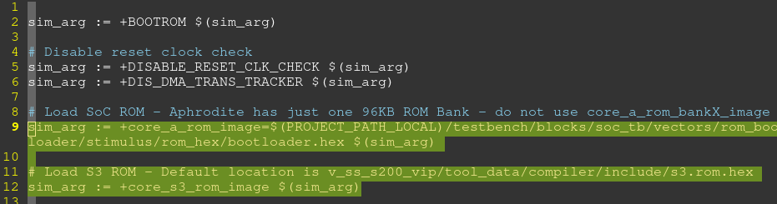

#### 指定test SV/SV 需要的参数

/home/kw47_verif_nobk2/richard_nxa28190/V_SS_KW47_SOC_TB_1.31_GLS03/testbench/common_blocks/v_ss_rom_verif_vip/vectors/rom_bootloader/stimulus/arg/bt_fast_lpuart_getproperty1_custom.arg

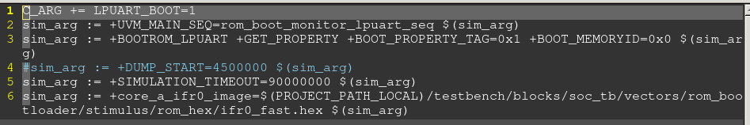

/home/kw47_verif_nobk2/richard_nxa28190/V_SS_KW47_SOC_TB_1.31_GLS03/testbench/common_blocks/v_ss_rom_verif_vip/vectors/rom_bootloader/stimulus/arg/bootloader_custom.arg

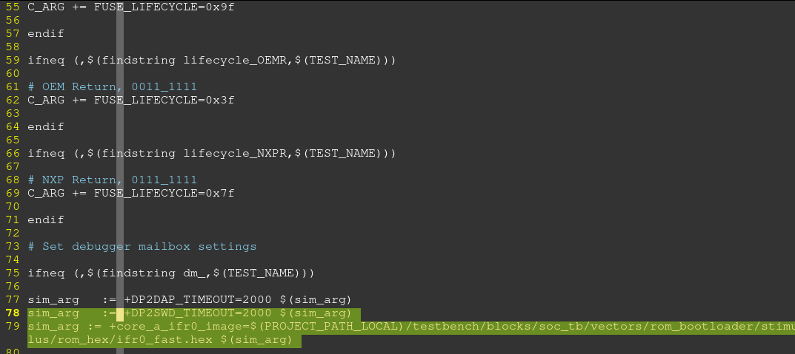

### Test command

RTL command：

bsub -q interq -I soc verilog -irun -tc default_rom -bc rtl -vec rom_bootloader -collect_arg -test bt_fast_lpuart_getproperty1 -sim_arg '-gui +MEMDUMP ' -keeptemps -shm -session rom &

bsub -q interq -I    soc verilog -irun -block soc_tb -bc postlayout -tc default_rom -vectors rom_bootloader -test bt_fast_lpuart_getproperty1 -sim_arg "-gui" -shm -keeptemps -collect_arg -cond worst -session gls_rom_worst &

bsub -q interq -I    soc verilog -irun -block soc_tb -bc postlayout -tc default_rom -vectors rom_bootloader -test bt_common_can_get_property_1M -sim_arg "-gui" -shm -keeptemps -collect_arg -cond worst -session gls_rom_worst &

1.0V 48M

bsub -q interq -I    soc verilog -irun -block soc_tb -bc postlayout_1p0v -tc default_rom -vectors rom_bootloader -test gls_bt_normal_lpspi_programReadFuseFlashIFR_lifecycle_BLANK -sim_arg "-gui" -shm -keeptemps -collect_arg -cond worst -session gls_rom_worst &

bsub -q interq -I    soc verilog -irun -block soc_tb -bc postlayout_1p0v -tc default_rom -vectors rom_bootloader -test gls_bt_normal_lpspi_programReadFuseFlashIFR_lifecycle_BLANK -sim_arg "-gui" -shm -keeptemps -collect_arg -cond best -session gls_rom_1p0_best &

bsub -q interq -I    soc verilog -irun -block soc_tb -bc postlayout_1p0v -tc default_rom -vectors rom_bootloader -test bt_normal_lpuart_getproperty2 -sim_arg "-gui" -shm -keeptemps -collect_arg -cond worst -session gls_rom_1p0_uart_worst &

## Test case

### rom_boot_monitor_lpuart_seq

/home/kw47_verif_nobk2/richard_nxa28190/V_SS_KW47_SOC_TB_1.31_GLS03/testbench/common_blocks/v_ss_rom_verif_vip/testbench/classes_v/rom_boot_monitor_base_seq.sv

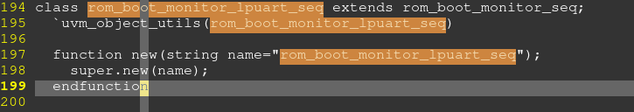

#### rom_boot_monitor_seq

/home/kw47_verif_nobk2/richard_nxa28190/V_SS_KW47_SOC_TB_1.31_GLS03/testbench/common_blocks/v_ss_rom_verif_vip/testbench/classes_v/aphrodite/rom_boot_monitor_seq.sv

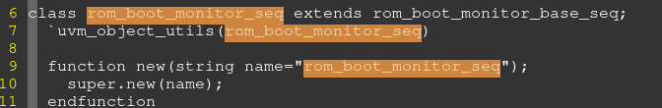

#### rom_boot_monitor_base_seq

classes_v/rom_boot_monitor_base_seq.sv

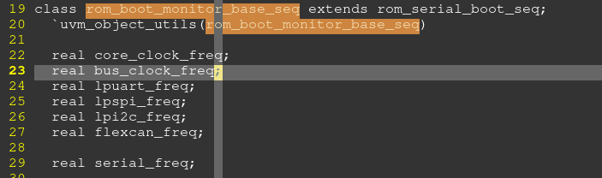

#### rom_serial_boot_seq

classes_v/rom_serial_boot_seq.sv

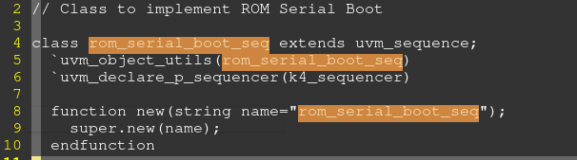

### rom_boot_isp

/home/kw47_verif_nobk2/richard_nxa28190/V_SS_KW47_SOC_TB_1.31_GLS03/testbench/common_blocks/v_ss_rom_verif_vip/testbench/modules_v/rom_boot_isp.sv

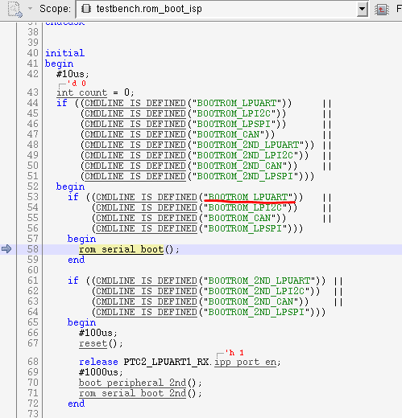

#### rom_serial_boot

v_ss_rom_verif_vip/testbench/modules_v/rom_boot_isp.sv

Log: VIP_setup

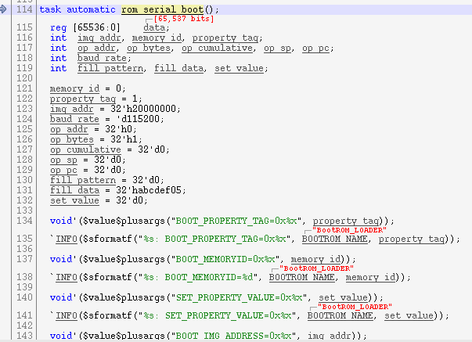

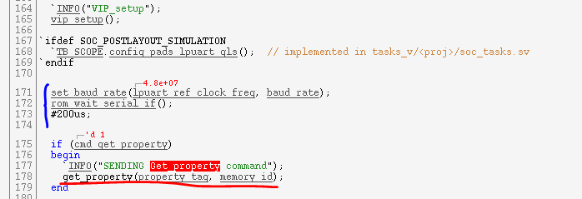

##### get_property

tasks_v/rom_api_task.sv

log: Waiting get-property respons

-Report of Get_propert

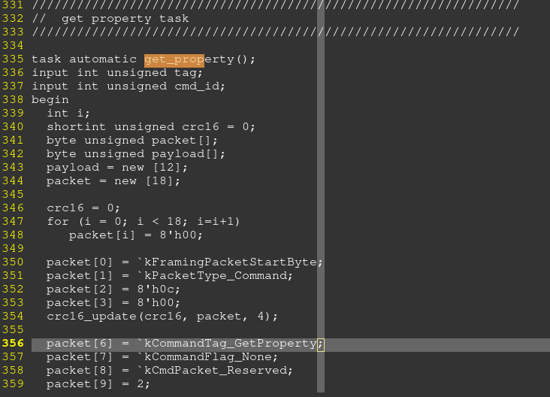

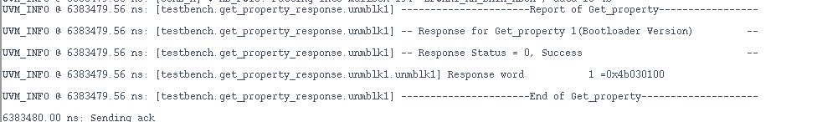

### Random reset issue

S200 ROM 没有对32K RAM 进行初始化。32K对应两个16K的物理RAM。 PRAM0/PRAM1

USM只是对PRAM1进行了初始化。

ROM访问相同的USM 初始化的地址时，由于S200有memory mapping的问题。导致ROM访问到了PRAM0上面。在LC》=3d的时候，ECC校验会打开，这就回导致ECC multiple issue。。 System ROM 根据S200 ROM返回的错误，从而reset整个系统。

#### 测试思路

Preload PRAM0/1 带ECC error的数据，测试LC=3的ROM case

#### Testbench修改

**Preload：**

/home/kw47_verif_nobk1/richard_nxa28190/V_SS_KW47_SOC_TB_1.38.1/testbench/blocks/soc_tb/testbench/forces_v/ ramdom_reset_read_mem.sv

**修改RAM 模型，增加preload功能s**

/home/kw47_verif_nobk1/richard_nxa28190/V_SS_KW47_SOC_TB_1.38.1/memories/ts_cln40ulpef_nxp_edlvspram_04096x039c08l128_mu_r_m7/BEHAVIOUR/sts_cln40ulpef_nxp_edlvspram_04096x039c08l128_mu_r_m7_behaviour_pwr.v

#### Waveform

/home/kw47_verif_nobk1/richard_nxa28190/V_SS_KW47_SOC_TB_1.38.1/testbench/blocks/soc_tb/vectors/rom_bootloader/results/bt_normal_lpspi_programReadFuseFlashIFR_lifecycle_PROVVrtlCunitM_kw47-random-reset-fixed.shm/

# GLS

Reading SDF file from location "/home/kw47_verif_nobk2/richard_nxa28190/V_SS_KW47_SOC_TB_1.31_GLS03/chip_be/timing/postlayout/PssgV1710V1620V0990Tm40_cmax.sdf"

## Arg

V_SS_KW47_SOC_TB_1.34_GLS00/testbench/blocks/soc_tb/arg/Block.arg

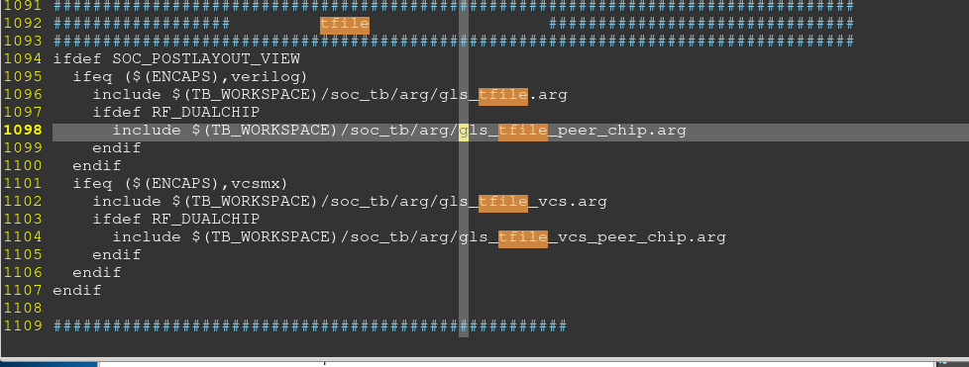

testbench/blocks/soc_tb/arg/gls_tfile.arg

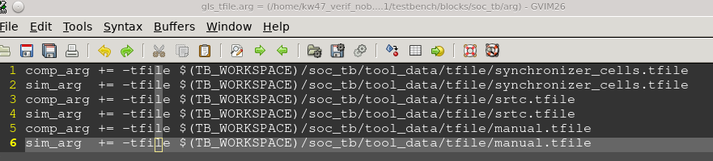

gls_tfile_vcs.arg

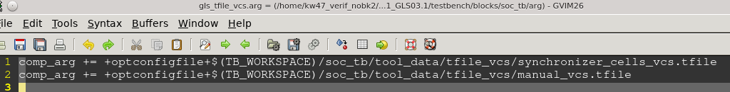

## Tfile

testbench/blocks/soc_tb/tool_data/tfile/manual.tfile

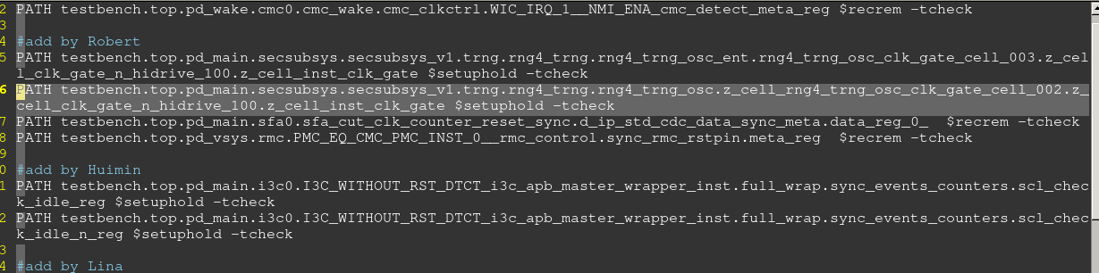

testbench/blocks/soc_tb/tool_data/tfile_vcs/manual_vcs.tfile

注意不要加注释，否则编译报错



# Make

## Makefile参数

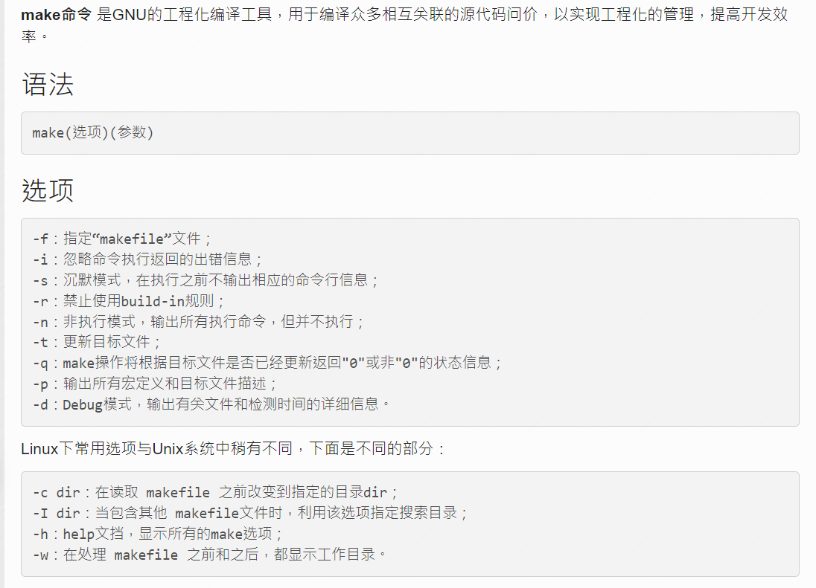

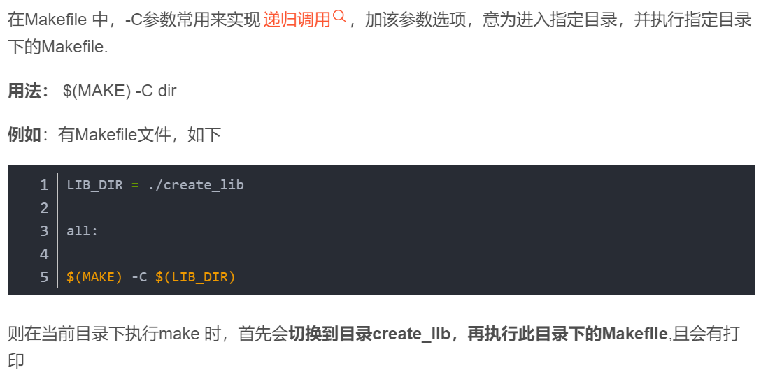

Stringgray会在如下目录生成一个verilog打头的文件夹，里面包含了run_all.sh

Run_all.sh 会调用如下两个脚本： run_make_stim.sh/run_sim.sh

/home/kw47_verif_nobk1/richard_nxa28190/V_SS_KW47_SOC_TB_1.6/testbench/blocks/soc_tb/tool_data/verilog/

## run_tbmake.sh

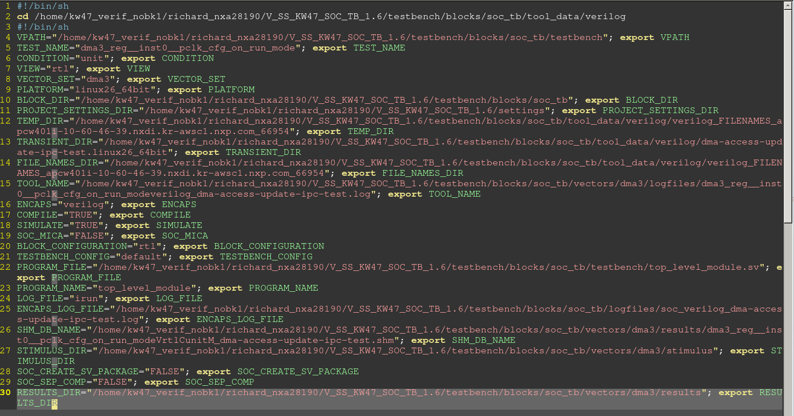

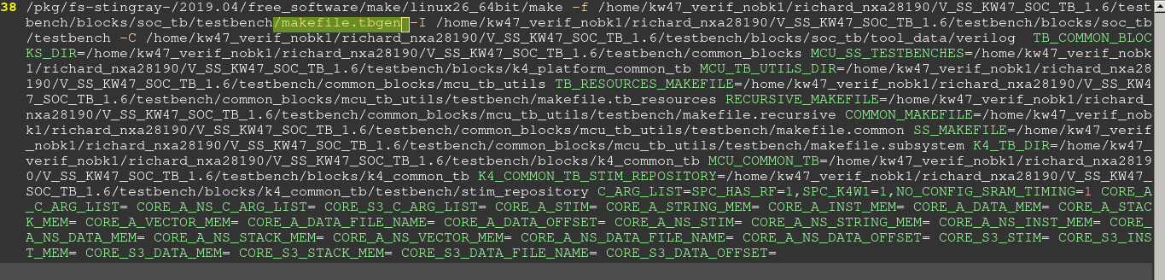

### Makefile.tbgen

V_SS_KW47_SOC_TB_1.6/testbench/blocks/soc_tb/testbench/ makefile.tbgen

生成C跟V编译需要的.mem_map、.h

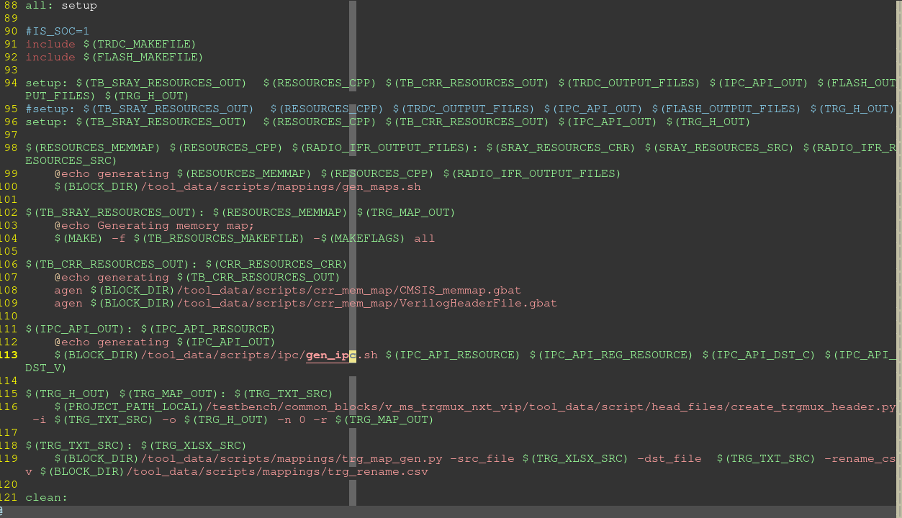

### Ipc register offset

IPC 寄存器的offset 生成到这个文件：

V_SS_KW47_SOC_TB_1.6/testbench/blocks/soc_tb/tool_data/compiler/include/generated/ crr_reg_map.h

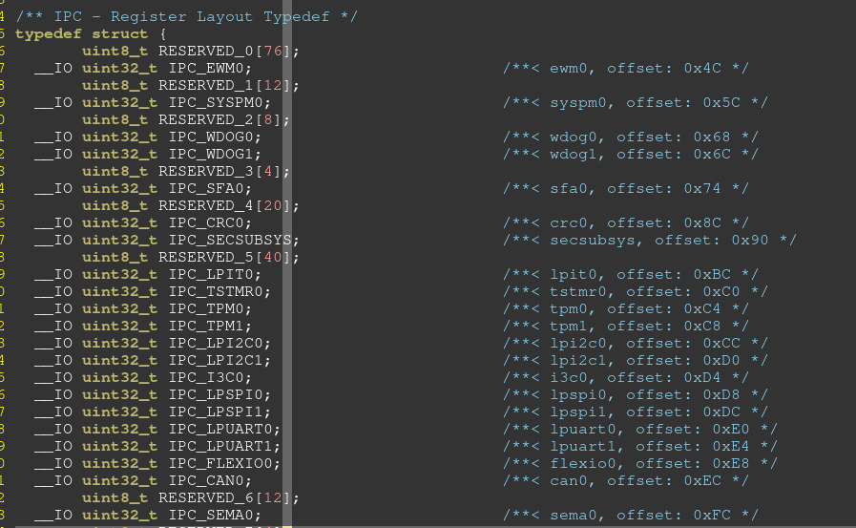

生成ipc 寄存器用到的文档中指定了模块offset：

V_SS_KW47_SOC_TB_1.6/testbench/blocks/soc_tb/tool_data/scripts/ipc/temp_reg_source/ ipc.regs

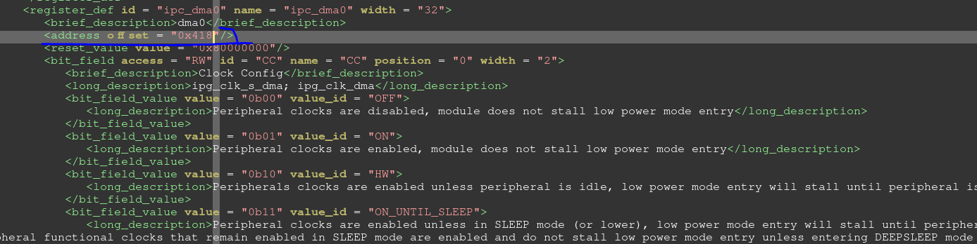

## Run_all

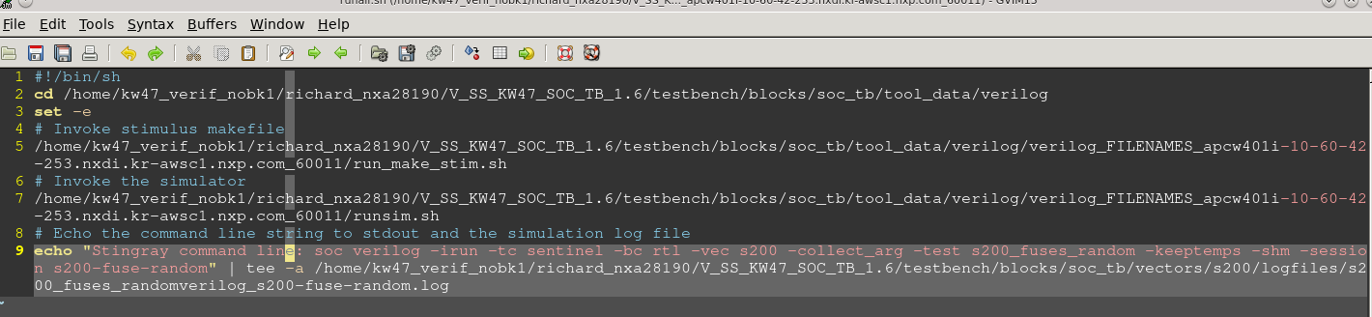

### run_make_stim.sh

test case名，测试log目录，编译用到的编译器，编译参数。都在这里指定

奇怪的是，VPLAN里面不设定core 为sentinel，如果tc选择为sentinel.tc这里也会编译sentinel

/pkg/fs-stingray-/2019.04/free_software/make/linux26_64bit/make

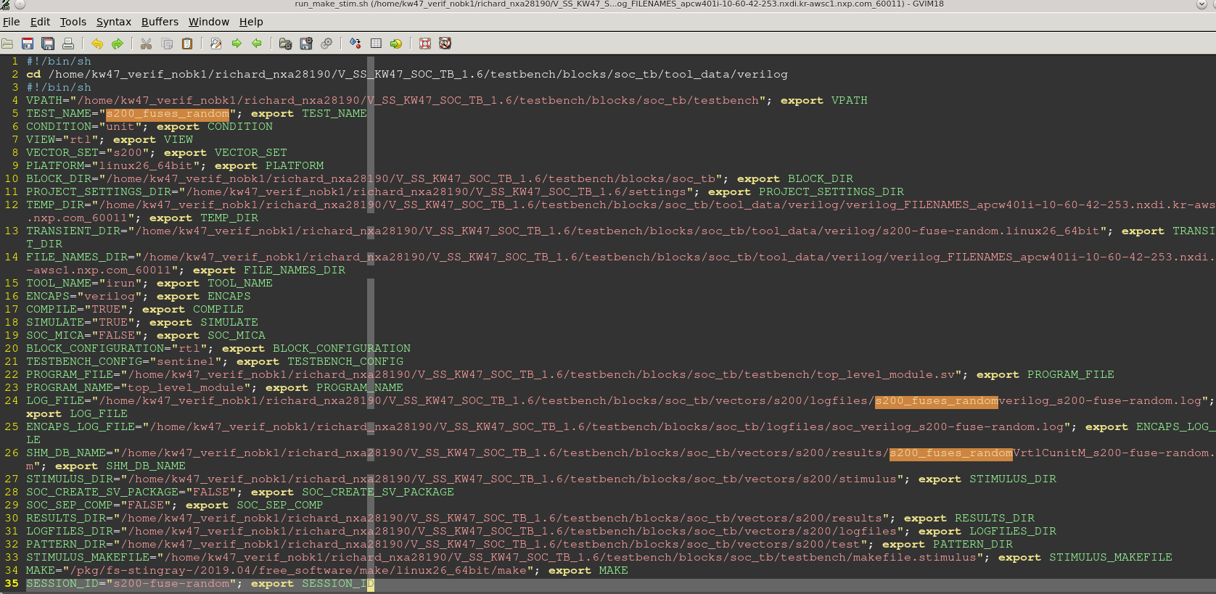

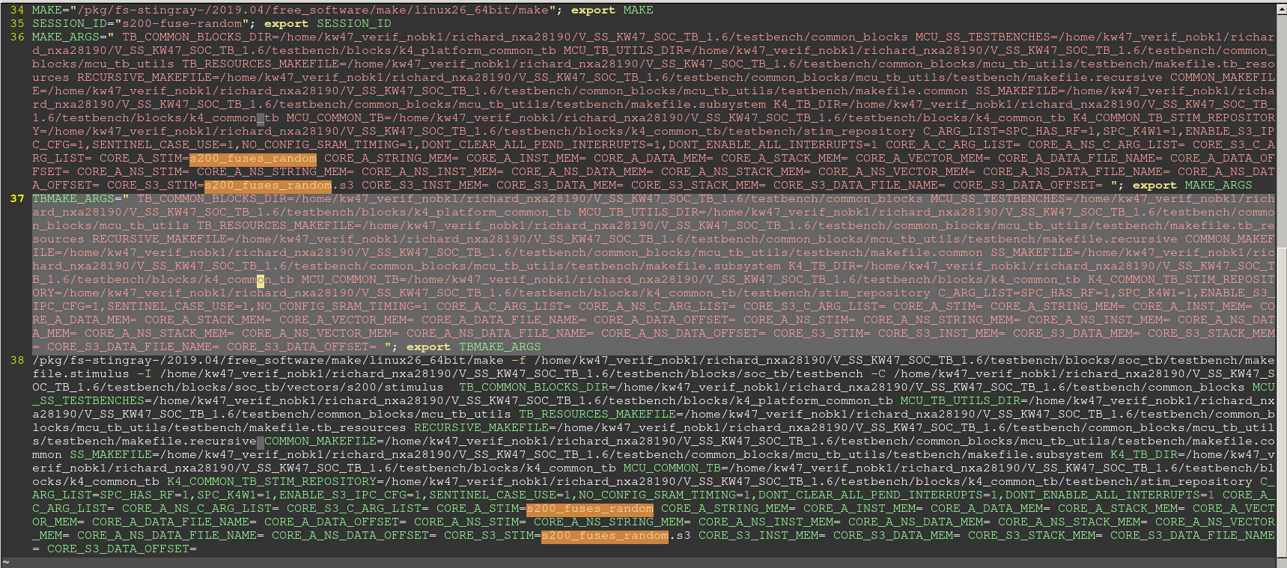

MAKE="/pkg/fs-stingray-/2019.04/free_software/make/linux26_64bit/make"; export MAKE

SS_MAKEFILE=/home/kw47_verif_nobk1/richard_nxa28190/V_SS_KW47_SOC_TB_1.6/testbench/common_blocks/mcu_tb_utils/testbench/makefile.subsystem

MCU_TB_UTILS_DIR=/home/kw47_verif_nobk1/richard_nxa28190/V_SS_KW47_SOC_TB_1.6/testbench/common_blocks/mcu_tb_utils

FILE_NAMES_DIR="/home/kw47_verif_nobk1/richard_nxa28190/V_SS_KW47_SOC_TB_1.6/testbench/blocks/soc_tb/tool_data/verilog/verilog_FILENAMES_apcw401i-10-60-42-253.nxdi.kr-awsc1.nxp.com_60011"; export FILE_NAMES_DIR

TESTBENCH_CONFIG="sentinel"; export TESTBENCH_CONFIG

Make 参数：

使用参数-f，指定makefile

-f /home/kw47_verif_nobk1/richard_nxa28190/V_SS_KW47_SOC_TB_1.6/testbench/blocks/soc_tb/testbench/makefile.stimulus

参数-I， 补充用的makefile

-I /home/kw47_verif_nobk1/richard_nxa28190/V_SS_KW47_SOC_TB_1.6/testbench/blocks/soc_tb/testbench

使用参数-C，切换到对应的目录下，执行该目录下的makefile

-C /home/kw47_verif_nobk1/richard_nxa28190/V_SS_KW47_SOC_TB_1.6/testbench/blocks/soc_tb/vectors/s200/stimulus

#### 主makefile(makefile.stimulus)

V_SS_KW47_SOC_TB_1.4/testbench/blocks/soc_tb/testbench/ makefile.stimulus

根据不同core的定义，指定makefile，编译对应core的case

#### Core A makefile

A core， CM33：

配置环境变量，指定下makefile.subsystem为下一个调用的makefile

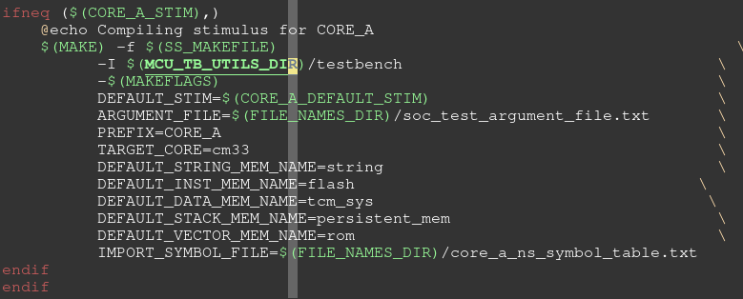

/home/k4w1_bk/richard_nxa28190/SOC_K4W1_CLN40ULP_1.13_TB1_TO/testbench/common_blocks/mcu_tb_utils/testbench



Crt0.s:

testbench/common_blocks/mcu_tb_utils/tool_data/gnu/cm33/crt0.s

Log:

Compiling stimulus for CORE_A

GLOBAL_OBJS= s200_fuses_random_crt0.o s200_fuses_random.o

##### makefile.subsystem

testbench/common_blocks/mcu_tb_utils/testbench/makefile.subsystem

定义一些变量，调用makefile.recursive

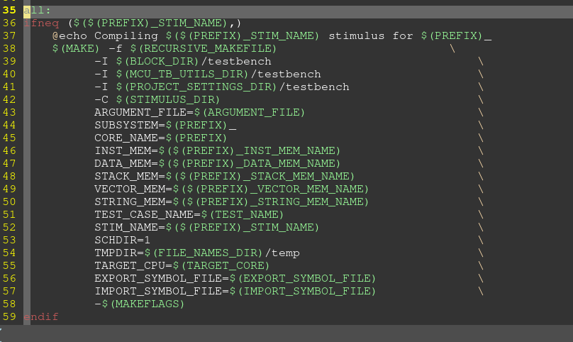

##### makefile.recursive

testbench/common_blocks/mcu_tb_utils/testbench/makefile.recursive

创建make用的临时文件夹，调用makefile.common

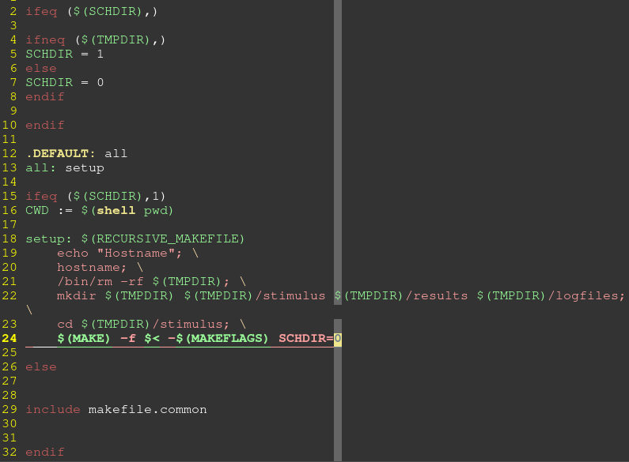

##### makefile.common

testbench/common_blocks/mcu_tb_utils/testbench/makefile.common

创建elf文件：

1. 生成linkfile
2. 编译CRT0.S，case.c得到两个.O。 然后进行链接生成elf

arm-none-eabi-as / arm-none-eabi-g++/ arm-none-eabi-ld

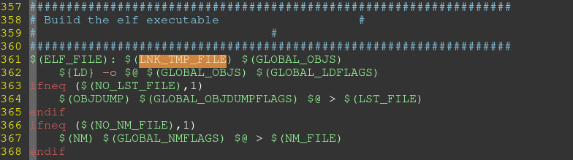

###### 创建linkfile

testbench/blocks/soc_tb/tool_data/gnu/cm0p/cm0p.lnk

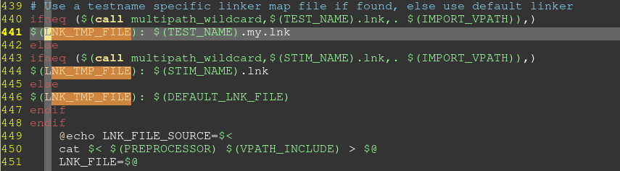

###### 编译elf

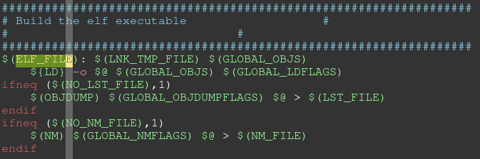

GLOBAL_OBJS



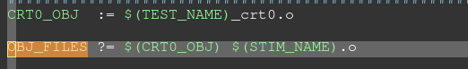

编译crt0.s

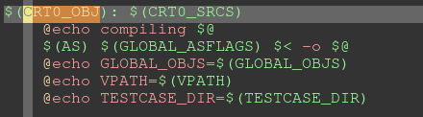

编译testcase.c

STIM_NAME



###### 生成hex，srec

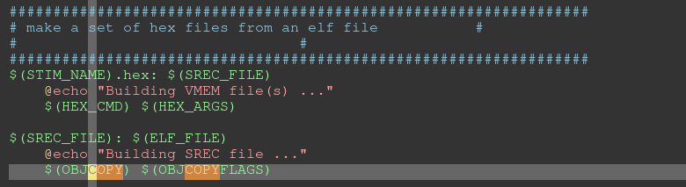

##### makefile.defs

定义makefile.common中gcc用到的指令。

Makefile.common include了这个文件

#### Core S3 makefile

主makefile根据core的定义指定makefile



##### Makefile.stimulus

testbench/common_blocks/v_ss_s200_vip/testbench/ makefile.stimulus

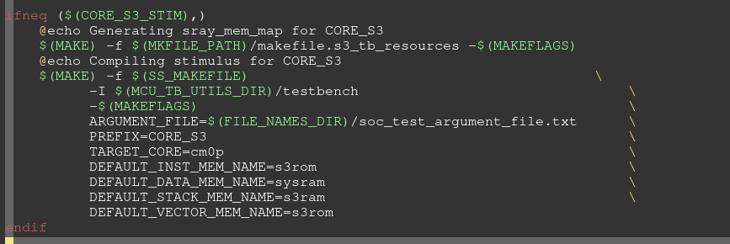

Crt0:

testbench/common_blocks/mcu_tb_utils/tool_data/gnu/cm0p/crt0.s

Log:

Generating sray_mem_map for CORE_S3

GLOBAL_OBJS= s200_fuses_random_crt0.o s200_fuses_random.s3.o

### runsim.sh

## Log

编译log

/home/kw47_verif_nobk1/richard_nxa28190/SOC_K4W1_CLN40ULP_1.16_TB1/testbench/blocks/soc_tb/logfiles

# C code

## Crt0.s

S200：

/home/kw47_verif_nobk1/richard_nxa28190/SOC_K4W1_CLN40ULP_1.16_TB1/testbench/common_blocks/mcu_tb_utils/tool_data/gnu/cm0p/crt0.s

CM33:

/home/kw47_verif_nobk1/richard_nxa28190/SOC_K4W1_CLN40ULP_1.16_TB1/testbench/common_blocks/mcu_tb_utils/tool_data/gnu/cm33/crt0.s

## Switch to NS

blocks/soc_tb/vectors/src/stimulus/dummy_s.c

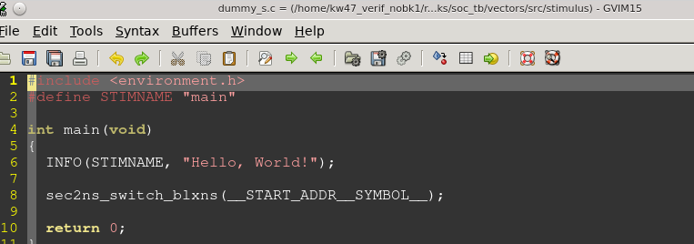

## _start.c

testbench/common_blocks/v_ip_capi/tool_data/compiler/include/ _start.c

CM33:

testbench/blocks/soc_tb/tool_data/compiler/CORE_A_include/pre_post_main.h

## pre_post_main.h – core CM33

testbench/blocks/soc_tb/tool_data/compiler/CORE_A_include/pre_post_main.h

如果用到了S200， CM33 pre_main中对S200 进行时钟的开启

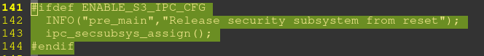

## pre_post_main.h – S200

S200:

testbench/blocks/soc_tb/tool_data/compiler/CORE_S3_include/pre_post_main.h

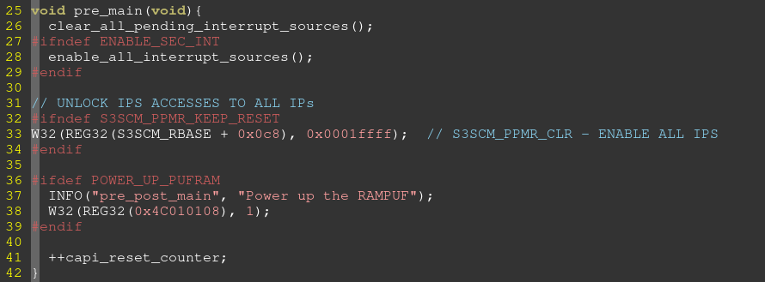

## 中断处理

中断向量表，从2-255都配置为 _capi_interrupt_handler+1。

V_SS_KW47_SOC_TB_1.6/testbench/common_blocks/mcu_tb_utils/tool_data/gnu/cm33/crt0_vector_table.s

所有的中断向量的名字都叫做_capi_interrupt_handler

这个函数内部根据一个数组来选择需要执行的中断服务函数。  
数组的下标就是向量号，内容就是中断服务函数

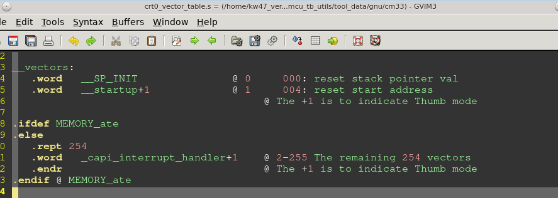

### _capi_interrupt_handler.h

testbench/blocks/soc_tb/tool_data/compiler/CORE_A_NS_include/capi_interrupt_handler.h

#### 读取ICSR，得到interrupt 号。

Log：capi_interrupt_handle

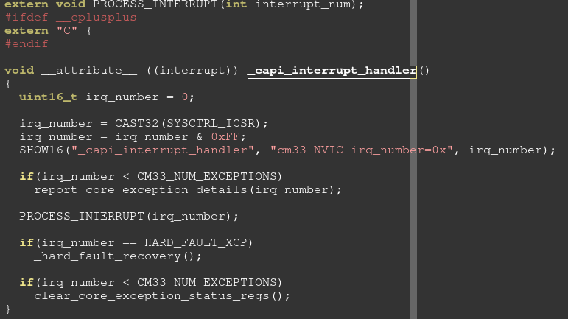

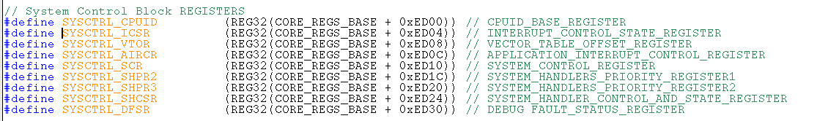

#### 如果interrupt号小于16，打印信息

report_core_exception_details(irq_number); log： Bus Fault

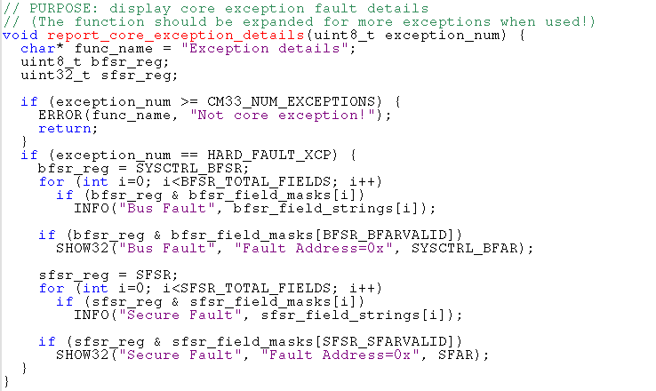

#### 处理中断 PROCESS_INTERRUPT(irq_number);

log: PROCESS_INTERRUPT:

INTERRUPT_JUMP_TABLE 数组存放中断服务函数，数组下标号为中断向量号。

执行的时候，从INTERRUPT_JUMP_TABLE中取出向量号对应的服务函数，传参为INERRUPT_TABLE[irq_num]。

使用方法：

INSTALL_ISR_WITH_CONTEXT(dma3_context->TEA_INT_VECTOR, dma3_tea_int_isr, dma3_context);

中断发生时，执行：

dma3_tea_int_isr(dma3_context);

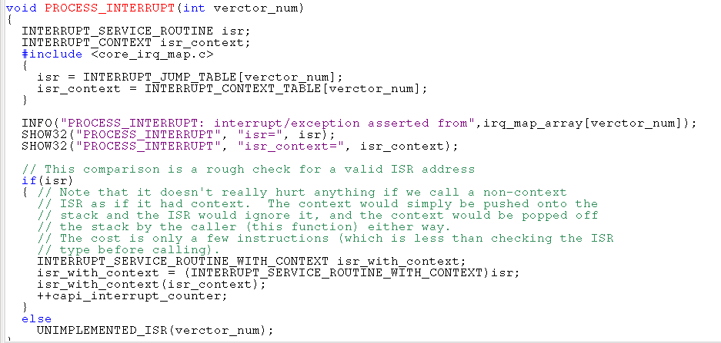

##### Irq table

INTERRUPT_JUMP_TABLE （中断服务函数数组，数组下标为中断向量号）

INTERRUPT_CONTEXT_TABLE （参数数组，数组下标为中断向量号）

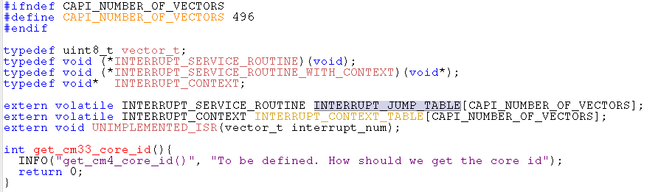

##### INSTALL_ISR_WITH_CONTEXT

blocks/soc_tb/tool_data/compiler/CORE_A_include/capi_int.h

Main函数中，注册一个中断服务程序。参数依次为中断向量号，中断服务函数，参数

INSTALL_ISR_WITH_CONTEXT(dma3_context->TEA_INT_VECTOR, dma3_tea_int_isr, dma3_context);

执行完该函数后：

1. INTERRUPT_JUMP_TABLE 数组，对应的向量号，存放中断服务函数
2. INTERRUPT_CONTEXT_TABLE数组，对应向量号，存放参数

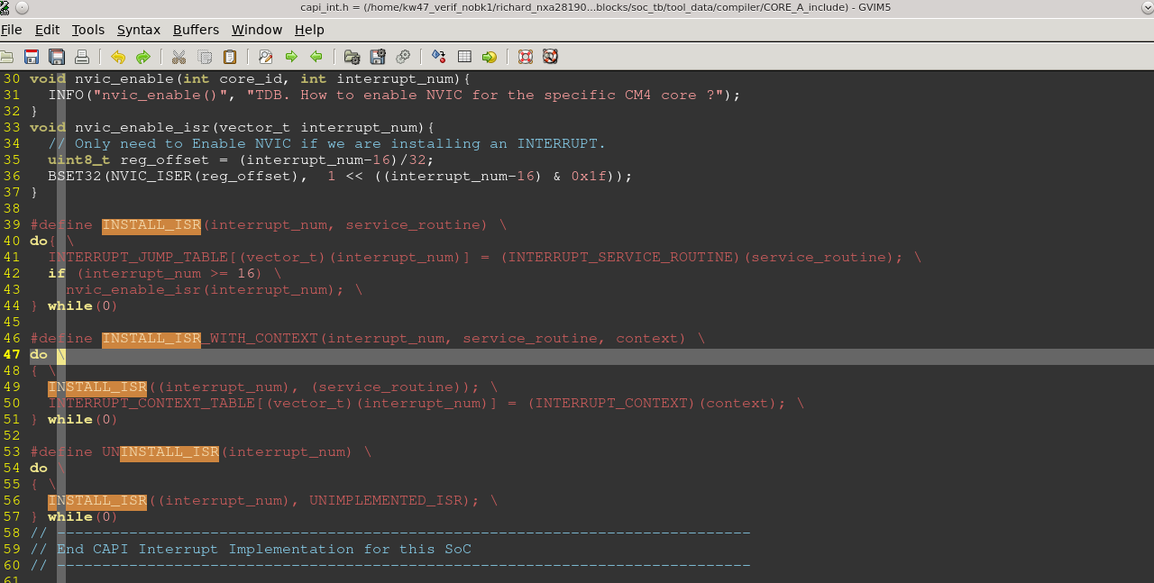

###### INSTALL_ISR

当中断向量号大于16，NVIC ISER寄存器注册向量号，激活中断

.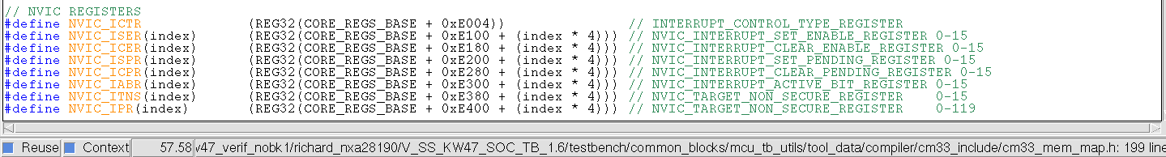

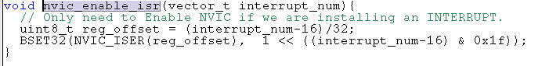



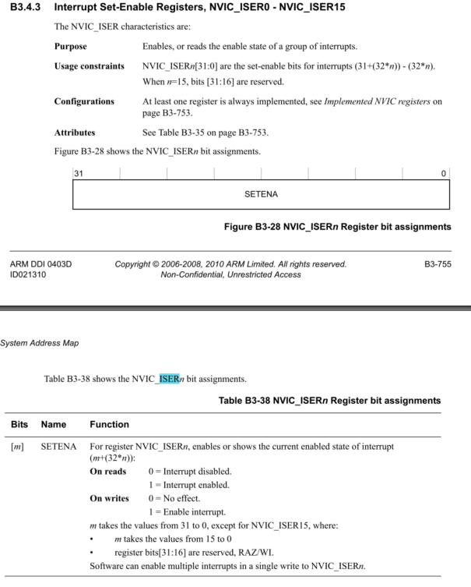

##### Irq_map_array 字符串

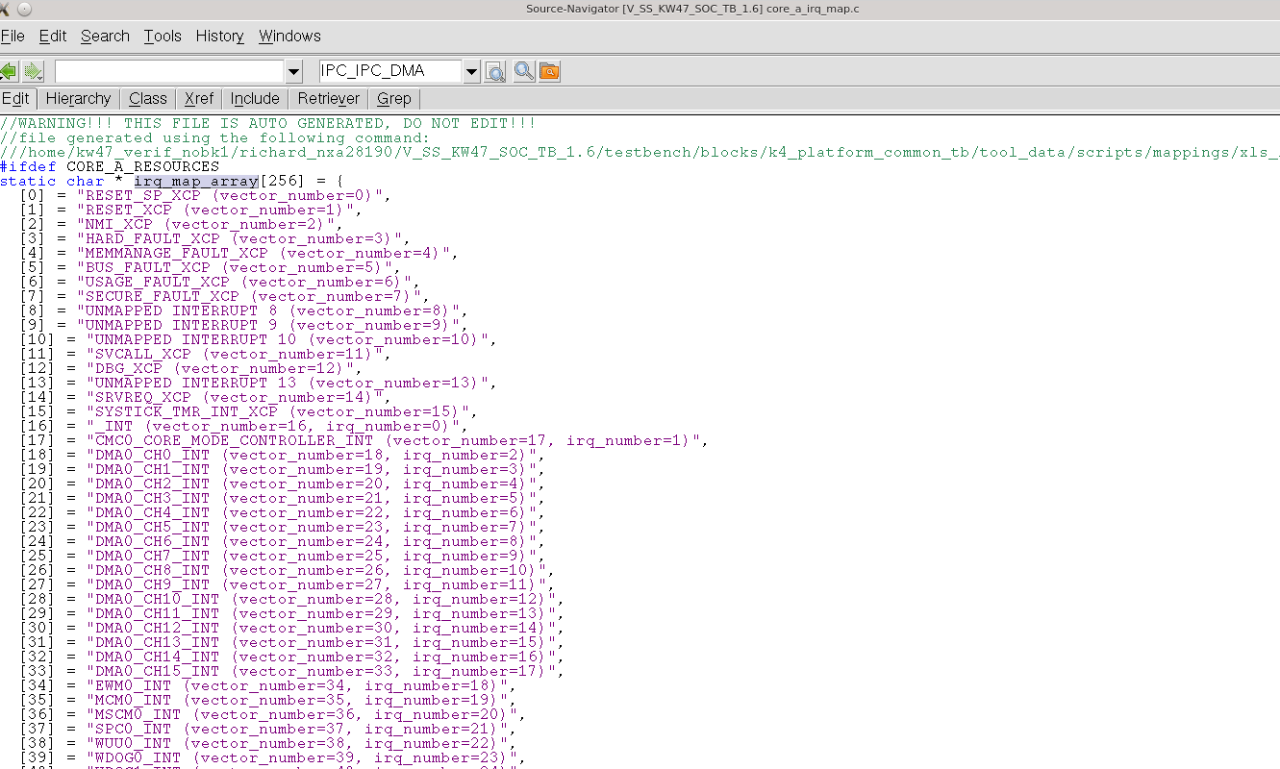

### Log

INSTALL_ISR_WITH_CONTEXT(dma3_context->TEA_INT_VECTOR, dma3_tea_int_isr, dma3_context);

1. 执行如上这个函数后，INTERRUPT_JUMP_TABLE （中断服务函数数组，数组下标为中断向量号）

INTERRUPT_CONTEXT_TABLE （参数数组，数组下标为中断向量号）会进行数据填充。

INTERRUPT_JUMP_TABLE[3] = dma3_tea_int_isr 的地址

INTERRUPT_CONTEXT_TABLE = dma3_context 的地址

2， 3号中断发生后，VECTABLE中的3号中断对应的函数是capi_interrupt_handle

执行这个函数后，会调用两个数组，跳到对赢的服务程序中，最终结果为

执行 dma3_tea_int_isr（dma3_context）

如下 是DMA 测试tea int的log：

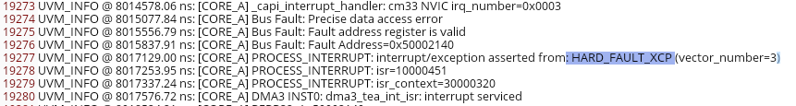

中断服务函数地址为flash中0x10000451

对应反汇编，服务函数的入口地址就是0x10000451

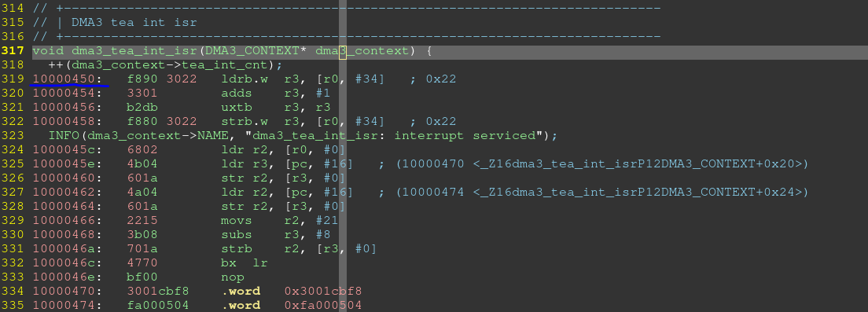

## 指针处理方法

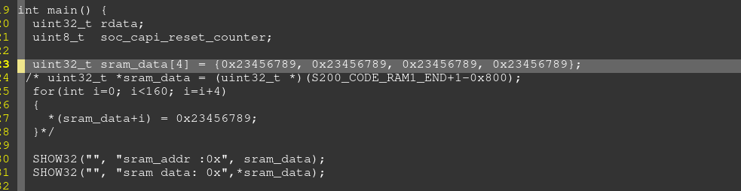

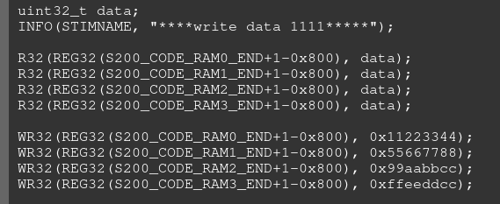

## s200_scm_mbist_init_req__swd

此case 涉及到三个编译。

Core A，core S3, USM

Core A跟CORE S3以及UVM交互。

1. Core S3DMA负责将USM 编译的数据，从SOC RAM搬运到S200 RAM中，然后配置好USM的参数供USM执行。
2. CoreA发动MBIST init request， USM接收到这个消息后，将MBIST init request拉高，硬件开始进行MBIST操作。

### 文件

#### USM

testbench/common_blocks/v_ss_s200_vip/vectors/s200/stimulus/s200_scm_mbist_init_req.usm.s

编译依赖文件：

/testbench/common_blocks/v_ms_s3_usm_nxt_vip/tool_data/compiler/include

# Register definition

## SOC

### MU

BASE ADDRESS: 0x4002_4000

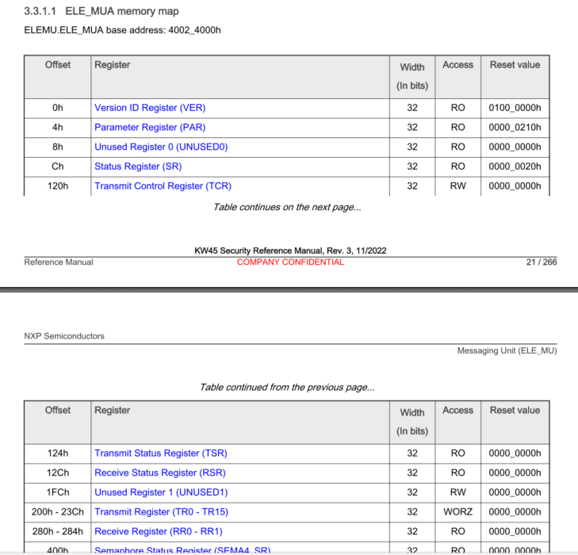

### DBGEN

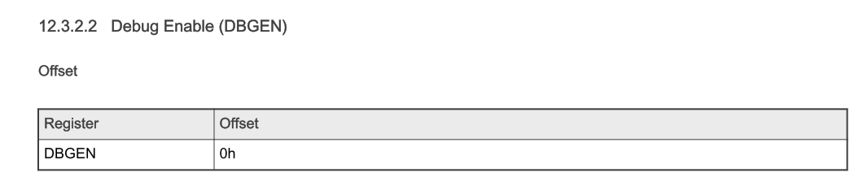

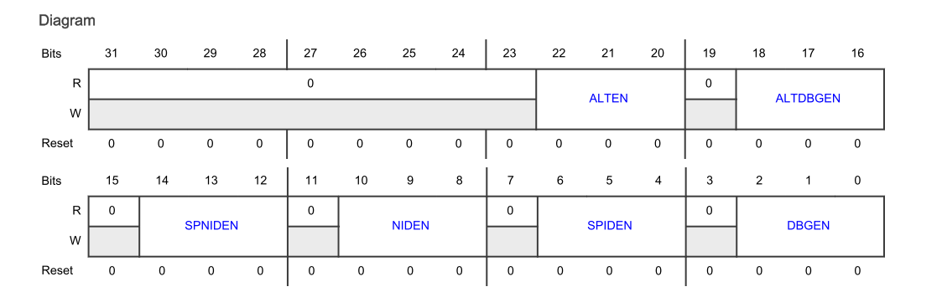

### SMSCM_LIFECYCLE

From S200 review: base address is : 0x4c0010d0(DBGEN)

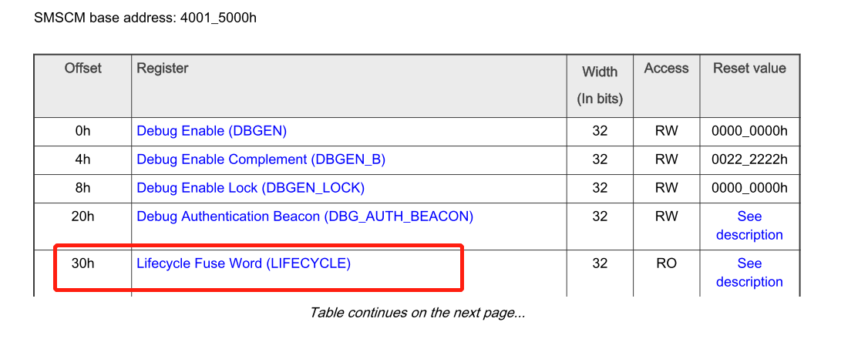

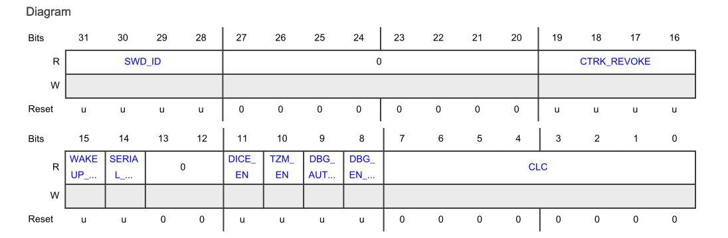

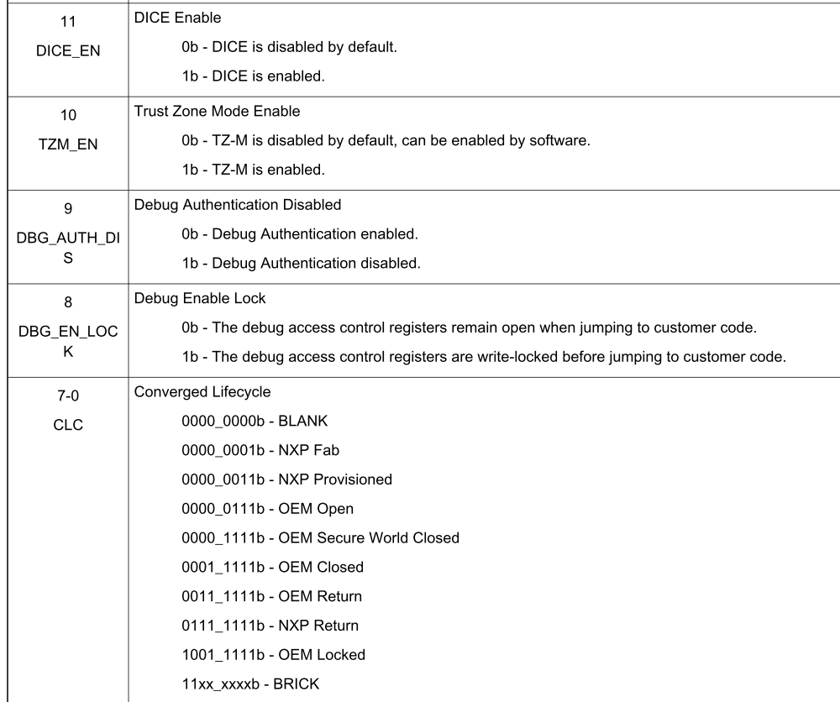

### SMSCM_LIFECYCLE_B

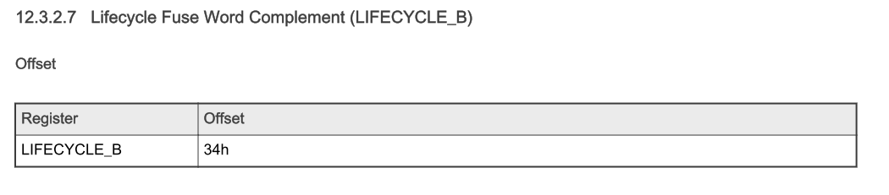

是SMSCM_LIFECYCLE 的取反

### CLOCK CONTROL CKCRTL

BASE ADDRESS: 0x4000_1000

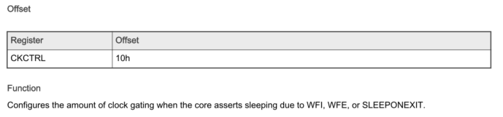

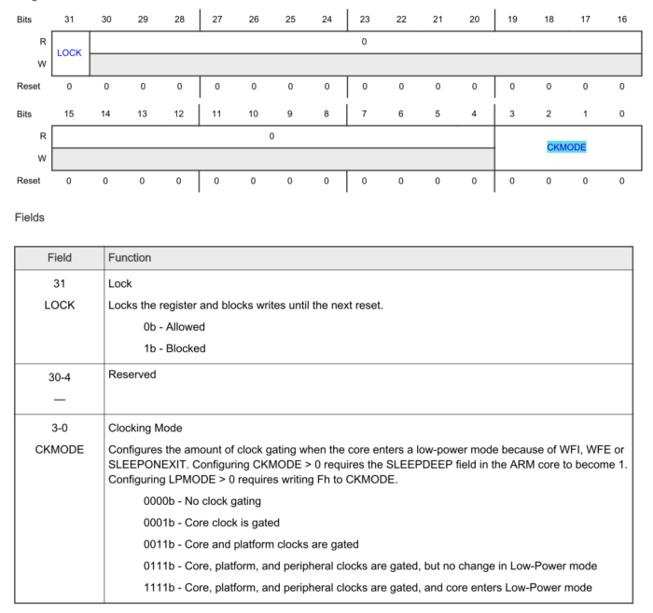

### Power mode protection (PMPROT)

0x40001018

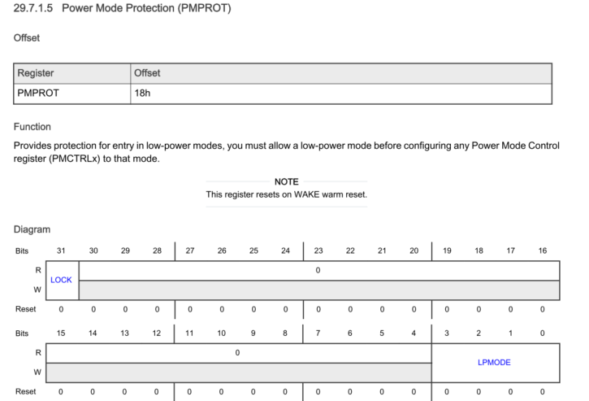

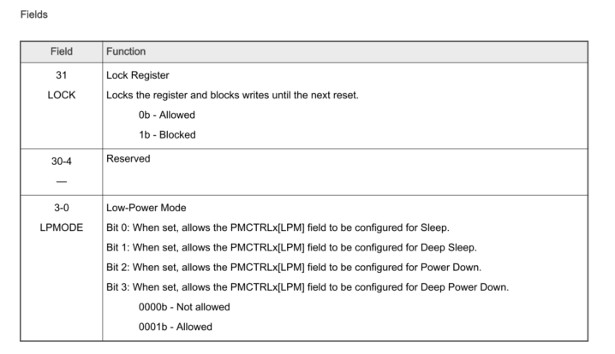

## S200

### S3SCM_RBASE

S3SCM: S3SCM_RBASE: 4c001000

### S3SCM_PPMR_CLR

- ENABLE ALL IPS

W32(REG32(S3SCM_RBASE + 0x0c8), 0x0001ffff);

W32: A=4c0010c8 W=0001ffff

### OTPC

OTPC_RBASE: 4c00f000

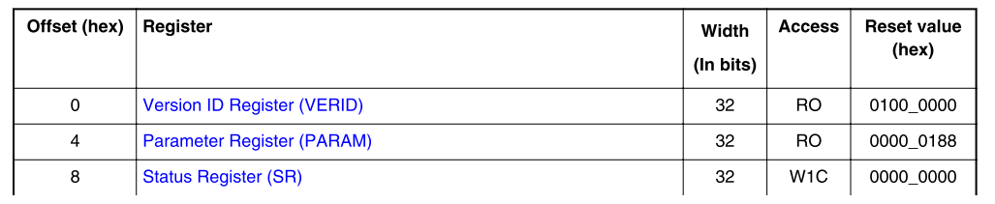

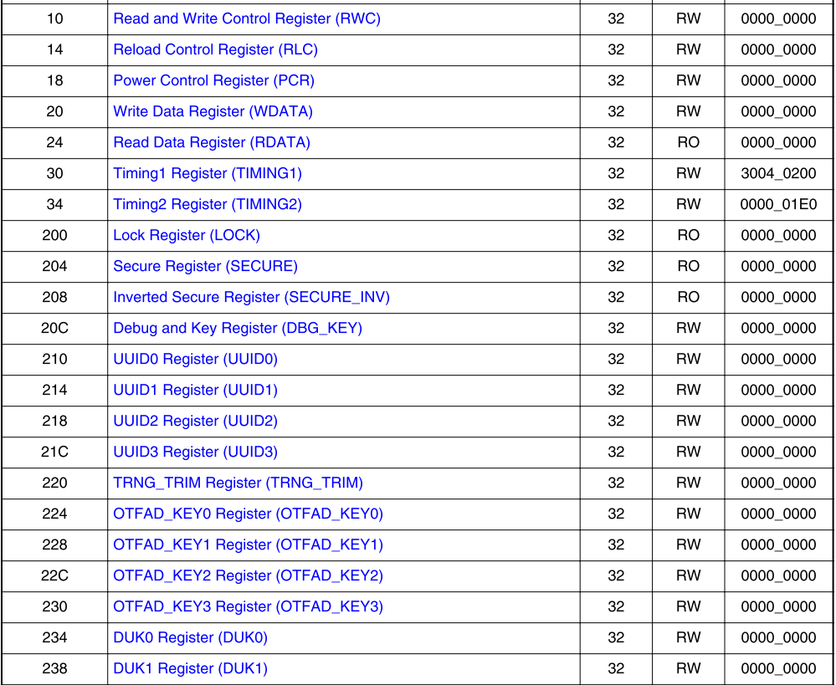

### S3SCM_SR1

Soc_tb/tool_data/compiler/include/generated/sray_mem_map.h

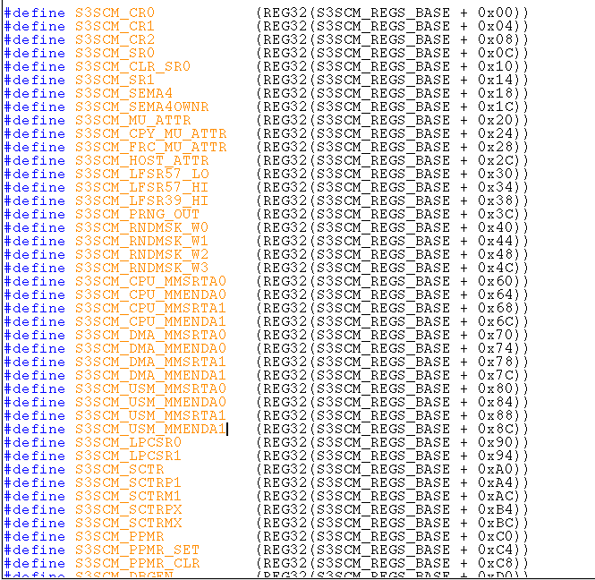

### S3SCM_SR0

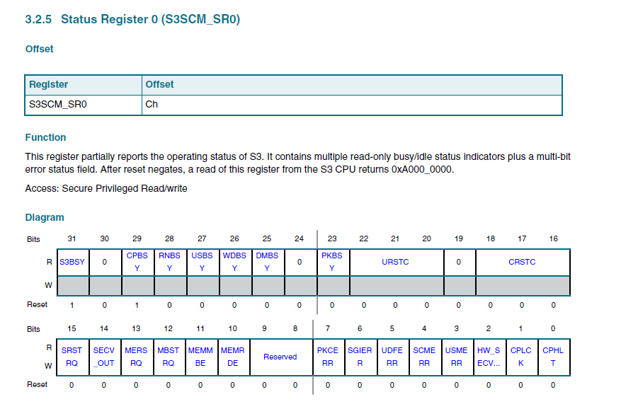

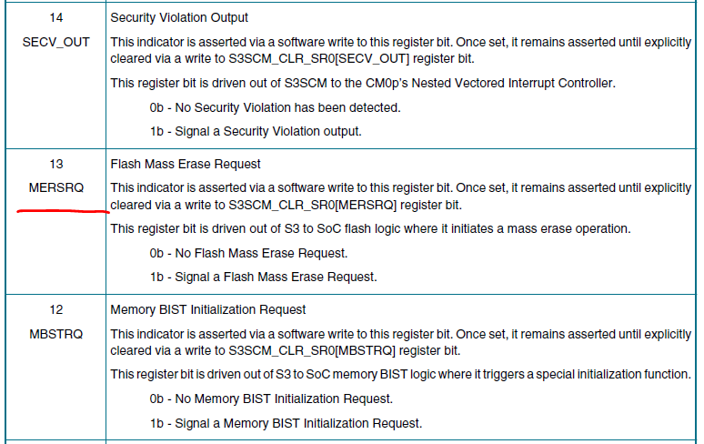

### S3SCM_TEST_LOCK

控制DBGEN[TOD], DBGEN[TEN]等寄存器的写权限

0： unlock

2： 不可以写

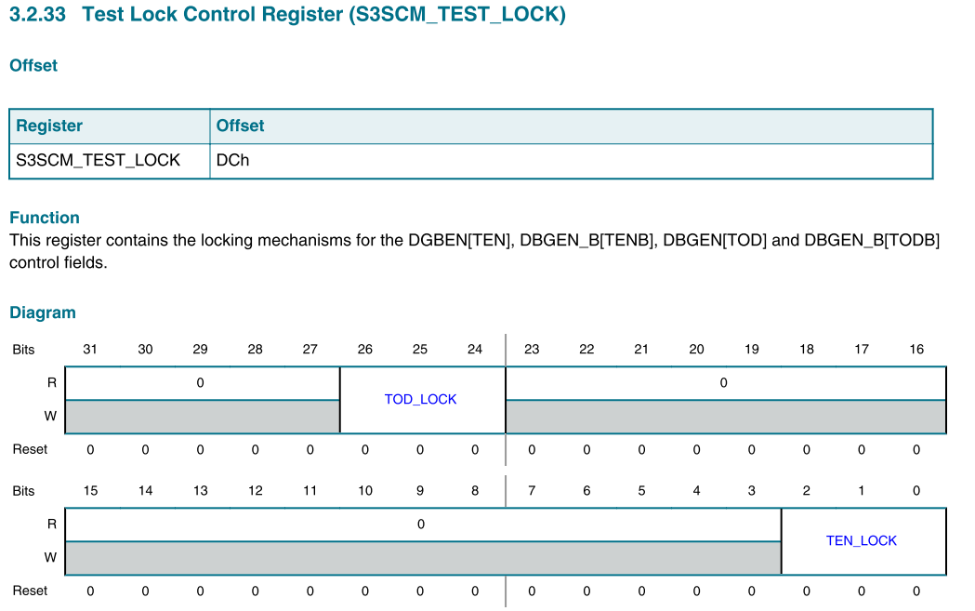

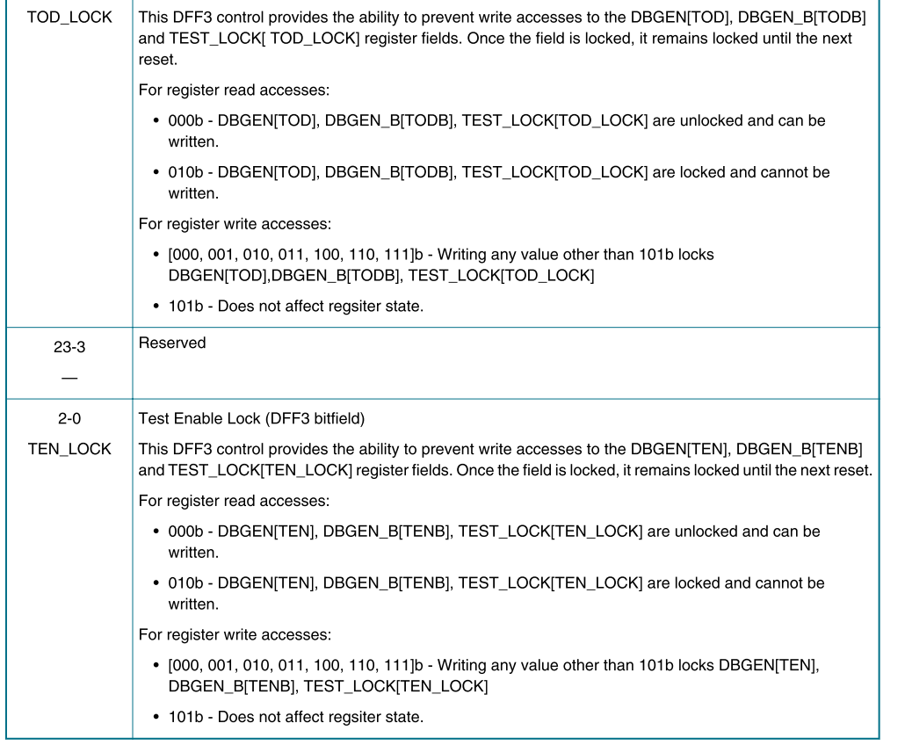

### S3SCM_DBG_LOCK

Lock S3 debug access register’s write permission. Lock the write access for DBGEN[DEN]/DBGENB[DENB]/DBG_LOCK[DEB_LOCK]

0： unlock

2： lock

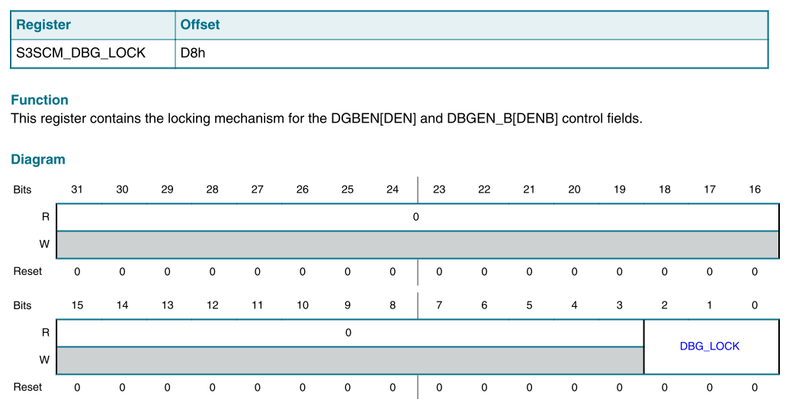

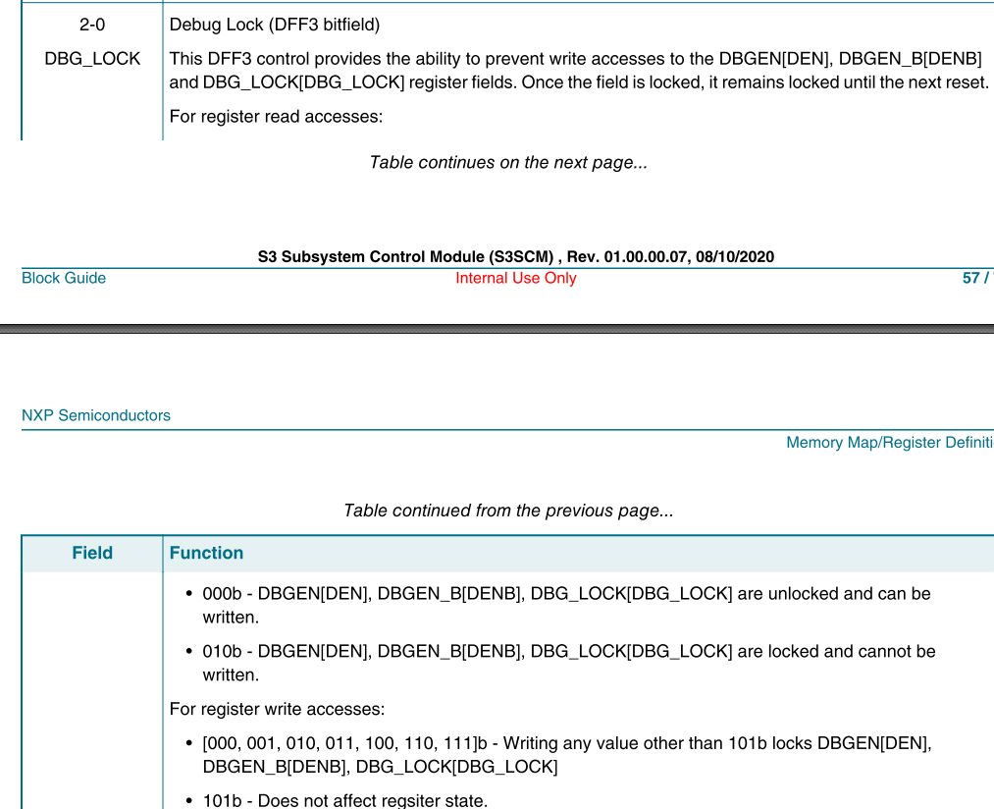

### S3SCM_DBGEN

TOD（test on disable）: enable SOC DFT/NVM test. （NXP跟OEM lifecycle下，这个是有差异的。 NXP （加上blank）的lifecycle，为enable。 OEM的lifecycle为disable）

读2-disable， 0-enable

写 5-enable , 2-disable

TEN（test enable）: enable SOC MBIST

读： 0-disable 2-enable

写： 2-enable， 5 disable

DEN(Debug enable)

读： 0-disable 2-enable

写：2-enable 5-disable

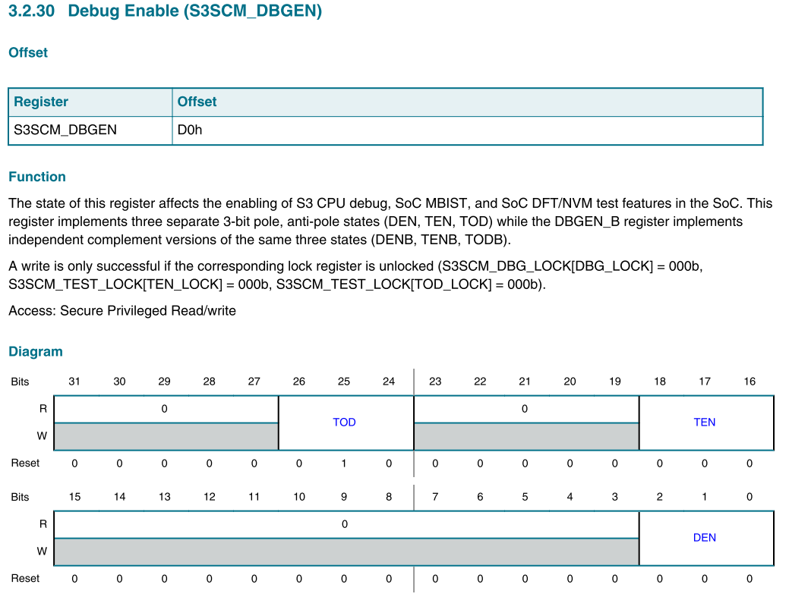

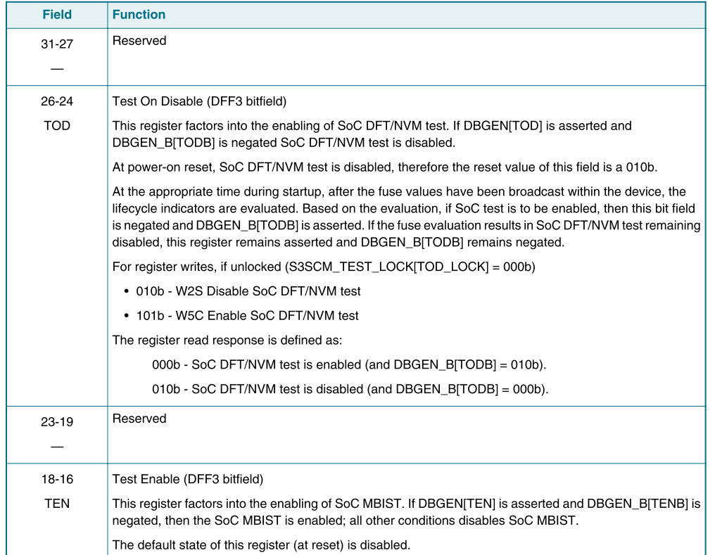

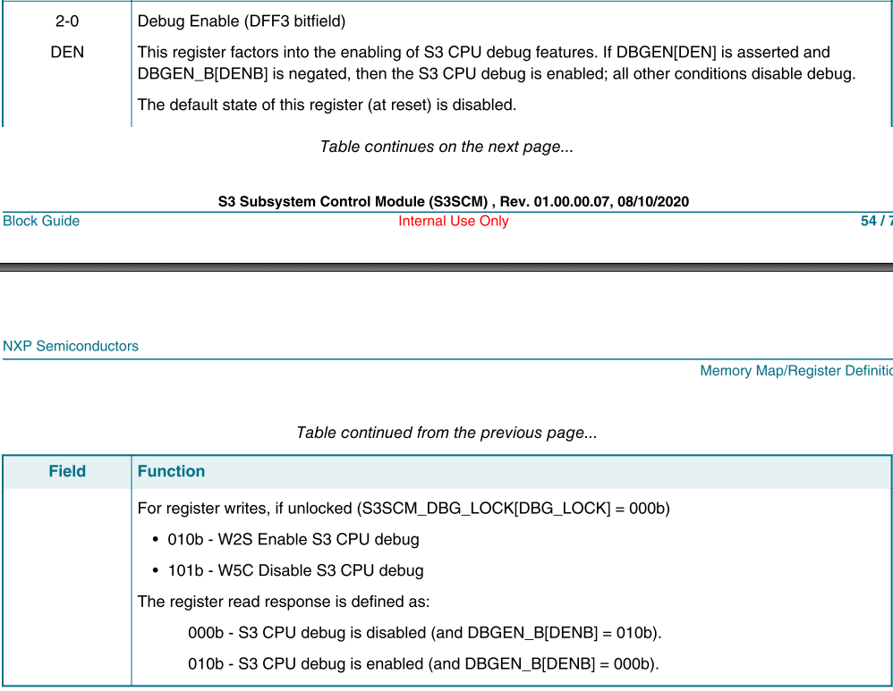

### S3SCM_DBGEN_B

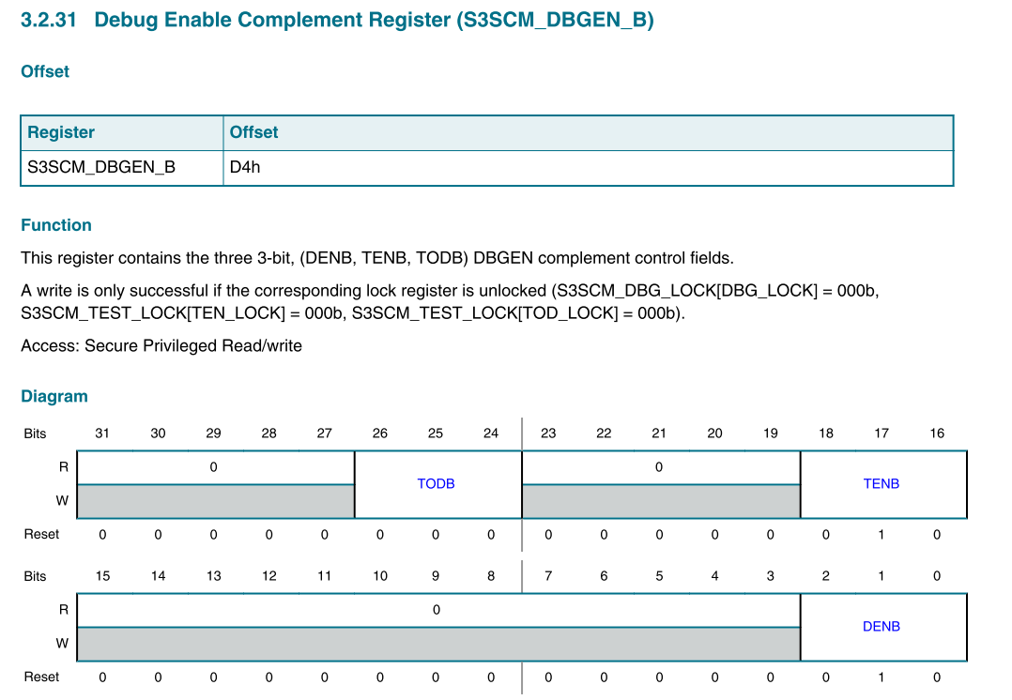

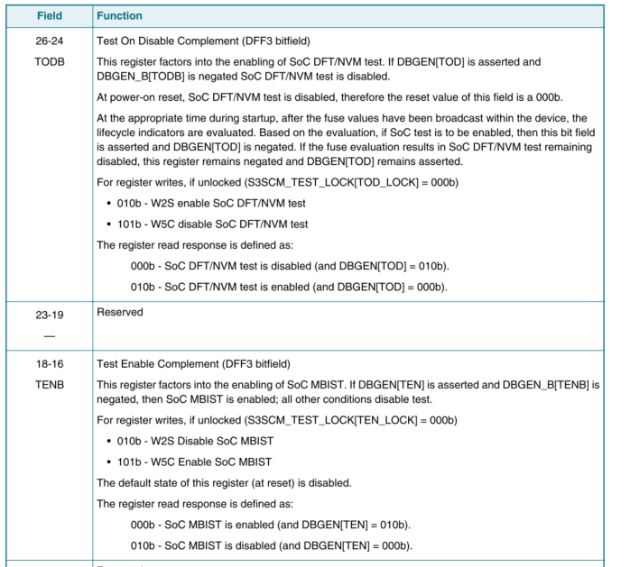

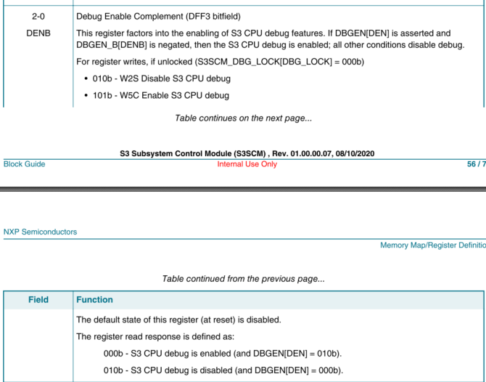

### S3SCM_GPO_SET

当core A的SMSCM DBGEN[ALTEN] 关闭时，core A不能够访问radio flash。

S200 GPO1 set后，可以使得CM33能够访问radio flash

GPO0 : enabled mass erase for SOC FLASH/NBU FLASH s200的这根线会连接到SOC flash/NBU_FLASH的soc_meen_ack

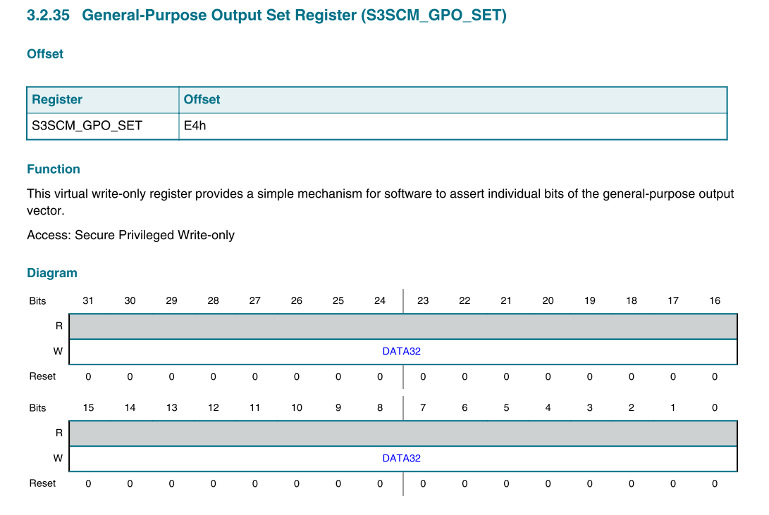

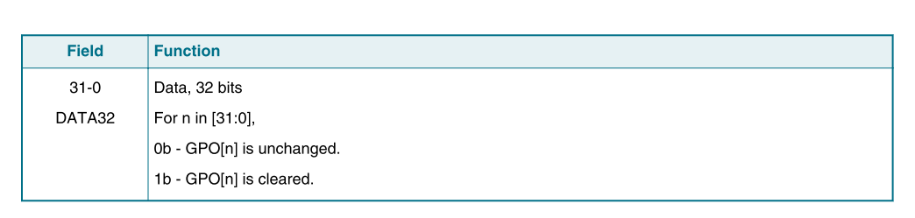

### S3SCM_LPCSR0

0x4c00_1090

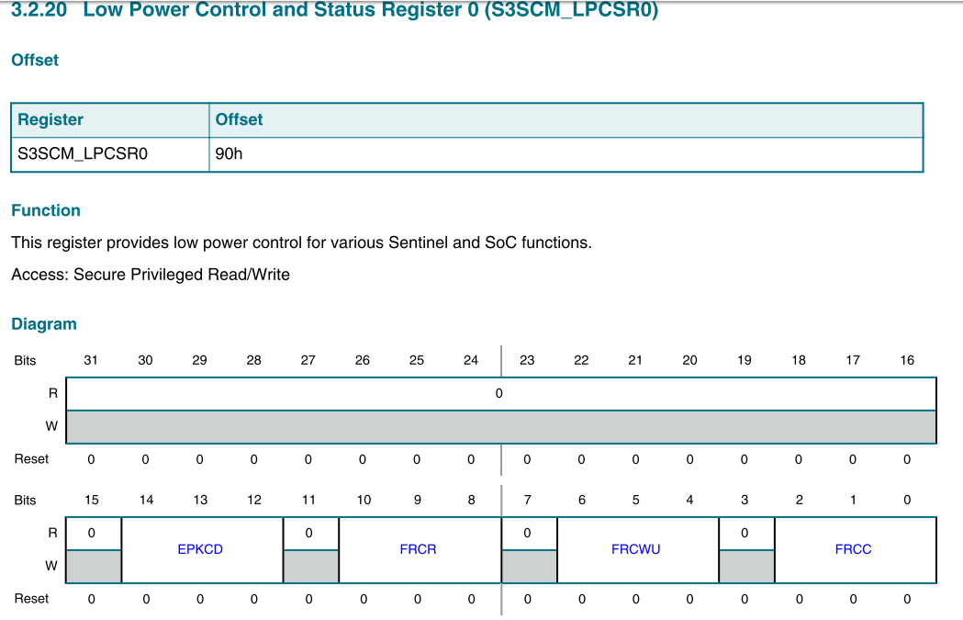

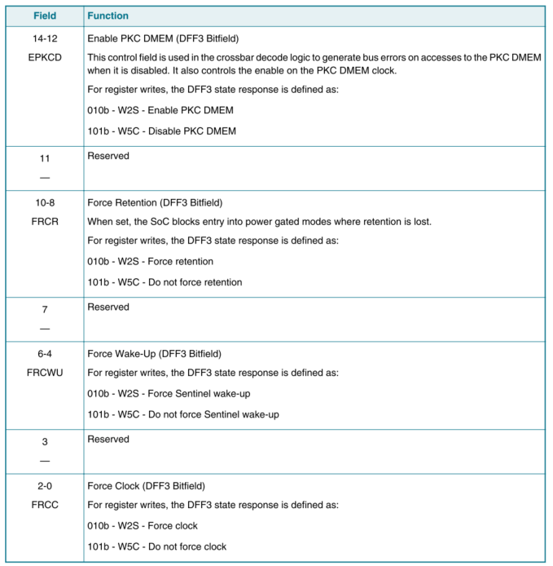

# S200

## Block diagram

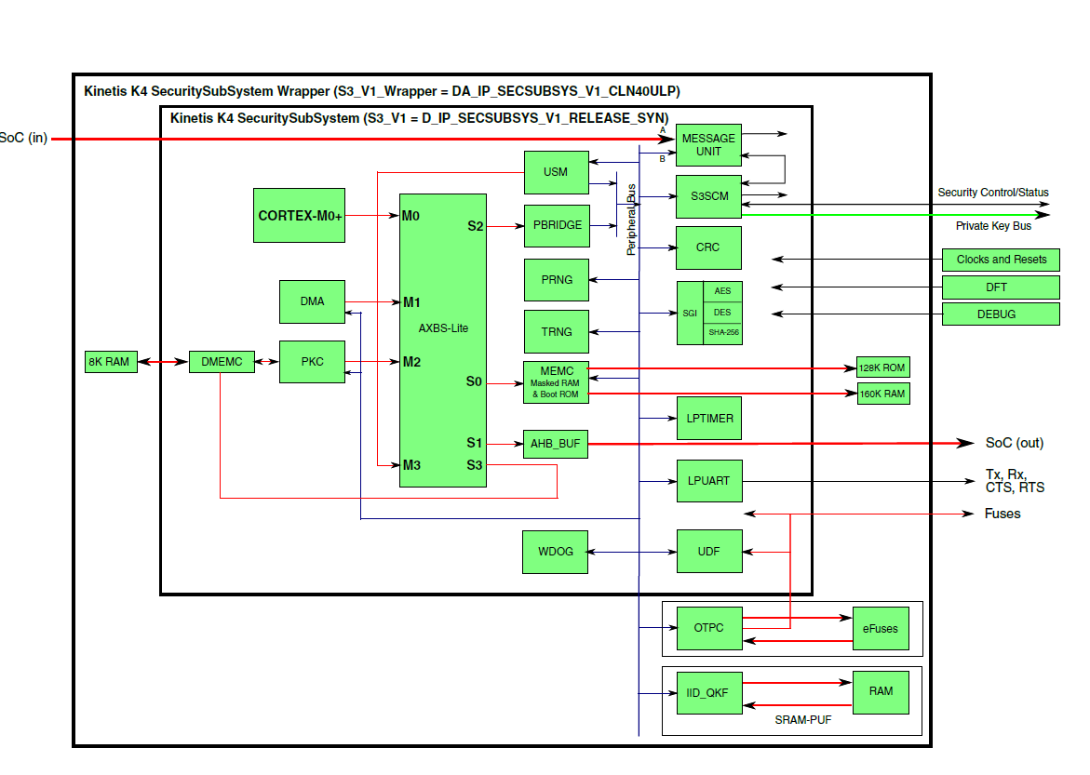

## CM33 request（V_SS_S200_VIP）

S200_CREATE_CONTEXT(); // SECSUBSYS_IP ： 35

CM33（主core）获取MU 寄存器base address等信息

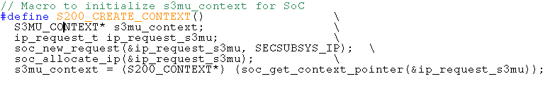

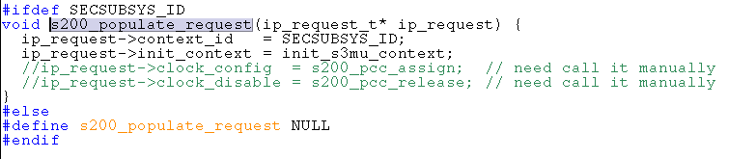

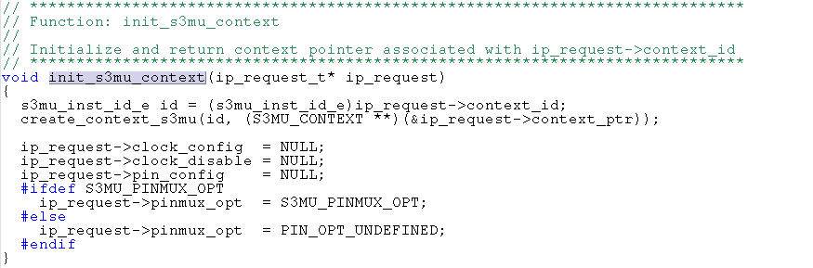

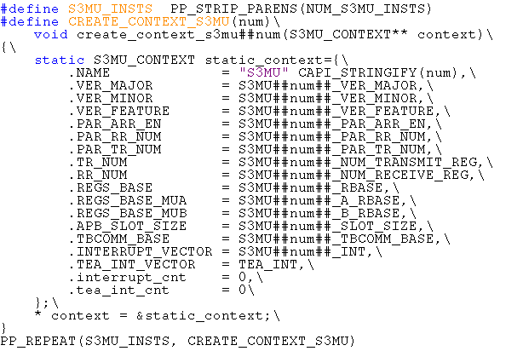

### S3MU_CONTEXT

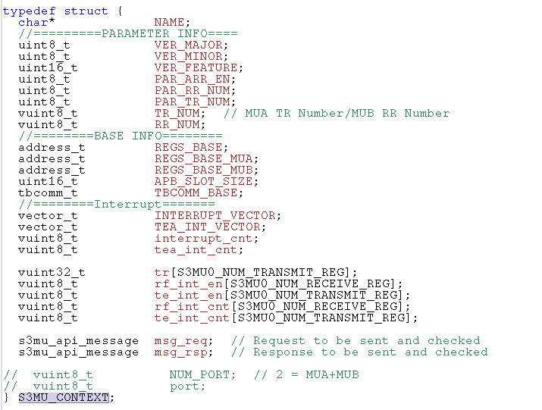

## S200 core request（V_MS_S3_VIP）

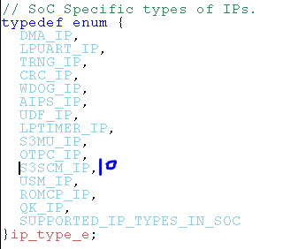

### S3SCM_CREATE_CONTEXT() - s3scm_populate_request

S200 相关的信息，包括寄存器base address， INT vector等信息

用到的VIP ： testbench/common_blocks/v_ms_s3_vip/ tool_data/compiler/include/context_s3_api.h

[S3SCM_IP]（0xa） = s3scm_populate_request,

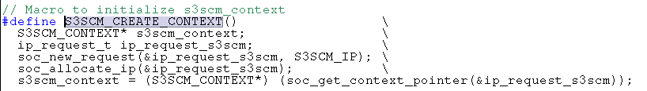

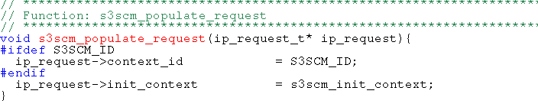

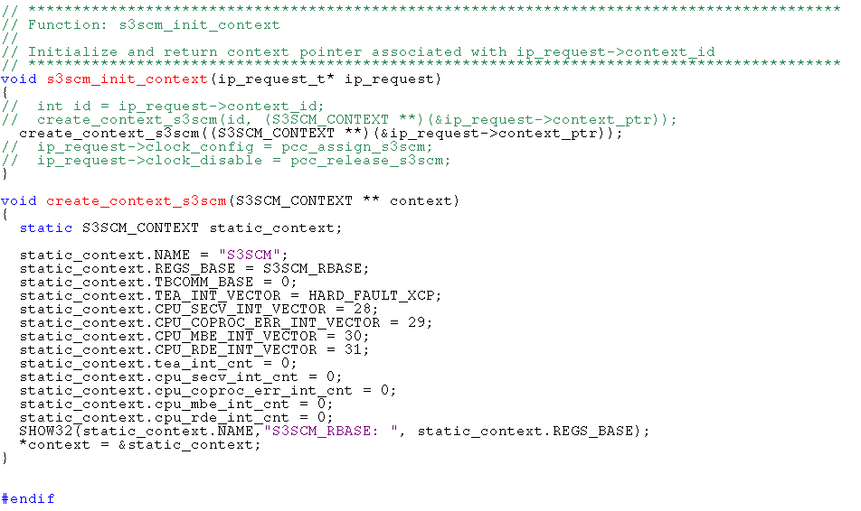

#### S3SCM_CONTEXT

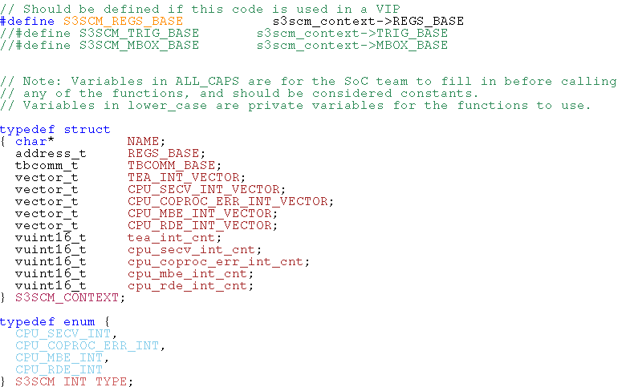

### ip_request_s3mu

S200 MU相关信息, 包括base address&中断等

0X8

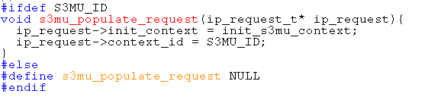

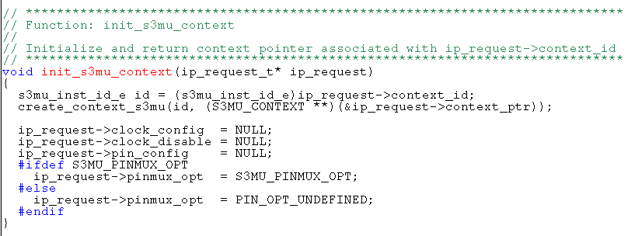

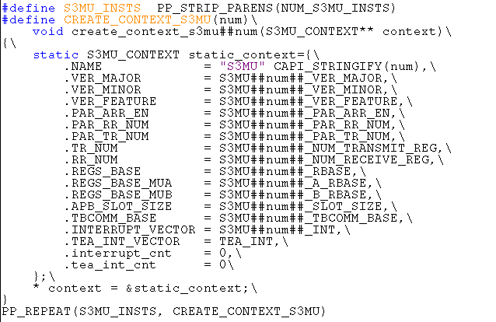

#### S3_MU_ID

V_ms_s3_vip/Tool_tada/compiler/include/S3_environment.h中定义了默认的ID

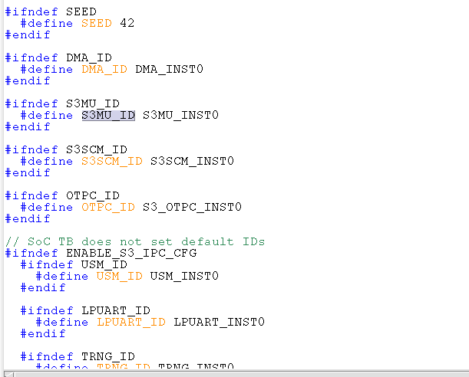

#### S3MU_CONTEXT

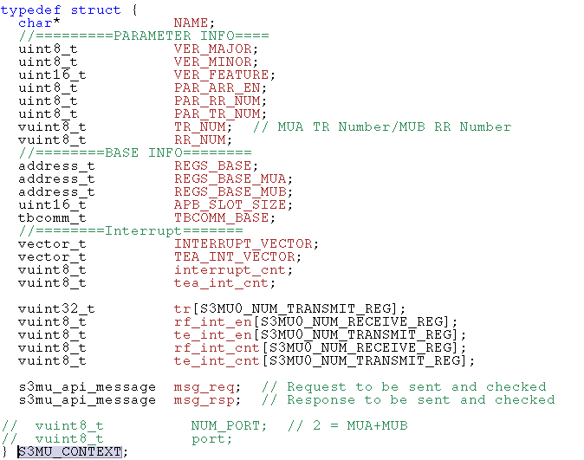

## MU

### Block diagram

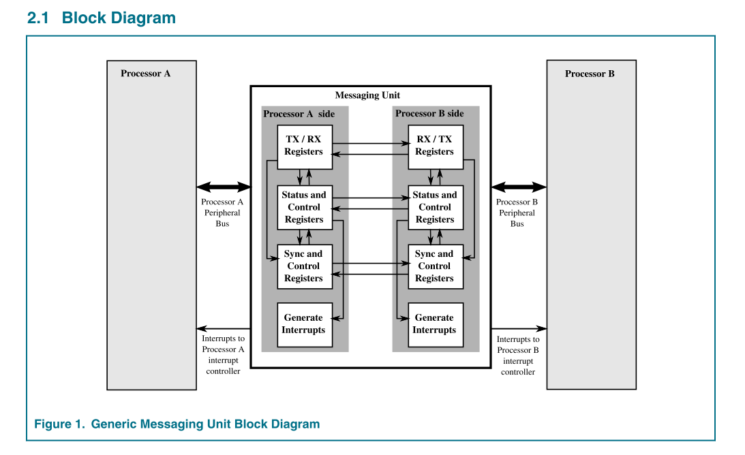

### Message transfer

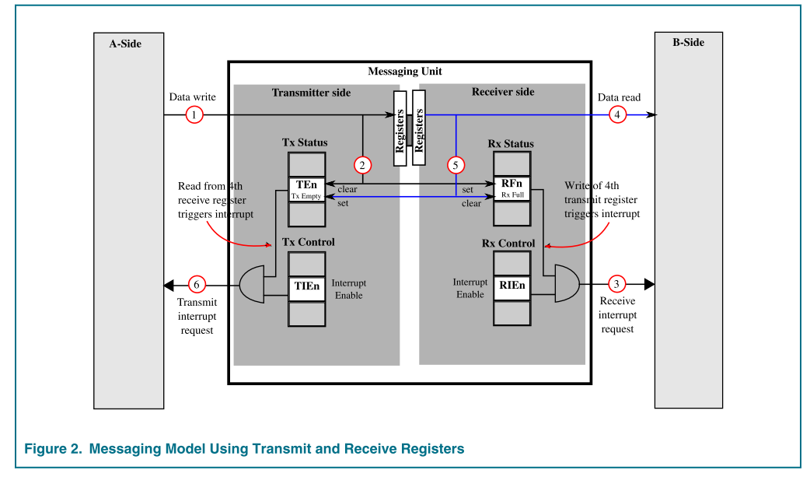

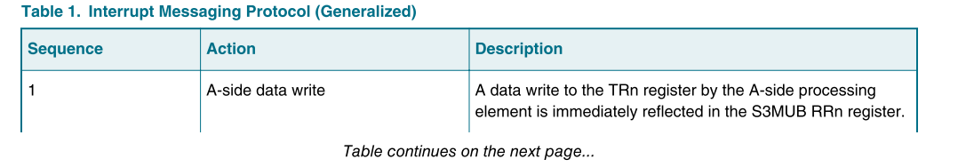

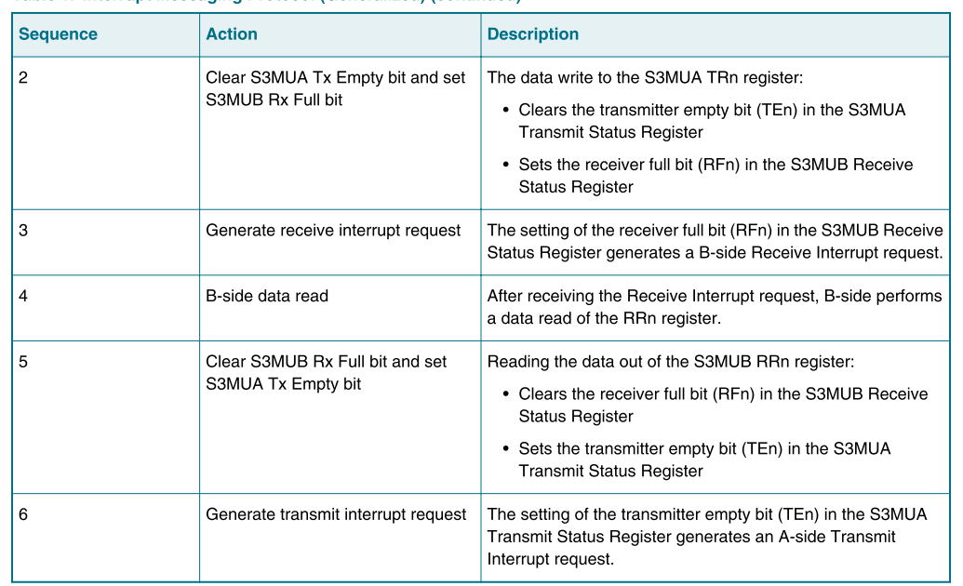

### Register

#### SOC端

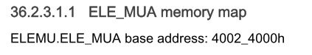

##### S3MU_SR status register

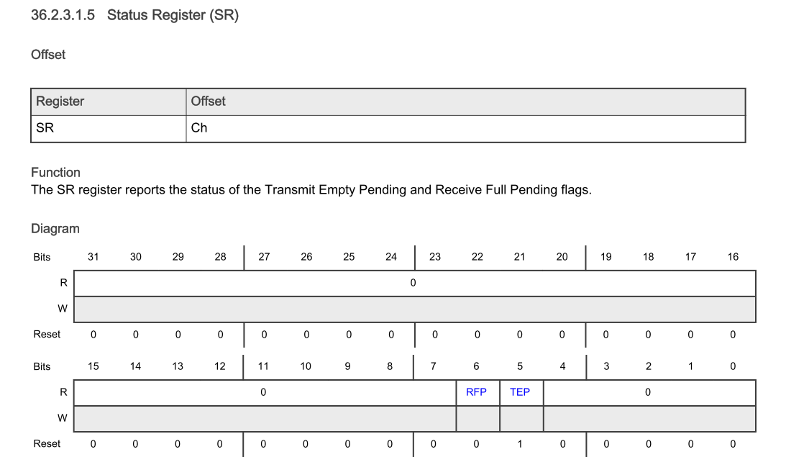

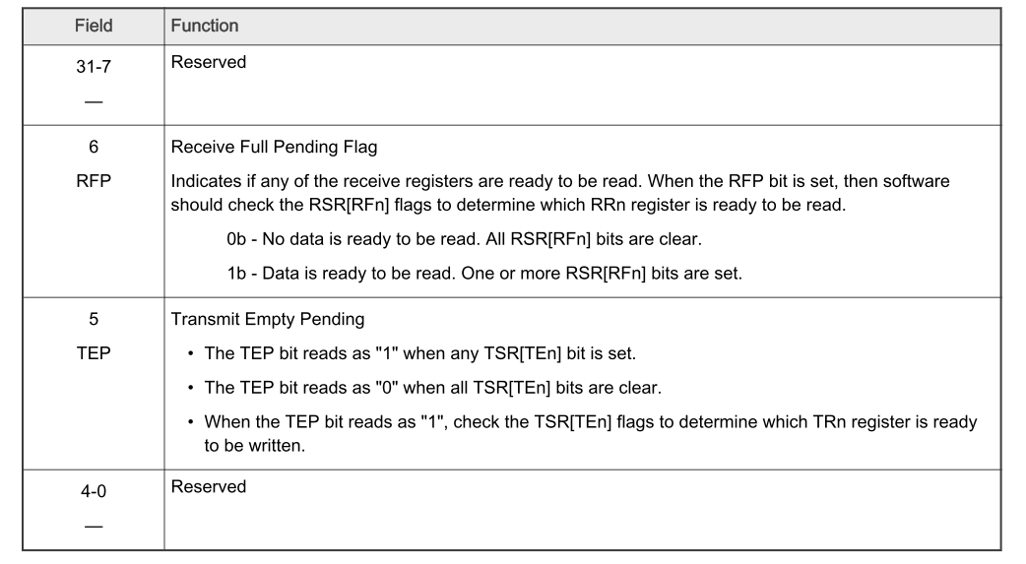

##### S3MU_RSR receive status register

Offset： 0x12c

BIT[1：0] 显示哪个RR寄存器可以读取数据。

0：RR0

2：RR1

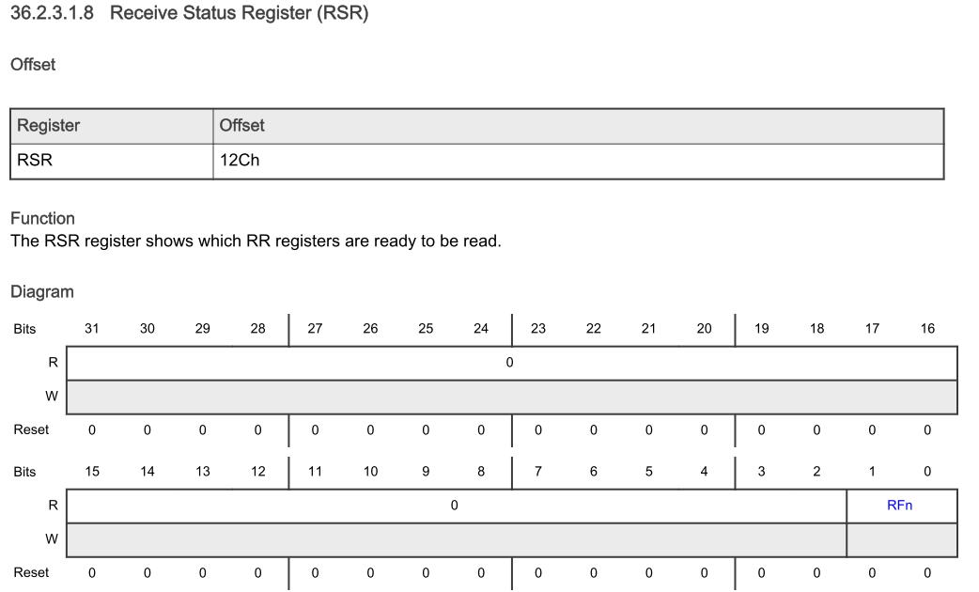

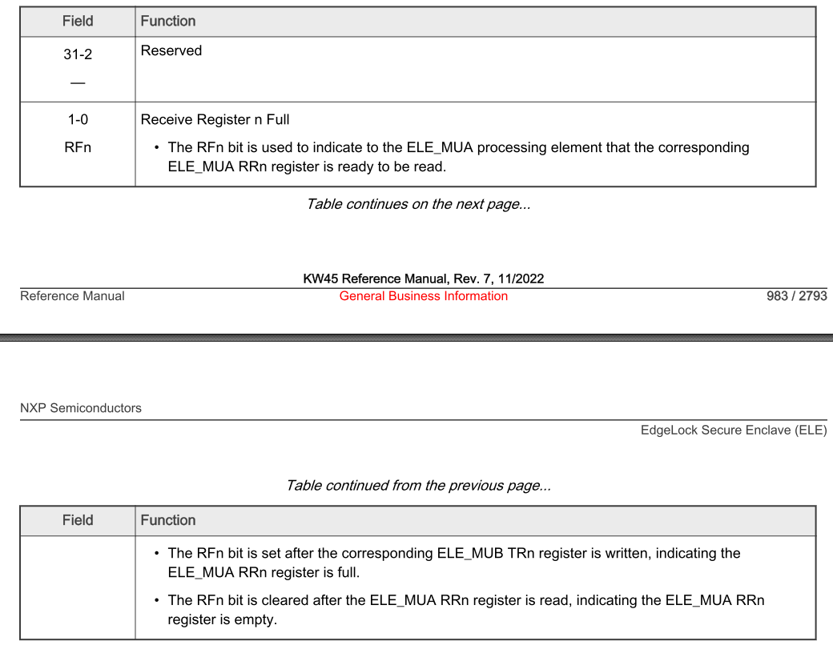

##### S3MU_RCR receive control register

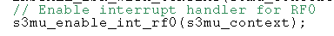

Offset 0x128

配置中断。如果配置为1，则对应RSR1置位后，产生中断

如果配置为0，对应RSR0置位后，产生中断

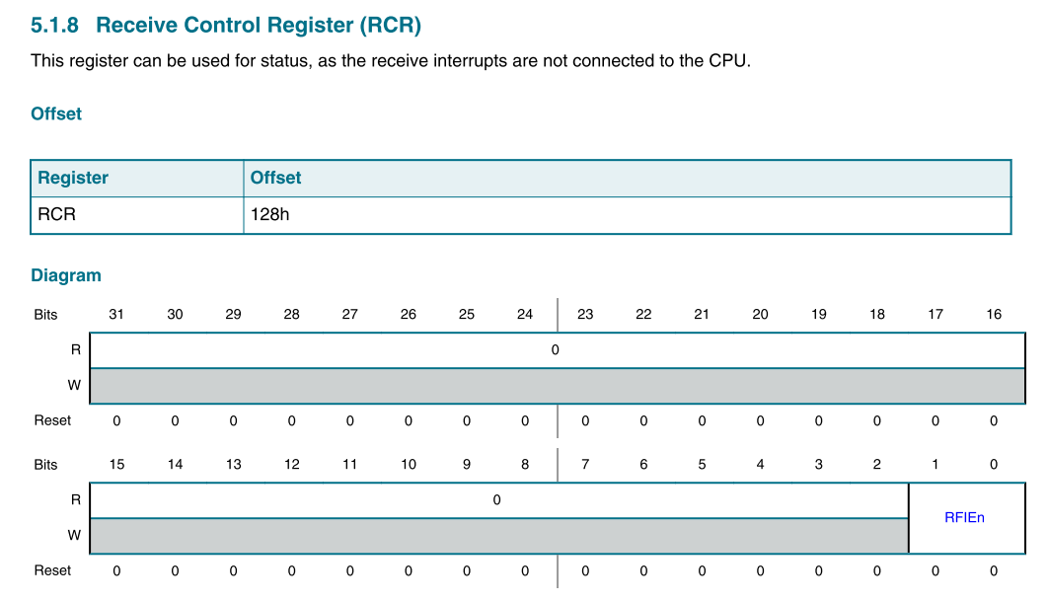

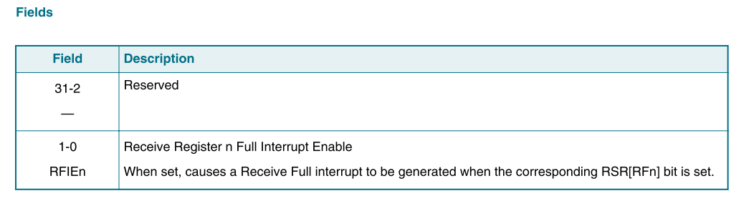

##### S3MU_RR receive register

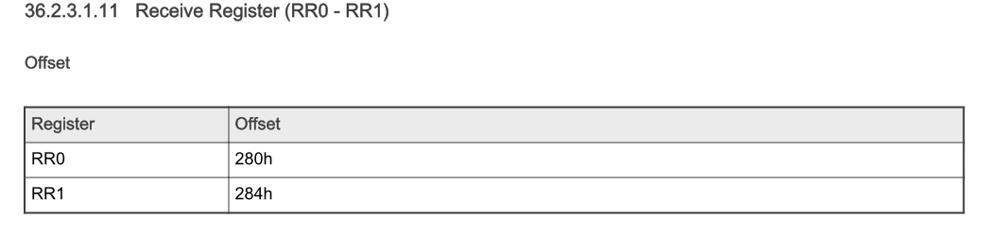

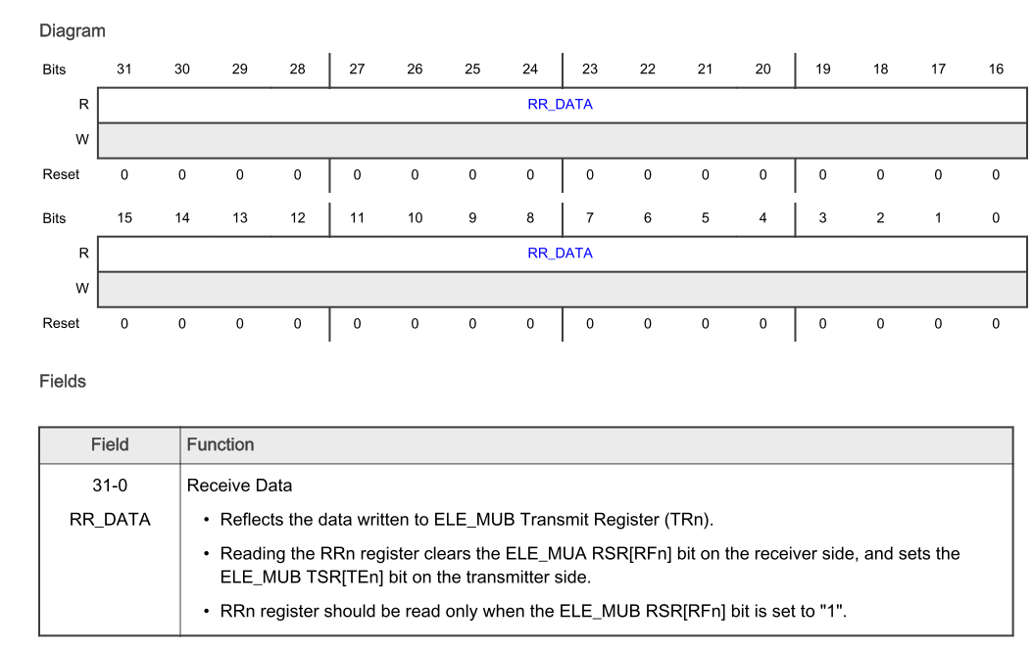

##### S3MU_TSR transmit status register

Offset 0x124 显示哪个发送寄存器可以用来传输数据

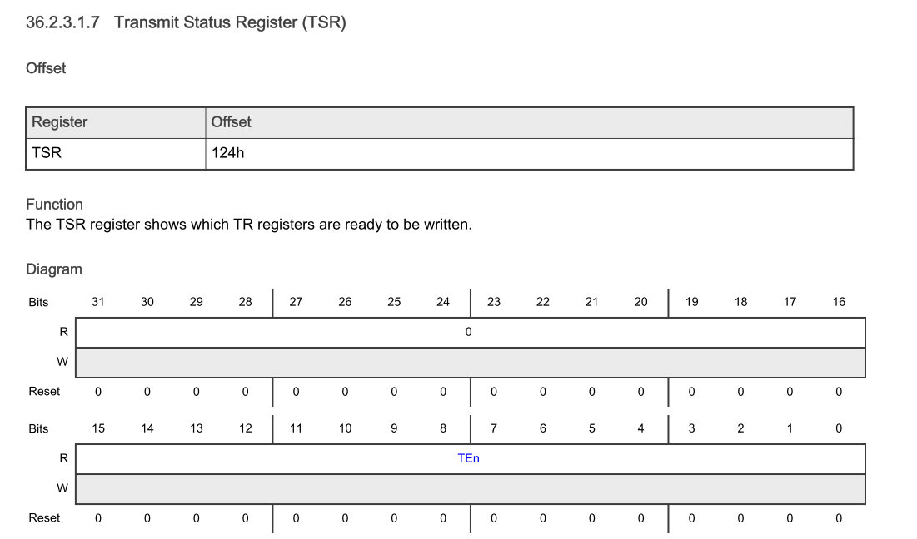

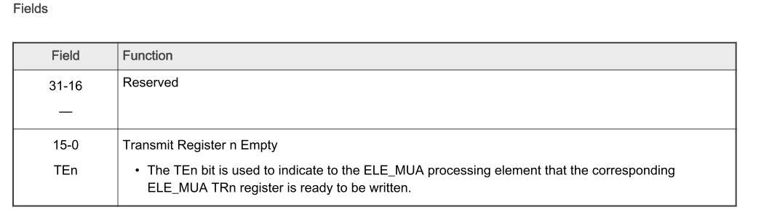

##### S3MU_TR transmit register

只有当TSR对应bit=1时，对应TR寄存器才可以被写

写入数据后，对应的接收端RSR寄存器对应的RR置1

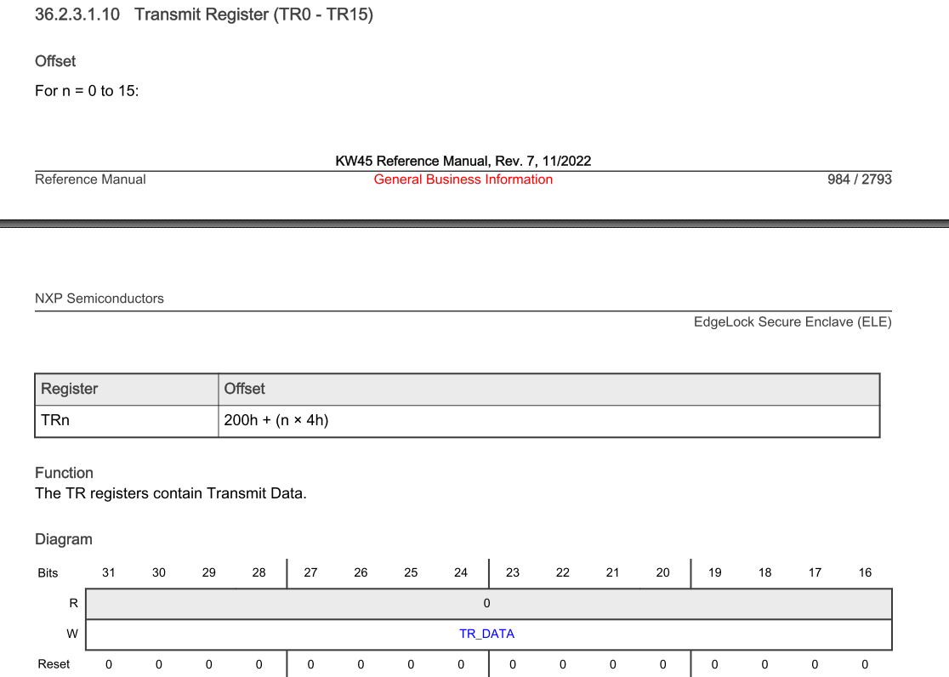

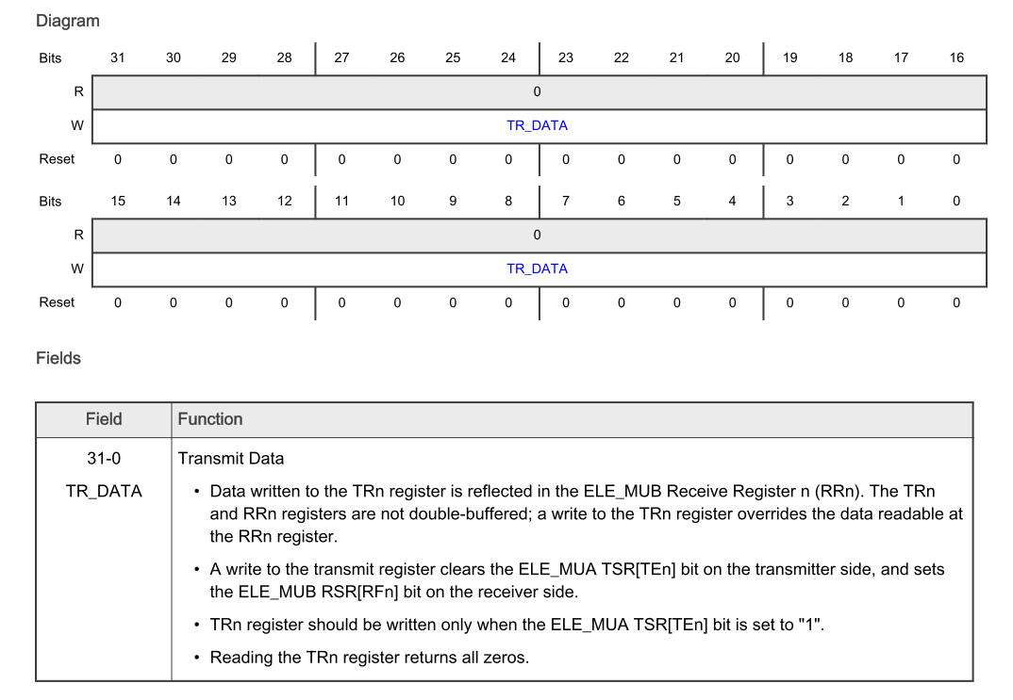

#### S200 端

S3MUA base: 0x4c003000

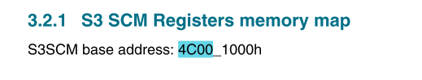

##### S3MU_SR

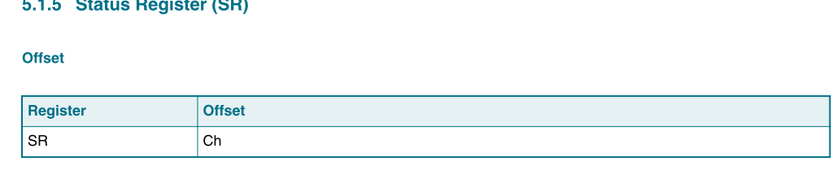

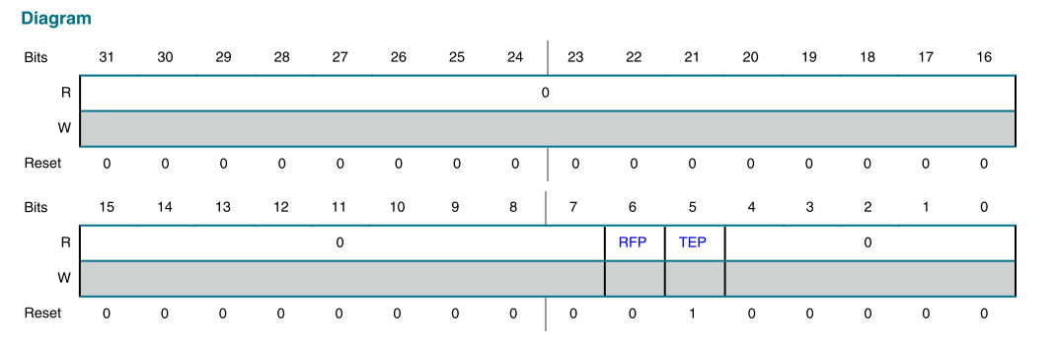

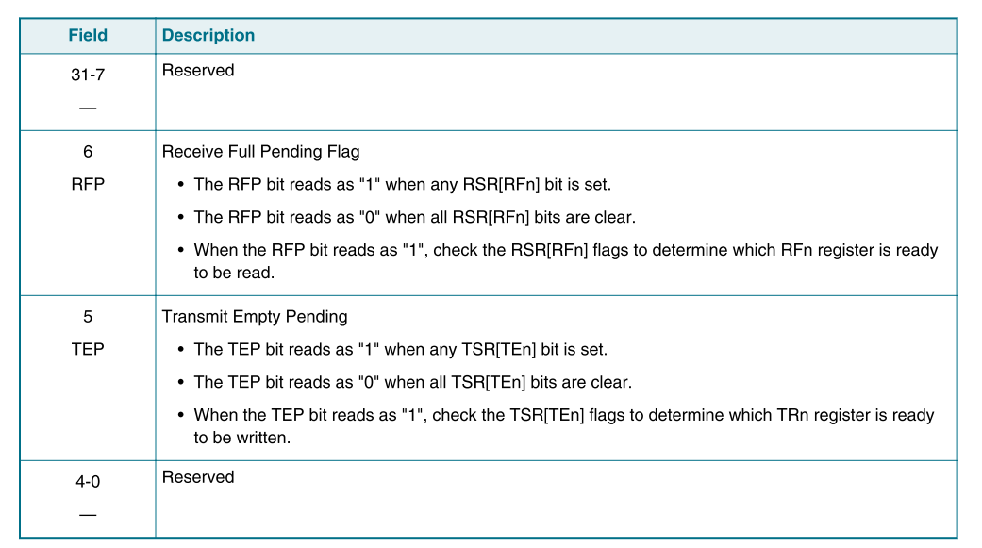

##### S3MU_RCR receive control register



Offset 0x128

配置中断。如果配置为1，则对应RCR1接收满数据后，产生中断

如果配置为0，对应RCR0接收满数据后，产生中断





##### S3MU_RR0

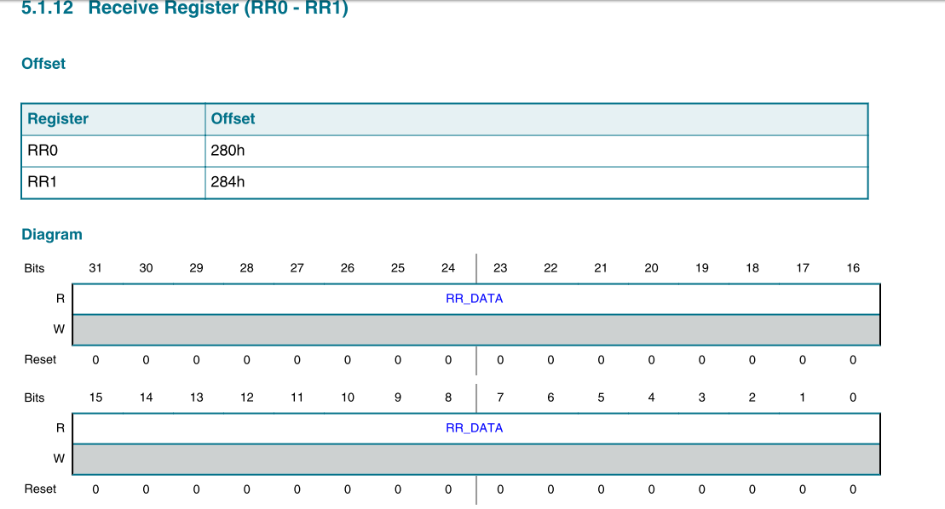

##### S3MU_TSR transmit status register

显示哪个TR寄存器可以用来发送数据

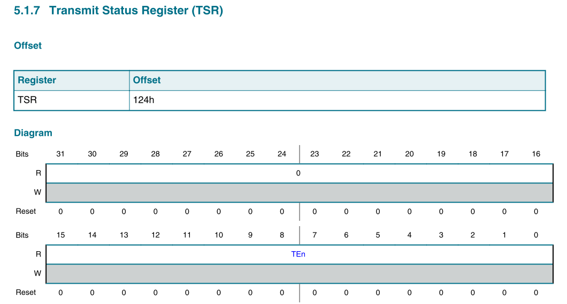

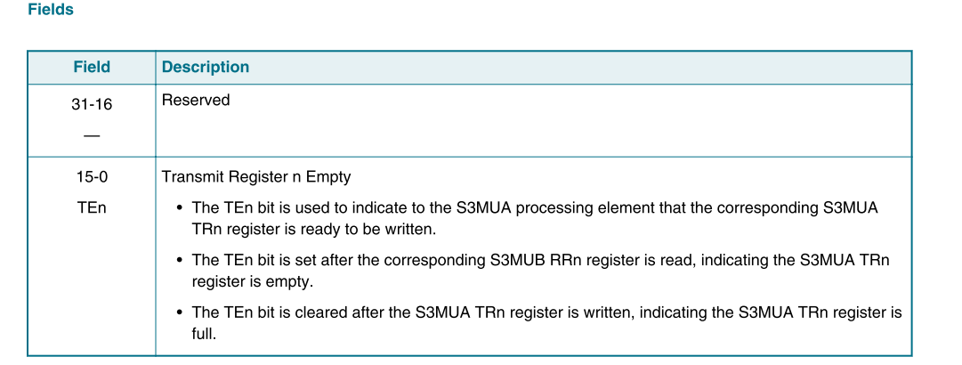

##### S3MU_TR1 transfer register

当寄存器写入数据后，对应的TSR会被clear。  
同时，接收端RSR会置位，显示哪个RR可以读取到数据

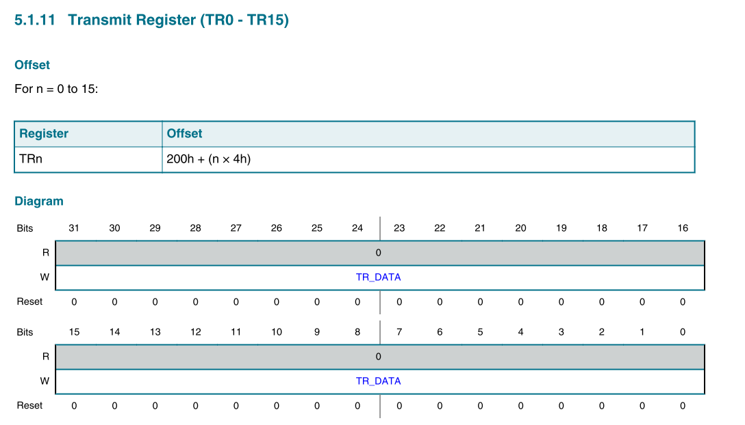

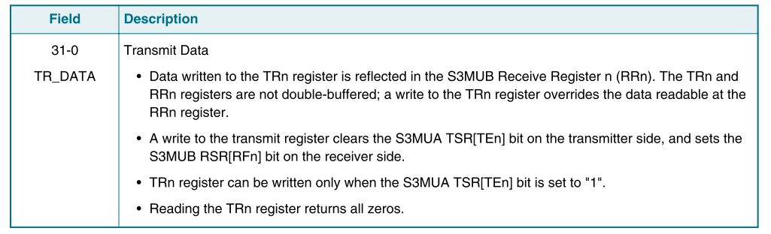

##### S3SCM_CR2 control register



配置CMDVAL=0, 所有的command都会发送给S3CPU， 而不是发送给USM

CMDVAL default值不是0

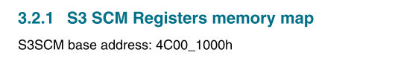

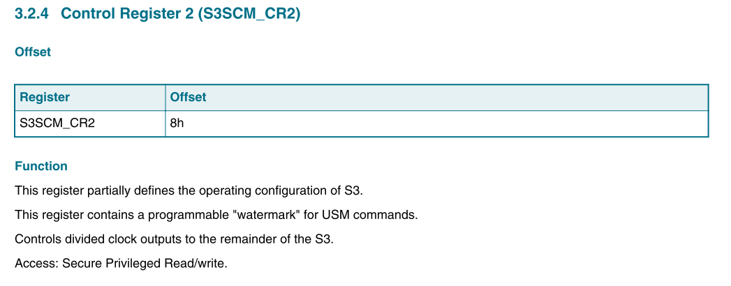

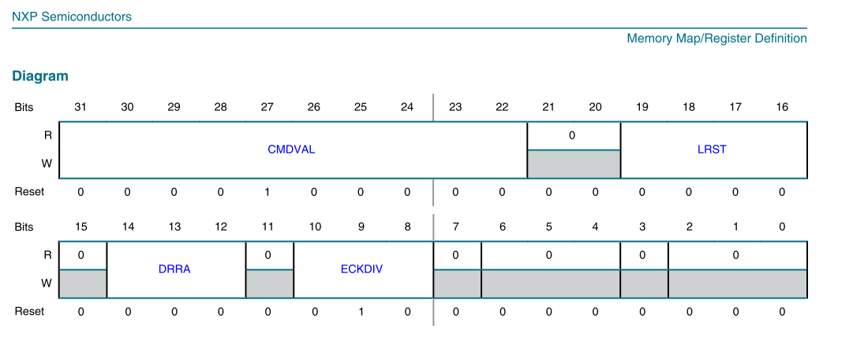

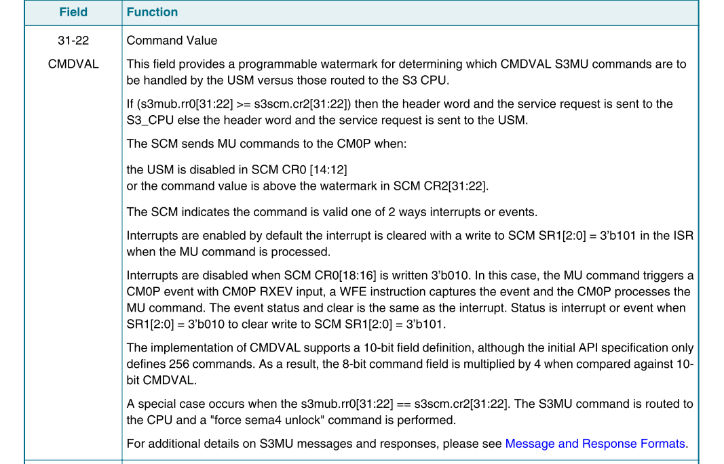

##### S3SCM_MU_ATTR

当host给S200发送消息时，该寄存器反应系统总线属性。

比如是否为secure/non-secure 访问

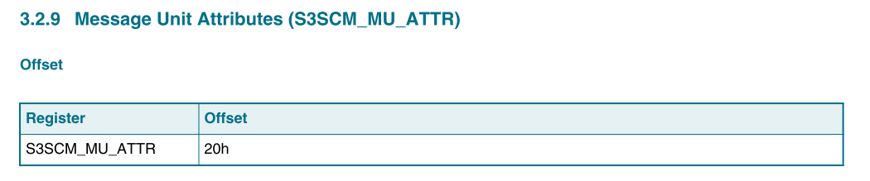

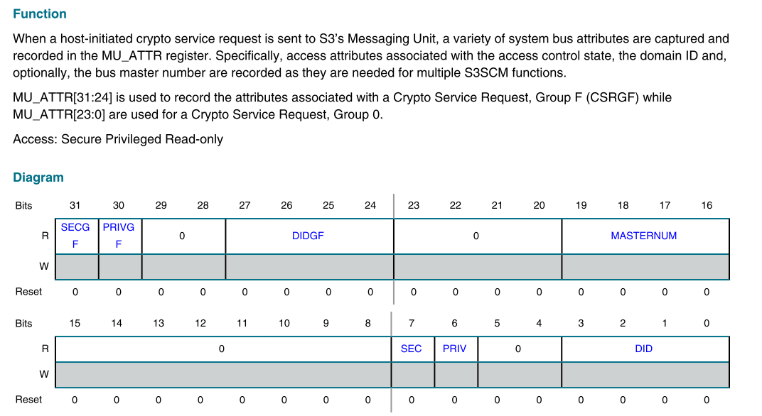

##### S3SCM_CPY_MU_ATTR

用户可以写CPY_MU_ATTR实现将S3SCM_MU_ATTR 的值复制到S3SCM_HOST_ATTR

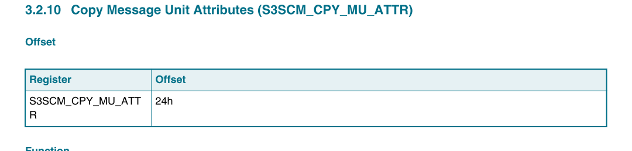

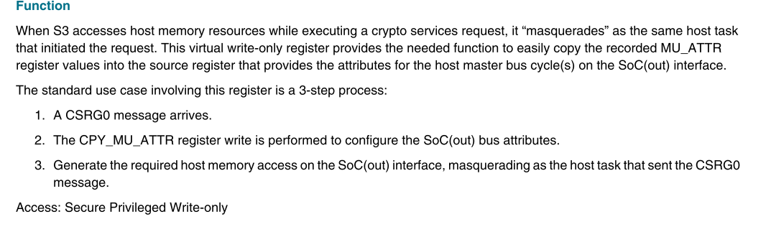

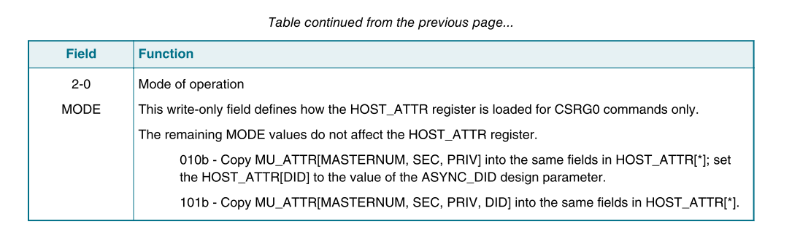

##### S3SCM_HOST_ATTR

这个寄存器的值将通过S200 SOC out信号传输给SOC

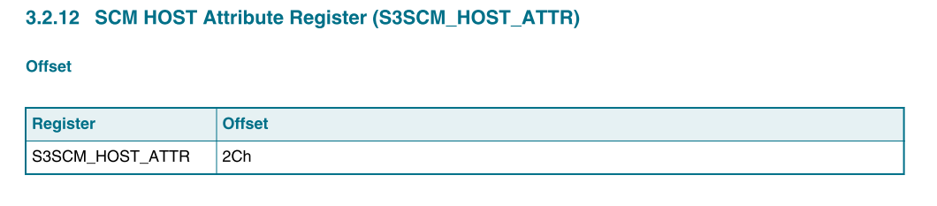

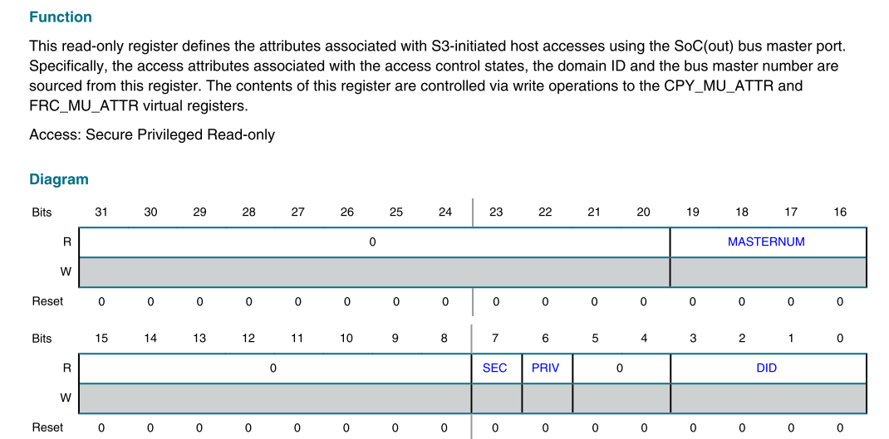

##### S3SCM_FRC_MU_ATTR

控制对外的信号输出。

寄存器的值会被load到S3SCM_HOST_ATTR

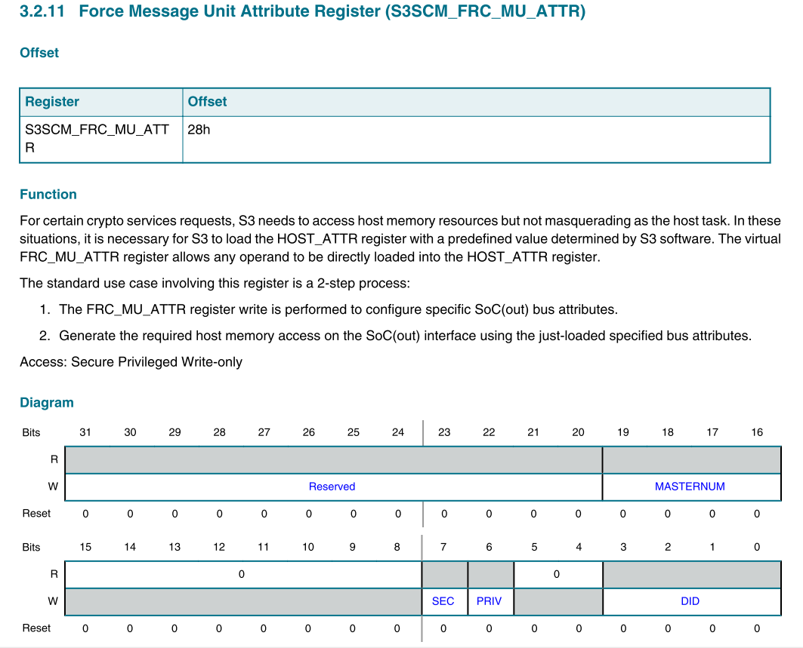

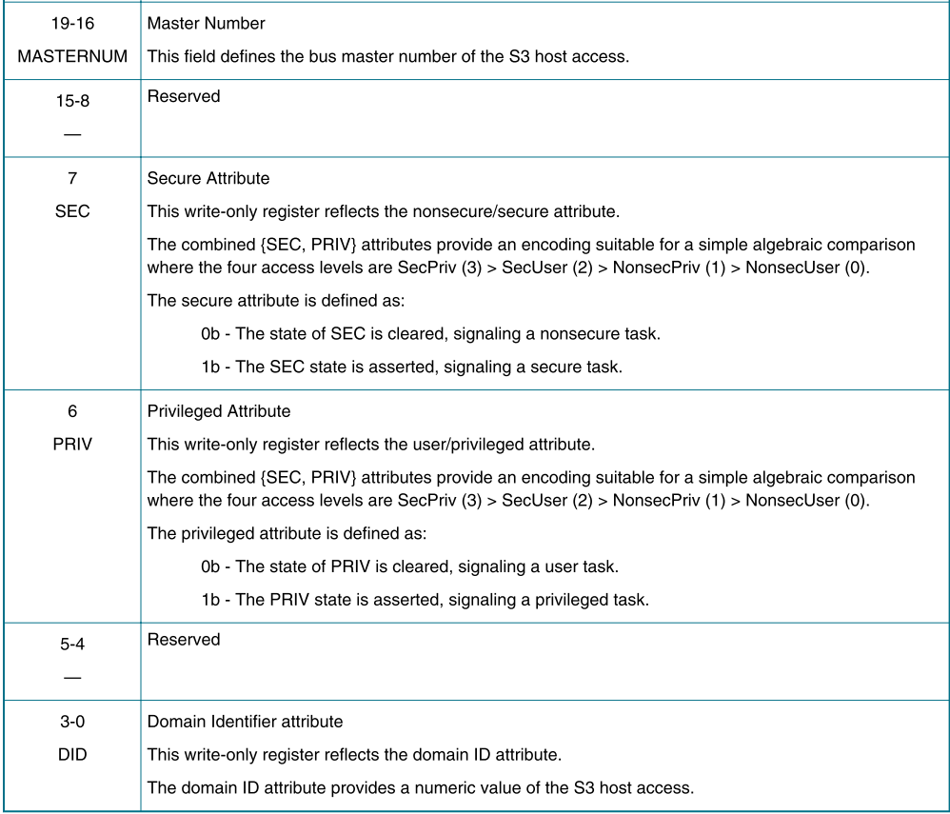

##### S3SCM_SR1

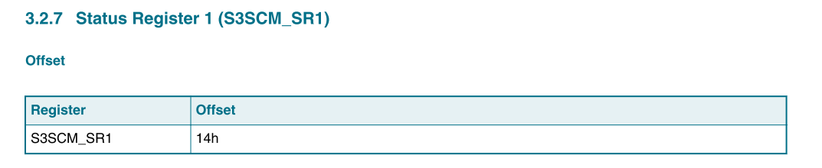

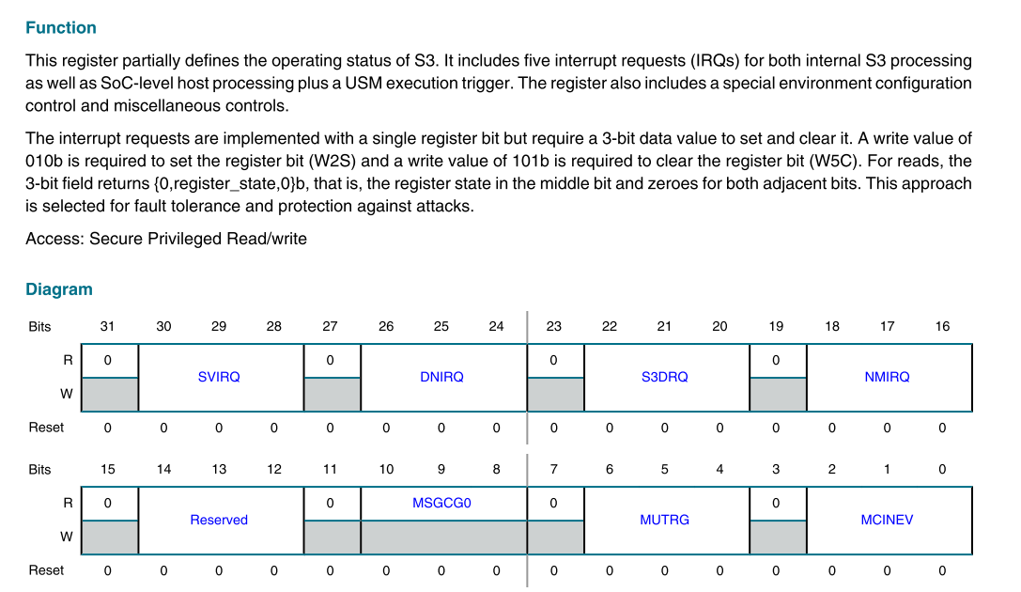

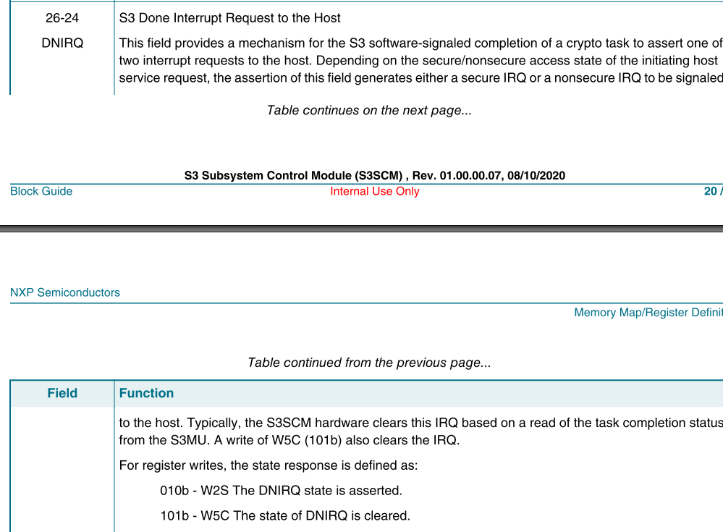

S200 配置ipd_requst到SOC DMA。。   
SOC DMA 完成传输后，done信号接到S200上，S200识别到done信号后自动disable request

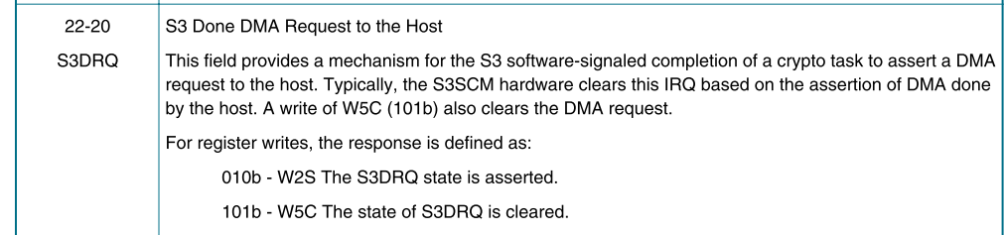

##### S3SCM_CSR

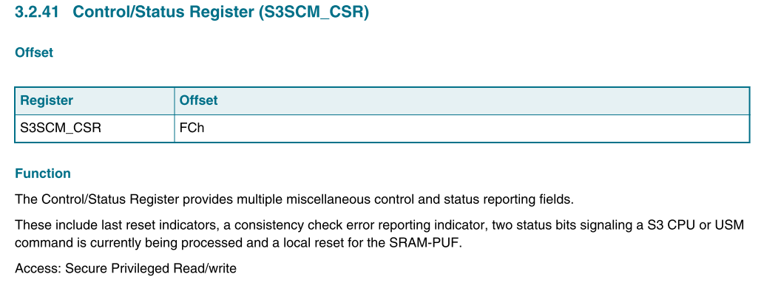

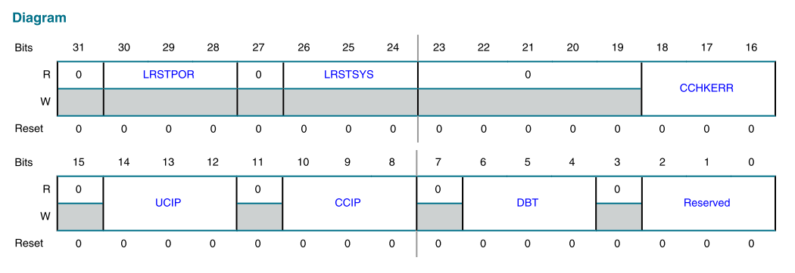

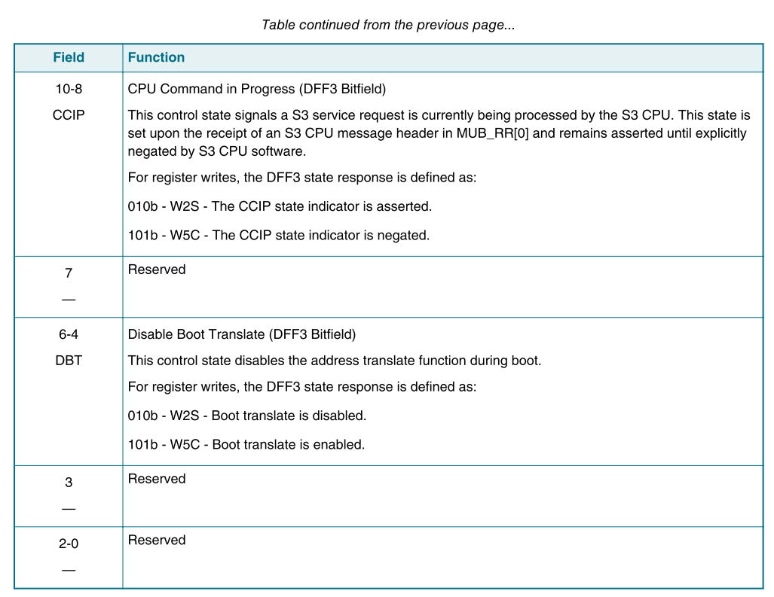

### Interrupt

SOC 端中断：

44: Sentinel command interface interrupt

45: Sentinel secure interrupt

46: Sentinel non-secure interrupt

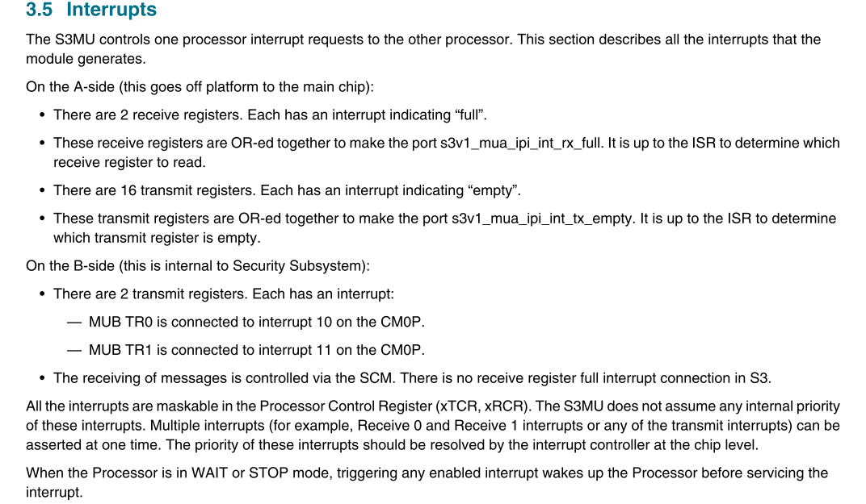

#### soc- s3mu_message_isr

1. 读S3MU_SR确定bit[6] RFP=1, 提示可以读取数据
2. 读S3MU_RSR，判断哪个RR可以读取数据。Bit[0]=1, 表示RR0可读。Bit[1]=1，表示RR1 可读
3. 根据如上选择出来的RR寄存器，进行数据读取 S3MU_RR

* S3MU_RCR receive control register 设置RR中断，当对应RSR bit0或者1置位后，产生中断

如果正确，打印“Correct message header received”，否则打印错误的message信息

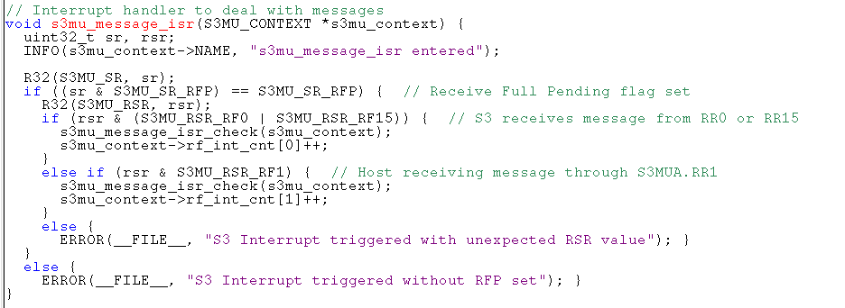

Receive interrupt

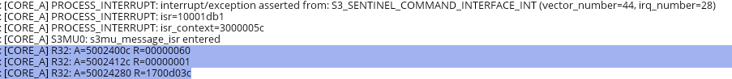

#### s200- s3_done_isr

如下是secure 访问的log：

1. HOST 向MU TR0写入数据时，由于S200端RR0寄存器中断打开。S200端触发RR0中断
2. S3SCM_MU_ATTR 读寄存器，检查host是否为secure（0xC0为secure，负责non-secure）

R32: A=4c001020 R=000000c0

1. 将2得到的数据写入S3SCM_HOST_ATTR 通过对 S3SCM_CPY_MU_ATTR 写2实现

W32: A=4c001024 W=00000002

1. 读取S3SCM_HOST_ATTR， 看是否copy属性成功

RE32: A=4c00102c R=000000c1 E=000000c1

1. S3SCM_SR1 set S3 secure/non-secure done IRQ request， 一旦设置为1. SOC 端会产生S3 secure/non-secure 中断

W32: A=4c001014 W=02000000

1. 清除S3SCM_SR1 done IRQ中断request

W32: A=4c001014 W=05000000



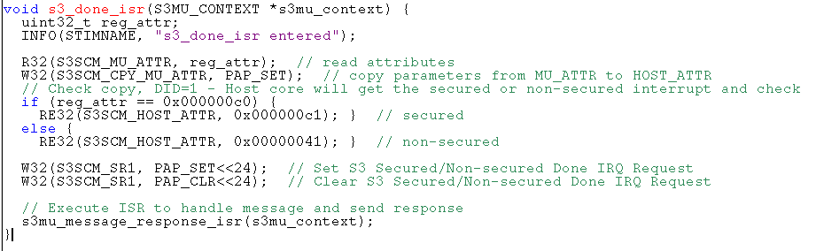

#### S200-s3mu_message_response_isr

1. 读S3MU_SR， 确定RFP 置位后，进行下一步
2. 读S3MU_RCR receive control register， 确定bit0=1，表示RR0可以读取
3. 读S3MU_RR0
4. 根据RR0的内容，解析message后装载到结构体中。再次读取RR0，对结构体中的数据进行校验

s3mu_load_header_word(&s3mu_context->msg_req, rr); // Load command message in context

s3mu_message_response_isr_check(s3mu_context); // Check message received

log： Correct message header received"

1. 发送response进行CCIP 等操作 S3SCM_CSR .

s3scm_clear_mcinev(); // Check and clear S3SCM_SR1.MCINEV

s3scm_api_set_ccip(0); // Check and clear S3SCM_CSR.CCIP

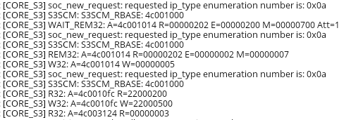

1. 检查TSR，确定TR0是否能够发送数据，TR0发送message给SOC

// Send back response through S3MUB - Must send after CCIP is clear

s3mu_write_transmit(s3mu_context, &s3mu_context->msg_rsp);

W32: A=4c003200 W=0101803c

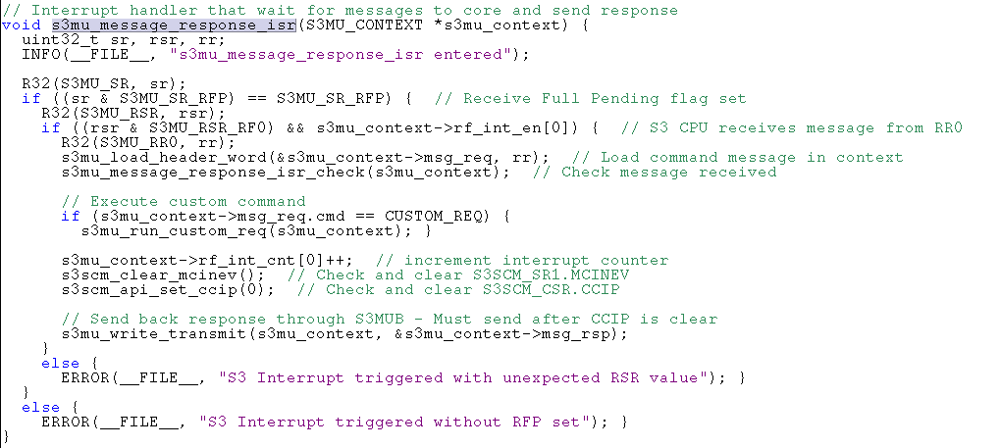

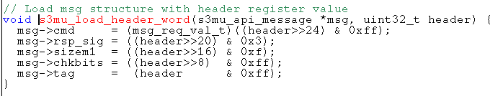

##### Customer req

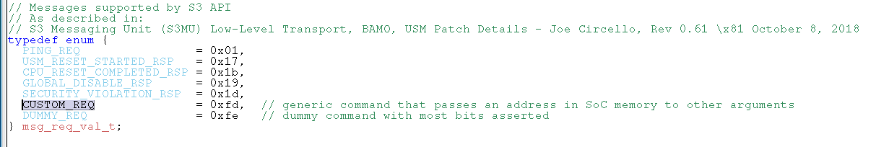

当CMD为0xfd（customer command时候），执行customer命令相关的操作

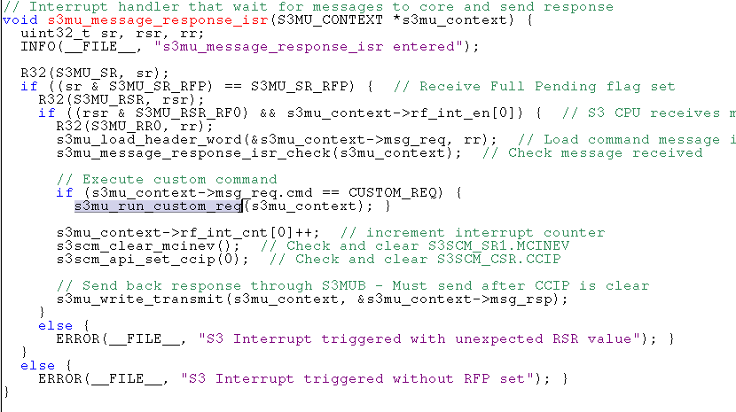

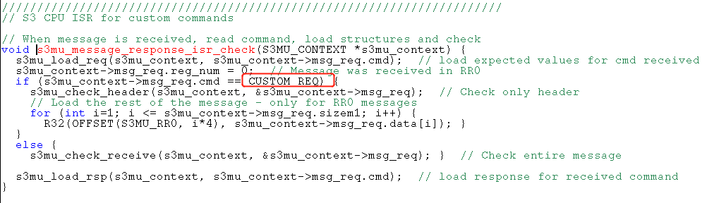

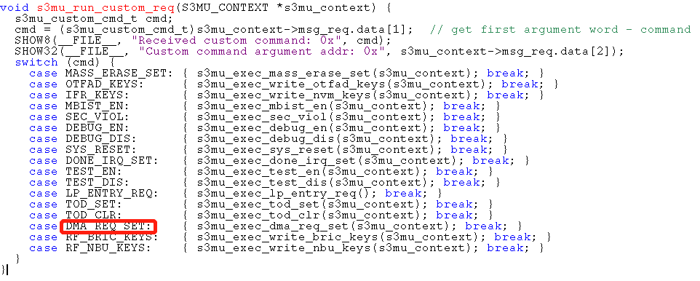

##### Customer request： DMA为例

当用户发送customer request时

Customer command： 0xfd

接收到0x14 后,配置S3SCM_SR1 的SOC dma request。。  
SOC 端DMA request口上该信号置为1后进行数据传输，DMA完成传输后，done的信号给S200。  
S200自动将该寄存器DMA request清零

SOC message log：

1. 发送customer command ID 为0xfd
2. 第二个MU中的数据0X14表示command，对应DMA_REQ_SET

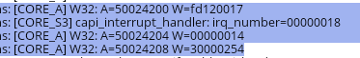

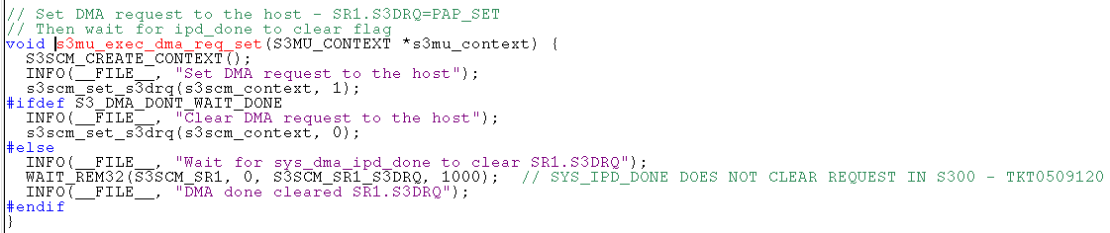

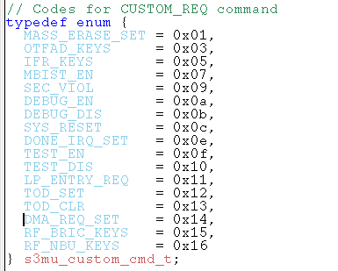

##### Customer command： mass erase

1. S200先设置GPO[0]=1
2. 配置S3SCM_SR0[13]=1

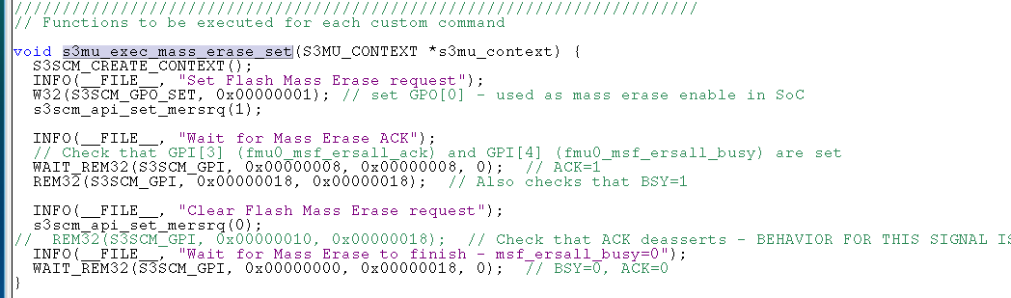

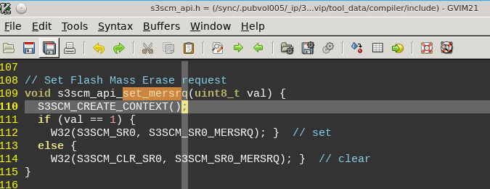

Main flash以及 radio flash两者的IFR1不会被擦除

### MU Message format

EdgeLock services are available via command messages communicated using a messaging unit S3MU.

Every EdgeLock service works on request -> response bases. It means that every service includes a

command message, written into S3MUA.TRx registers to request the EdgeLock service. Once the service

is completed the EdgeLock replies every command request with response message, which can be read

via S3MUA.RRx registers, see Figure 1.

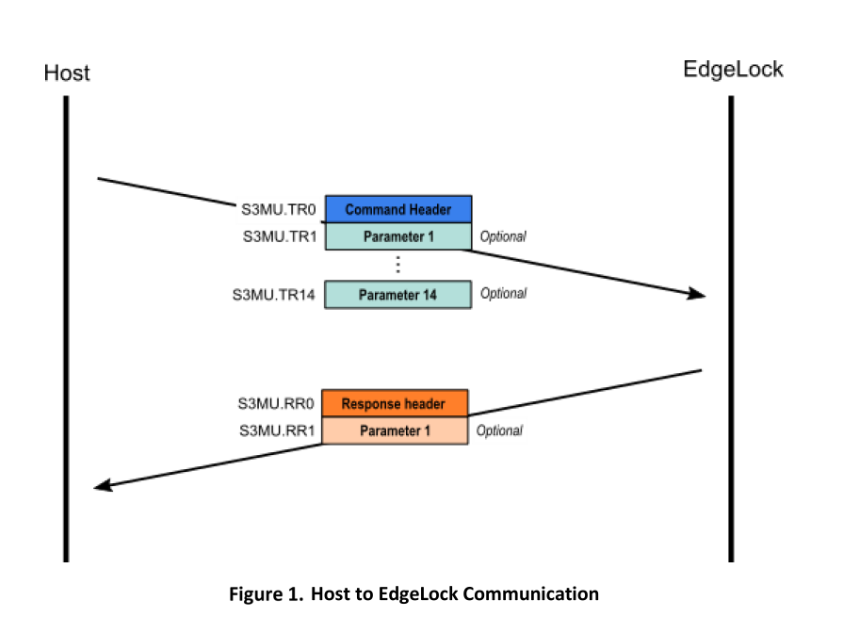

#### Command message format

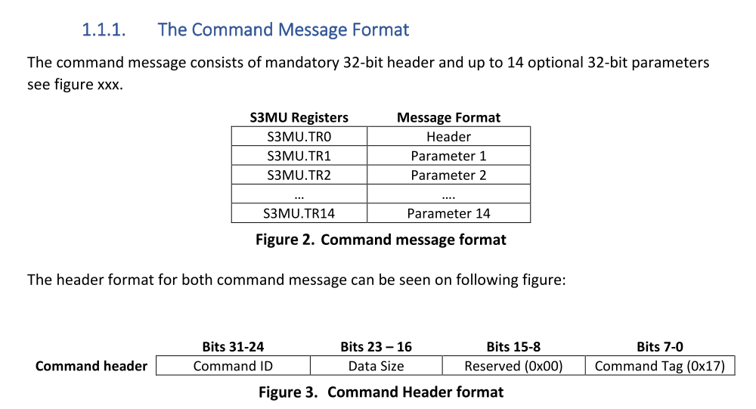

#### Response message format

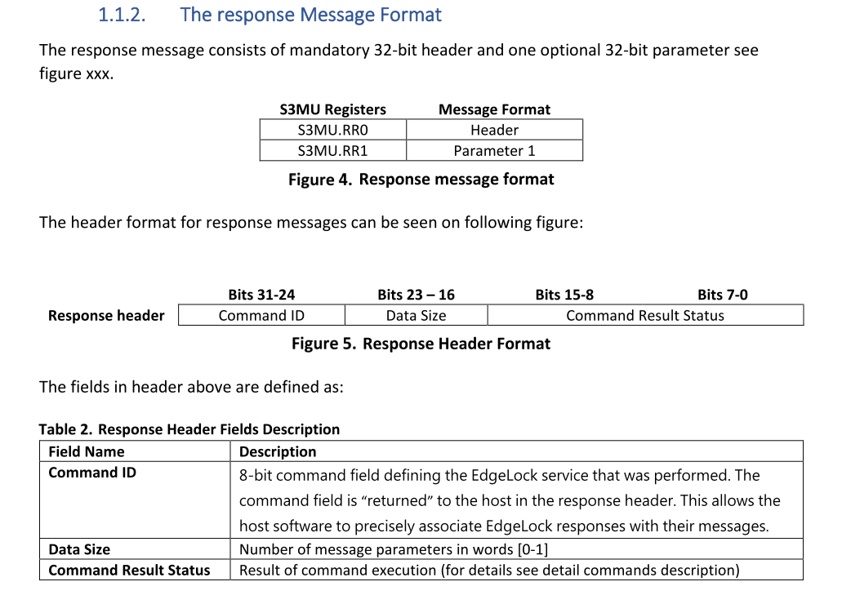

## Code

### Testbench MU message

s3mu_api_message

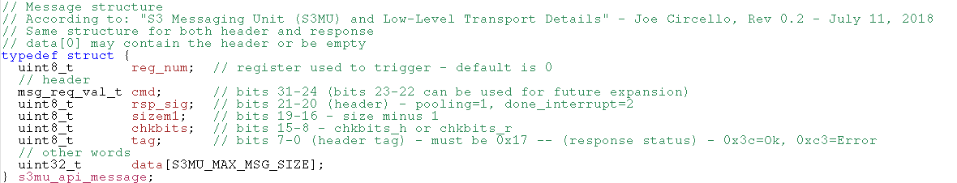

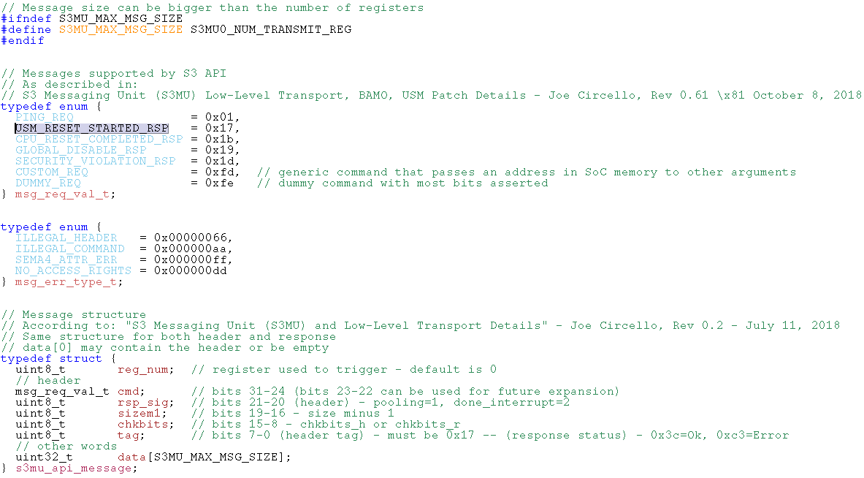

### Initialize MU(CM33-HOST)

// Function called by tests to initialize and check whatever is necessary before sending commands

S200 reset 后通过MU 发送给host（CM33）的message。用来检查S200是否初始化完毕。

一共两个word， 第一个word表示初始化开始。第二个word表示初始化结束。

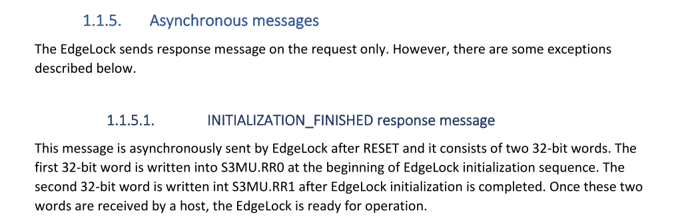

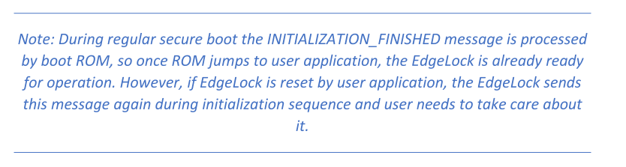

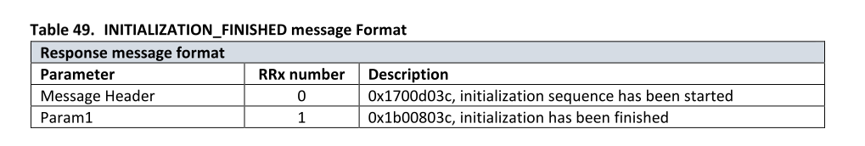

#### s3mu_initial_sequence

1. 等待USM的message 0x1700d03c, RR0读取
2. 等待S200 发送complete的message, 0x1b00803c， RR1读取

// Enable S3MUA RX Full IRQs and wait for response-only messages

void s3mu_initial_sequence(S3MU_CONTEXT *s3mu_context) {

// Read and check USM reset started response-only message

s3mu_wait_usm_reset_started(s3mu_context);

// Read and check CPU reset completed response-only message

s3mu_wait_cpu_reset_completed(s3mu_context);

}

##### s3mu_wait_usm_reset_started

MU中断触发，RR0接收USM的message 1700d03c

UVM_INFO @ 108184.21 ns: [CORE_A] S3MU0: s3mu_message_isr entered

UVM_INFO @ 108329.98 ns: [CORE_A] R32: A=5002400c R=00000060 // receive full pending flag

UVM_INFO @ 108569.46 ns: [CORE_A] R32: A=5002412c R=00000001 //bit1=1，可以从RR0读取message

UVM_INFO @ 109444.07 ns: [CORE_A] R32: A=50024280 R=1700d03c //读取RR0的message



// Wait and check response-only message USM_RESET_STARTED

void s3mu_wait_usm_reset_started(S3MU_CONTEXT* s3mu_context) {

s3mu_load_rsp(s3mu_context, USM_RESET_STARTED_RSP); // Load expected response

INSTALL_ISR_WITH_CONTEXT(s3mu_context->INTERRUPT_VECTOR, s3mu_message_isr, s3mu_context);

s3mu_enable_int_rf0(s3mu_context); // Enable interrupt handler for RF0

//BSET32: A=50024128 Ri=00000000 M=00000001 Rf=00000001

INFO(__FILE__, "Wait for ISR to execute and check response");

s3mu_enable_rx_full_irq(s3mu_context);

// WR32: A=50024128 W=00000003 R=00000003

while(s3mu_context->rf_int_cnt[0] == 0);

REM32(S3MU_RSR, 0, S3MU_RSR_RF0); // check for receiver register empty

//REM32: A=5002412c R=00000000 E=00000000 M=00000001

INFO(__FILE__, "Received USM_RESET_STARTED");

// Call SoC TB function to enable all interrupts

// Must be called after S3 interrupt is installed because interrupt signal should be already set

s3mu_os_clear_all_pending_interrupts();

os_enable_all_interrupt_sources();

}

###### s3mu_enable_rx_full_irq(s3mu_context);

这个寄存器SOC secure RM中没有讲解

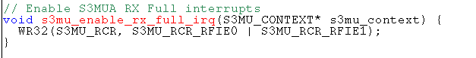

A] WR32: A=50024128 W=00000003 R=00000003

##### s3mu_wait_cpu_reset_completed

Core A RR1寄存器等待S200 发送0x1b00803c

[CORE_A] R32: A=50024284 R=1b00803c

SOC code

// Wait and check response-only message CPU_RESET_COMPLETED

void s3mu_wait_cpu_reset_completed(S3MU_CONTEXT* s3mu_context) {

s3mu_context->rf_int_cnt[1] = 0; // must clear interrupt counter - will be set if S3 reset

s3mu_load_rsp(s3mu_context, CPU_RESET_COMPLETED_RSP); // Load expected response

s3mu_enable_int_rf1(s3mu_context); // Enable interrupt handler for RF1

while(s3mu_context->rf_int_cnt[1] == 0);

REM32(S3MU_RSR, 0, S3MU_RSR_RF1); // check for receiver register empty

// ] REM32: A=5002412c R=00000000 E=00000000 M=00000002

BCLR32(S3MU_RCR, S3MU_RCR_RFIE1); // disable interrupt for RF1

//BCLR32: A=50024128 Ri=00000003 M=00000002 Rf=00000001

INFO(__FILE__, "Received CPU_RESET_COMPLETED");

}

###### S200 code



设置发送寄存器为TR1，发送1b00803c

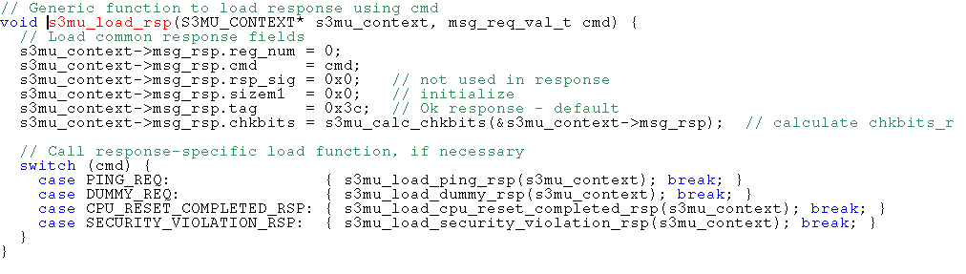

1. 读取TSR 寄存器S3MU_TSR transmit status register

R32: A=4c003124 R=00000003， BIT[1]需要为1，表示TR1可以写数据

1. TR1发送数据 S3MU_TR1 transfer register

W32: A=4c003204 W=1b00803c

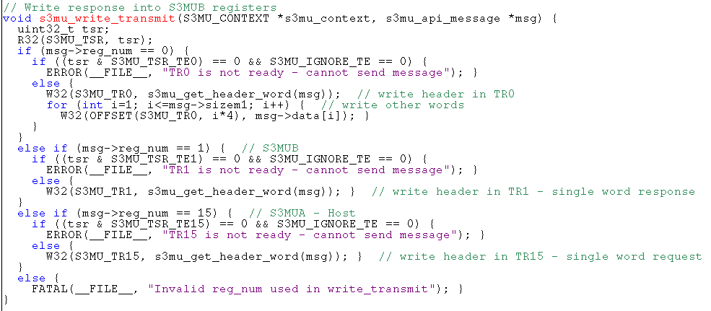

### MU SOC

#### 加载command

加载发送的message到机构体中

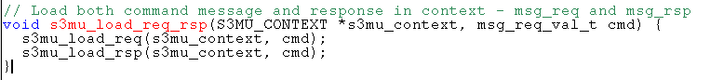

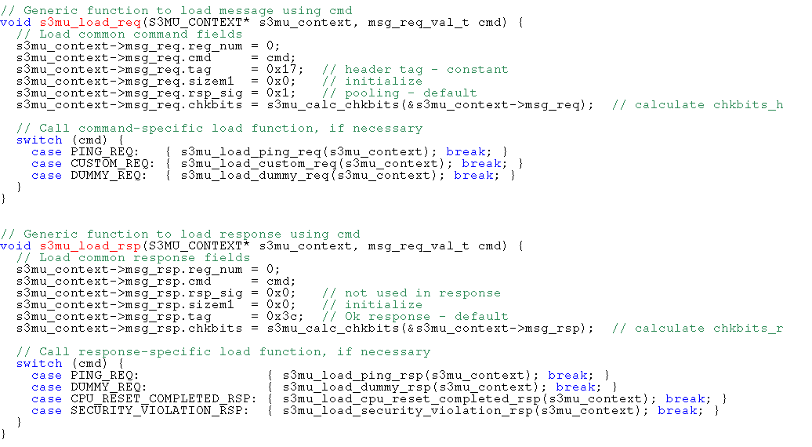

#### 发送command

1. 读取TSR，判断哪个TR寄存器可以用来发送数据（置1可以发送数据）

WAIT_REM32: A=50024124 R=0000ffff E=00000001 M=00000001 Att=1 //TR0可以用来发送数据

1. 将加载的command，发送出去TR。对应接收端的RSR相应bit会置1，可以选择对应的RR寄存器读取数据

W32: A=50024200 W=0110dc17

接收端，RCR寄存器开启了中断，一旦数据写入，接收端对应的RR有了数据后会产生中断

SOC 端RR中断：

44: Sentinel command interface interrupt

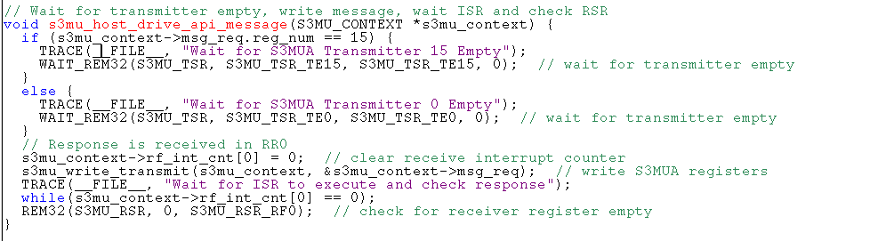

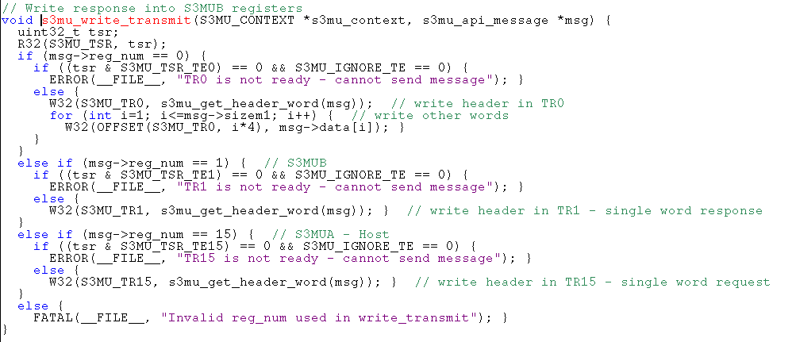

### MU S200

分两步：

1. 加载command到 s3mu_context->msg_rsp中
2. 发送命令



#### 加载command

设置参数用哪个TR发送，加载message

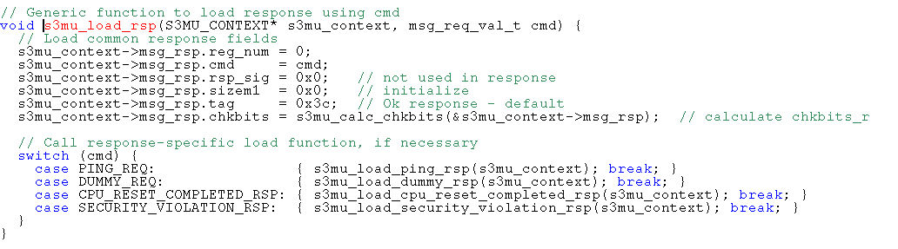

#### 发送command

1. 读取TSR 寄存器S3MU_TSR transmit status register

R32: A=4c003124 R=00000003， BIT[1]需要为1，表示TR1可以写数据

1. TR1发送数据 S3MU_TR1 transfer register

W32: A=4c003204 W=1b00803c

S200发送reset completely的log：

[CORE_S3] W32: A=4c003204 W=1b00803c

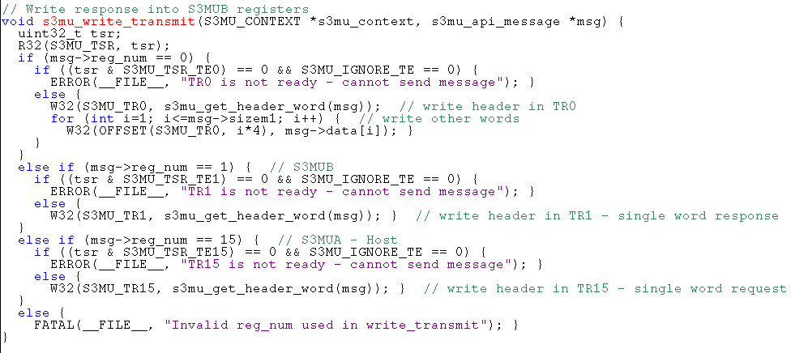

## Lifecycle

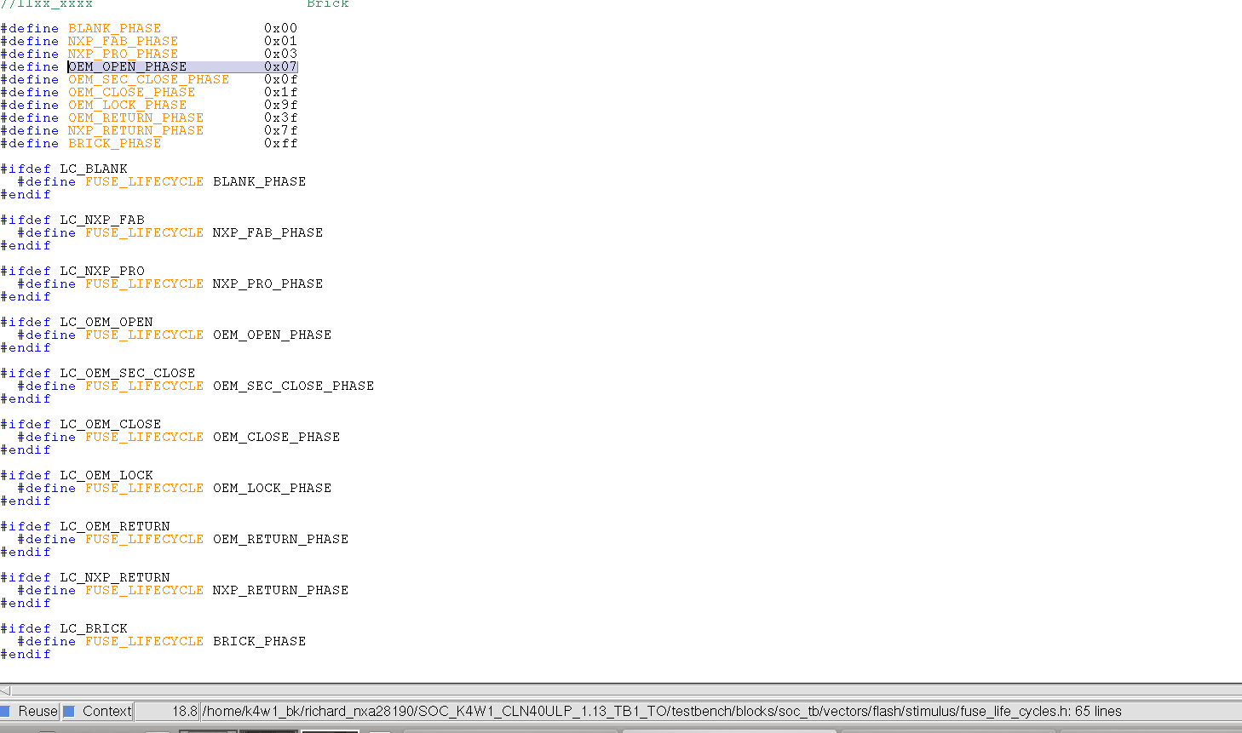

### Fuse 配置

1. Test case对应custom arg下配置了对应的FUSE_LIFECUCLE值，对应不同的lifecycle
2. 默认FUSE_TZM_EN =1, disable TZM

RE32: A=50015030 R=00000403 E=00000403 （test case：NXP provision）

1. FUSE_FIELD(value，offset1，size，base_offset)

例： FUSE_FIELD(4,0,7,0). Fuse从base_offset=0开始算，从offset1=0 长度为7 bit，写入值为4

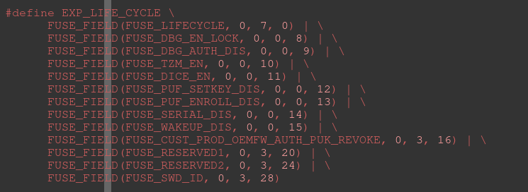

### Test code

#### S200 Check OTPC register reset value

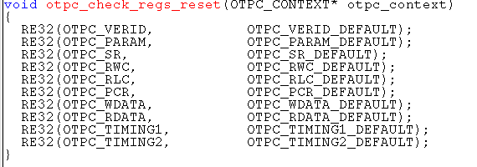

RE32: A=4c00f000 R=01000000 E=01000000

[CORE_S3] RE32: A=4c00f004 R=0000004c E=0000004c

[CORE_S3] RE32: A=4c00f008 R=00000000 E=00000000

[CORE_S3] RE32: A=4c00f010 R=00000000 E=00000000

[CORE_S3] RE32: A=4c00f014 R=00000000 E=00000000

[CORE_S3] RE32: A=4c00f018 R=00000000 E=00000000

[CORE_S3] RE32: A=4c00f020 R=00000000 E=00000000

[CORE_S3] RE32: A=4c00f024 R=00000000 E=00000000

[CORE_S3] RE32: A=4c00f030 R=1f010100 E=1f010100

[CORE_S3] RE32: A=4c00f034 R=00000140 E=00000140

#### Check shadow register

1. testbench/blocks/soc_tb/tool_data/compiler/include/fuse_map.h 包含了shadow register的信息
2. 读取shadow register（shadow register为offset 200-228）跟1中数据进行比对

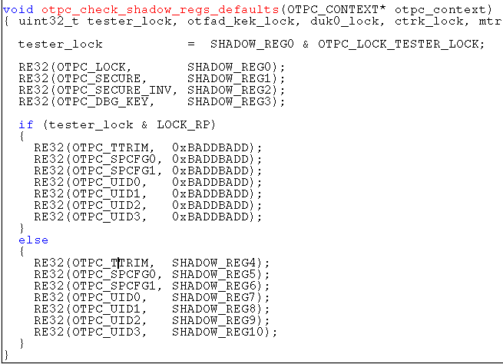

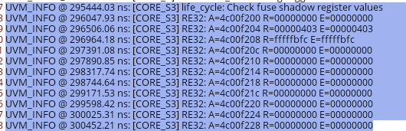

#### Test different DBGEN/DBGENB configuration

1. 单独配置DBGEN/DBGENB的DEN/TEN， 检查S200对外DBGEN信号线，信号应该不变。

同时配置DBGEN/DBGNB的DEN/TEN, 检查S200对外DBGEN信号线，信号应该改变

1. 不同的lifecycle下配置DBGEN的TOD寄存器，单独配置不起作用。只有两个寄存器同时配置，对外信号才会改变

testbench.top.pd_main.secsubsys.secsubsys_v1_s3v1_s3test_enable[2:0]

testbench.top.pd_main.secsubsys.secsubsys_v1_s3v1_s3teston_dis[2:0]

1. 如上寄存器配置以及信号检测做完后，S200对SOC的memory 进行访问。OEM lifecycle下需要配置GPO_1使得radio flash能够访问

### 不同属性

当lifecycle为BLANK/NXP_FAB/NXP_PROV/NXP_RET时，默认可以访问radio flash、debug。 TOD enable

DBGEN 四个信号enable

其他lifecycle时， 默认不可以访问radio flash。 TOD disable 。DBGEN 四个信号disable。

DBGEN 寄存器在不lock的情况下，可以修改

SOC端：

DBGEN bit[22:20] = 0x2, 表示可以访问radio flash

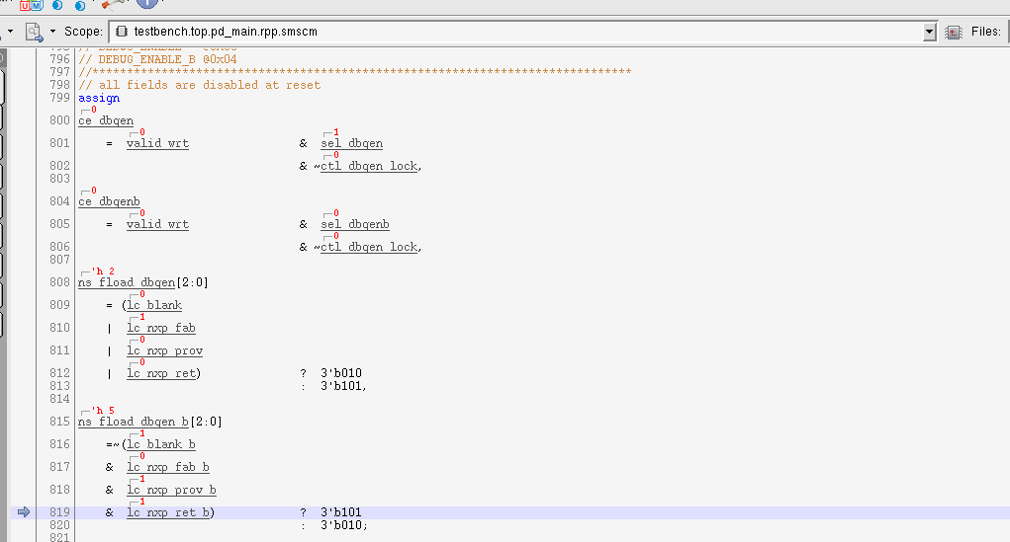

top.pd_main.rpp.smscm.ctl_alt_en 控制radio flash的访问，1表示可以访问radio flash

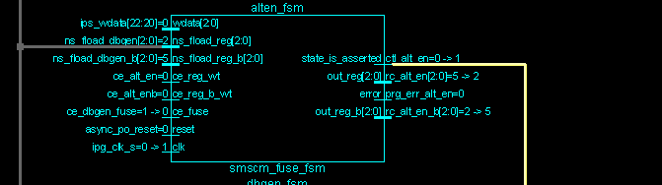

S200端

S3SCM_DBGEN bit[26:24] TOD 默认enable

## USM

For KW47

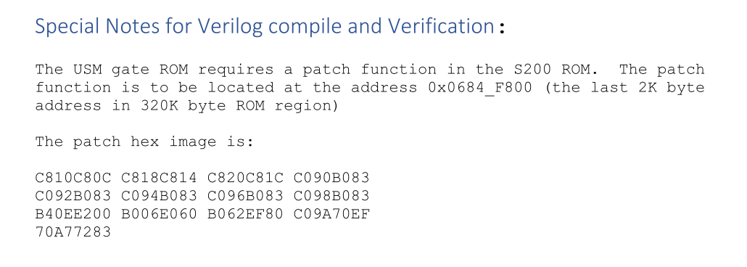

For KW45:

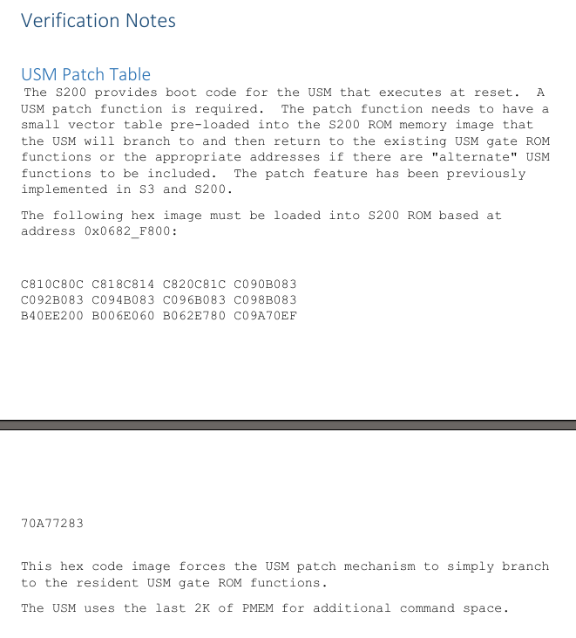

# Signals

## COREA

testbench.top.pd_main.rpp.uTEAL.HREADYC

testbench.top.pd_main.rpp.uTEAL.INTNUM[8:0]

testbench.top.pd_main.rpp.uTEAL.u_pd_core.u_core.u_tealcore_dpu.pc_value[31:0]

testbench.top.pd_main.rpp.uTEAL.u_pd_core.u_core.u_tealcore_dpu.r00_q[31:0]

## ROM

/home/kw47_verif_nobk1/richard_nxa28190/V_SS_KW47_SOC_TB_1.30/memories/ts_cln40ulpef_snps_hdrom_24576x032b4c32d1_ss_d0m2p0r0t1_kw47/BEHAVIOUR/ts_cln40ulpef_snps_hdrom_24576x032b4c32d1_ss_d0m2p0r0t1_kw47_behaviour_pwr_PttV1100V1100T025Etypical.v

testbench.top.pd_main.romcp0_mem.mem_rom0.mem.uut.mem_core_array[0:24575]

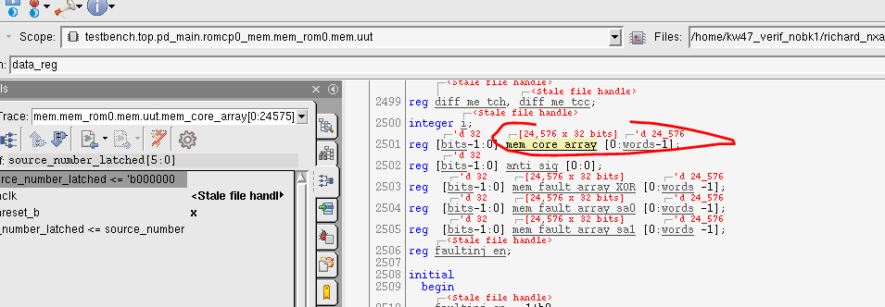

## S200

### ROM

ROM: testbench.top.pd_main.secsubsys.s3_mem_bistwrap.s3_mem.prom0

testbench.top.pd_main.secsubsys.secsubsys_v1.prom_rdata[31:0]

testbench.top.pd_main.secsubsys.s3_mem_bistwrap.s3_mem.prom1.data_out_r1[31:0]

common_blocks/v_ss_s200_vip/tool_data/sray/mem_map/s200_soc_resources.mem_map

`define S200_CODE_ROM0_BASE (`S200_CODE_ROM_BASE)

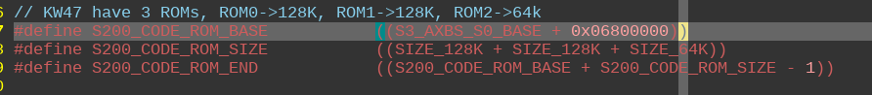

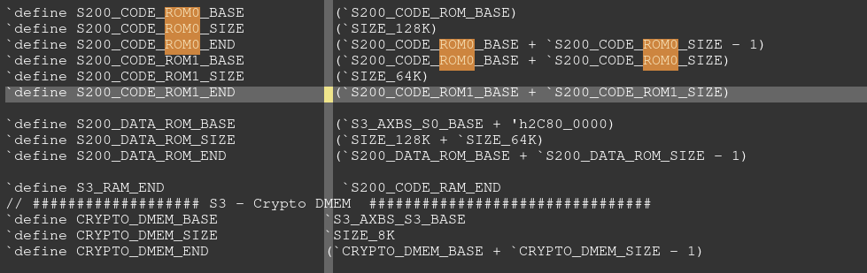

Int：

testbench.top.pd_main.secsubsys.secsubsys_v1.CORTEXM0PLUS.u_top.u_sys.u_core.int_num[5:0]

testbench.top.pd_main.secsubsys.secsubsys_v1.CORTEXM0PLUS.u_top.u_sys.u_core.r00_q[31:0]

## iomux

S200 UART pinmux:

|  |  |
| --- | --- |
| PTC0 | SEC_RX |
| PTC1 | SEC_TX |

testbench.top.iomix.iomux.iomux_ptc1

从下往上数这个信号，对应的是对应pin的各个alt功能。ALT6对应SEC_TX

ipp_ind_vc[15:0]

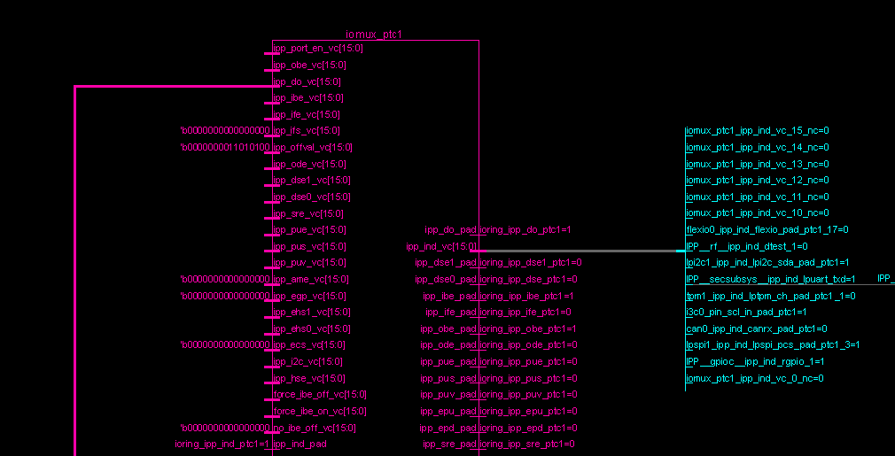

# Memory

## S200

KW47:

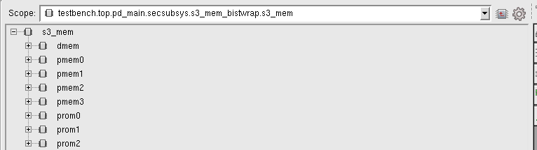

KW45:

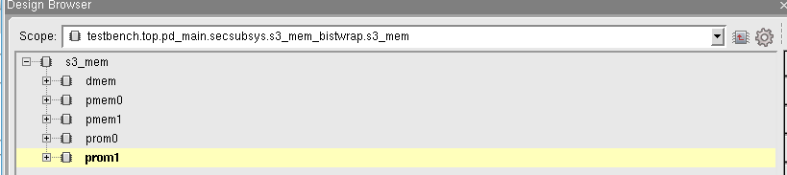

testbench.top.pd_main.secsubsys.s3_mem_bistwrap.s3_mem

### ROM

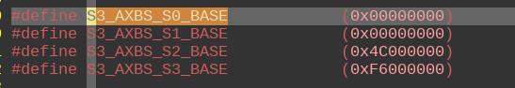



ROM0： 32768*4 bytes = 128K



testbench.top.pd_main.secsubsys.s3_mem_bistwrap.s3_mem.prom0.mem.uut.mem_core_array[0:32767]

ROM1：32768*4 bytes = 128K

testbench.top.pd_main.secsubsys.s3_mem_bistwrap.s3_mem.prom1.mem.uut.mem_core_array

ROM2:16384*4bytes = 64K



testbench.top.pd_main.secsubsys.s3_mem_bistwrap.s3_mem.prom2.mem.uut.mem_core_array

### RAM

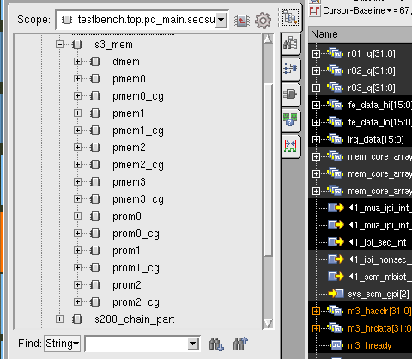

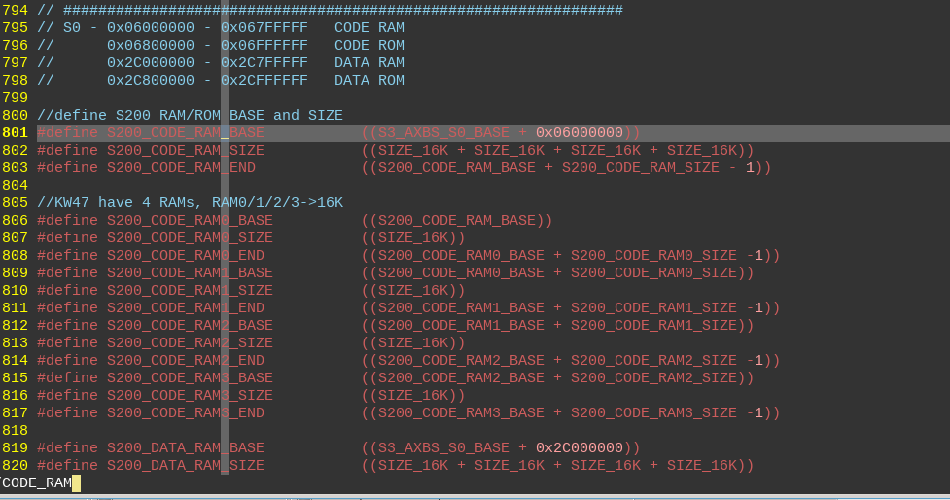

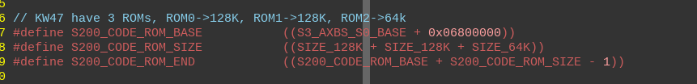

PRAM0: 512*40 bytes = 20K

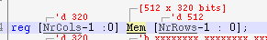

testbench.top.pd_main.secsubsys.s3_mem_bistwrap.s3_mem.pmem0.mem.Mem[511:0]

PRAM1: 512*40 bytes = 20K

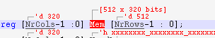

testbench.top.pd_main.secsubsys.s3_mem_bistwrap.s3_mem.pmem1.mem

PRAM2: 512*40 bytes = 20K

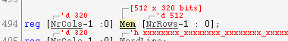

testbench.top.pd_main.secsubsys.s3_mem_bistwrap.s3_mem.pmem2.mem

PRAM3: 512*40 bytes = 20K

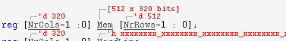

testbench.top.pd_main.secsubsys.s3_mem_bistwrap.s3_mem.pmem3.mem

# Clock

MRCC 控制模块clock&reset的开启。

Clock 有四种模式Clock configuration

## IPC(MRCC： Module reset and clock control)

Testbench 会自动生成ipc相关的api

testbench/blocks/soc_tb/tool_data/compiler/include/generated/ipc_api.h

IPC base：

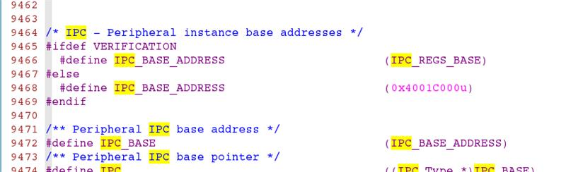

### Register

#### I2C

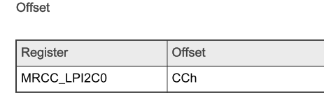

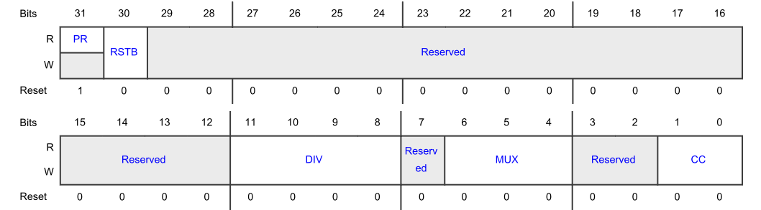

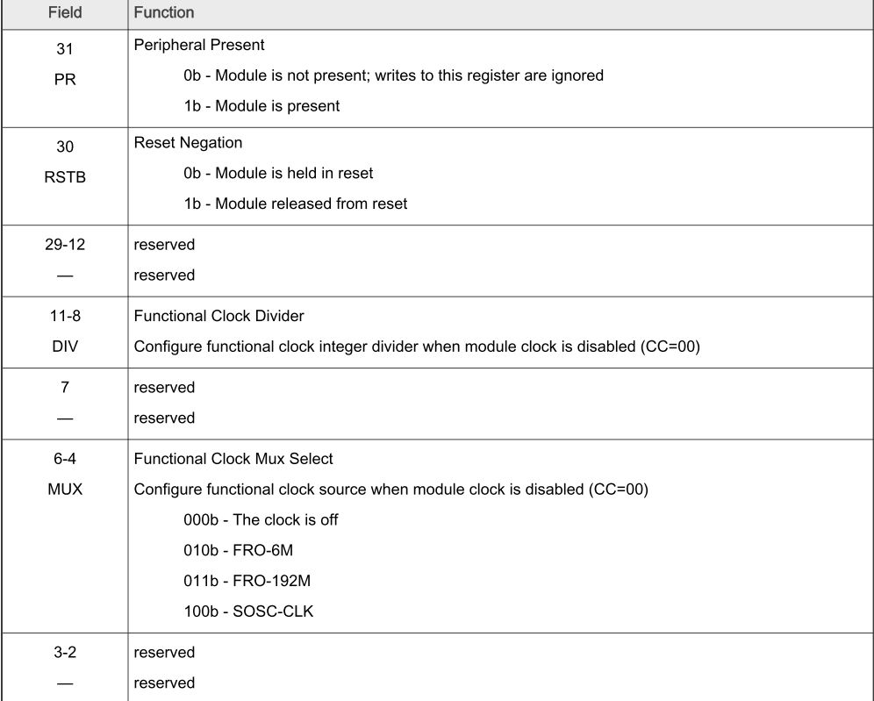

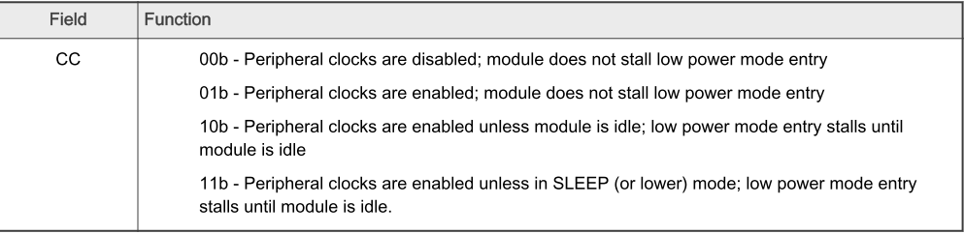

#### DMA

Bit 30： 配置reset

Bit 0-1： 配置clock

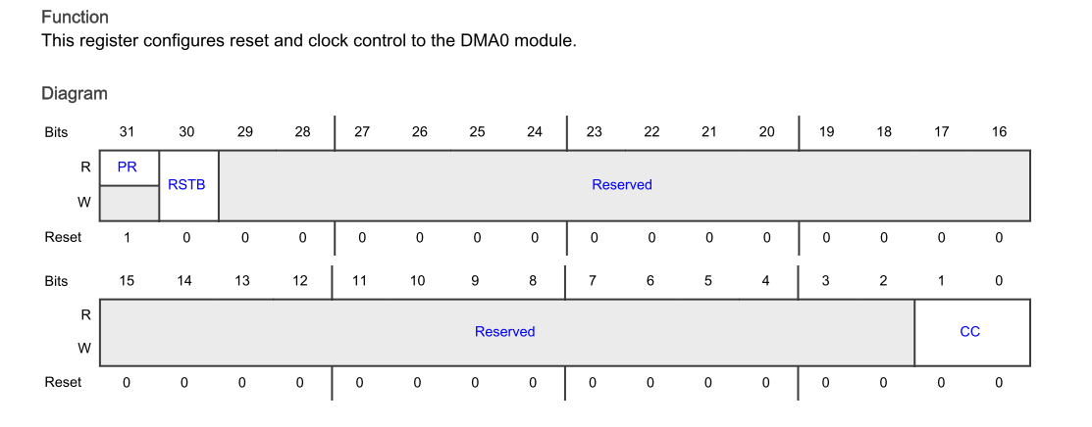

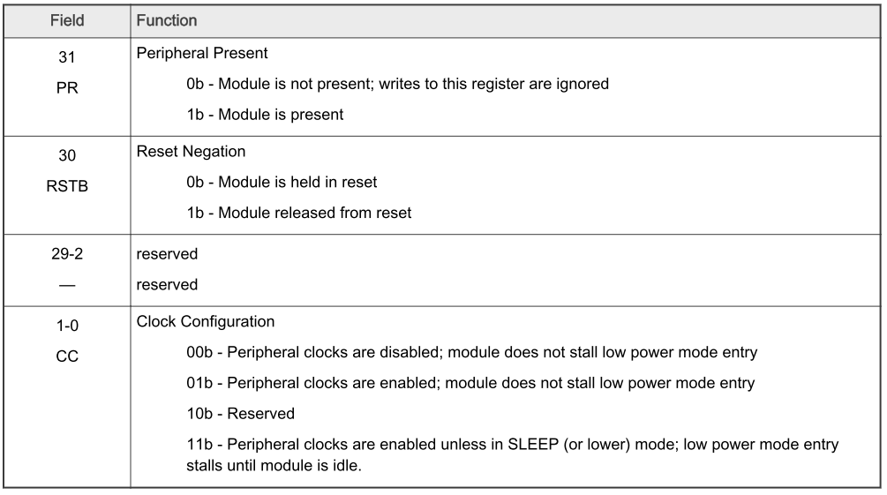

## Testbench中clock的配置

### SCG 寄存器配置

配置clock 源头

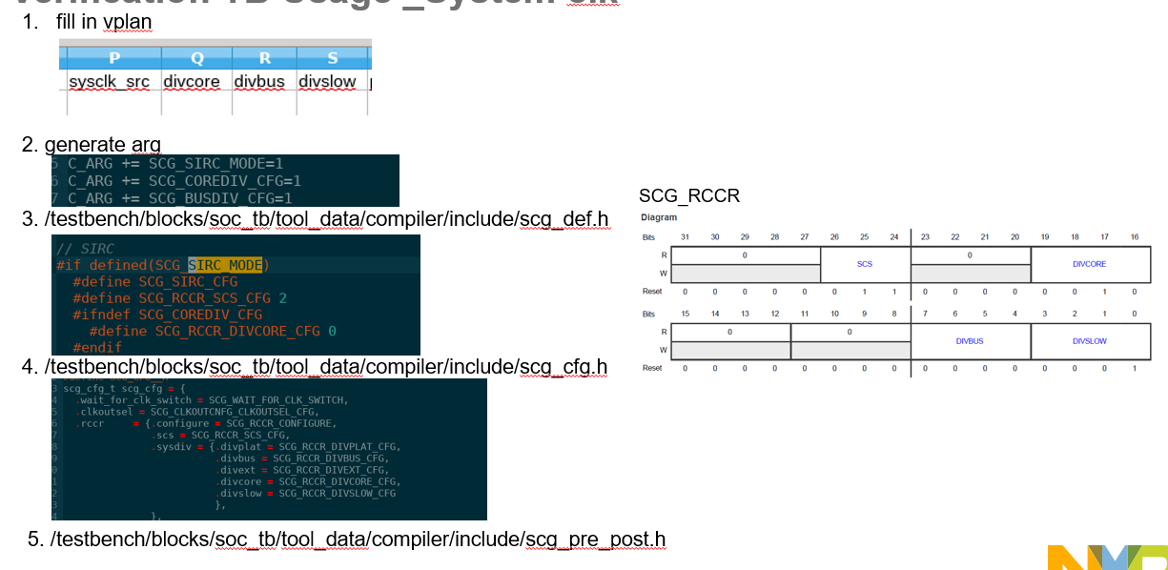

#### Register

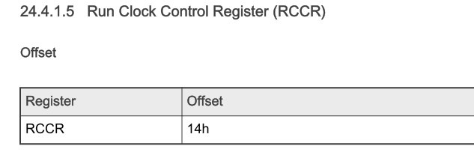

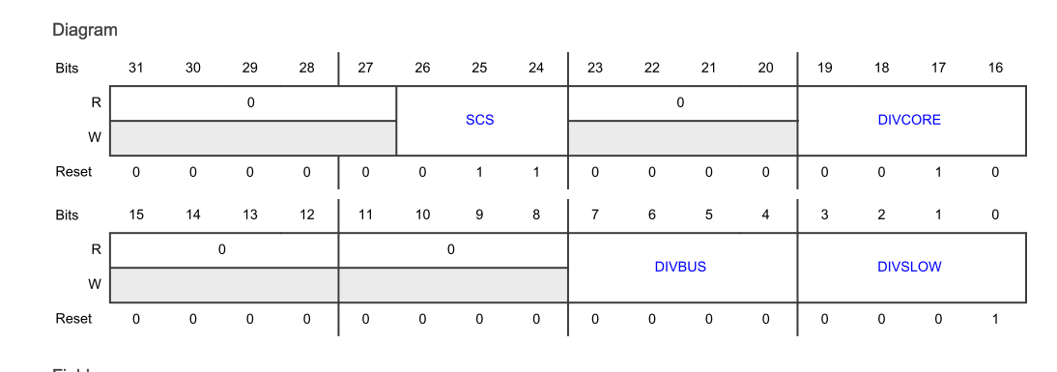

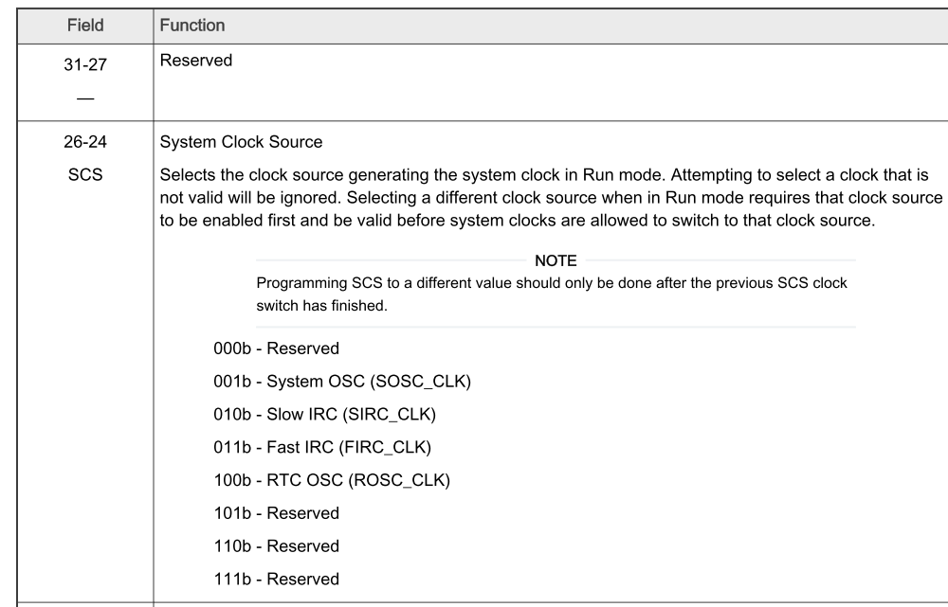

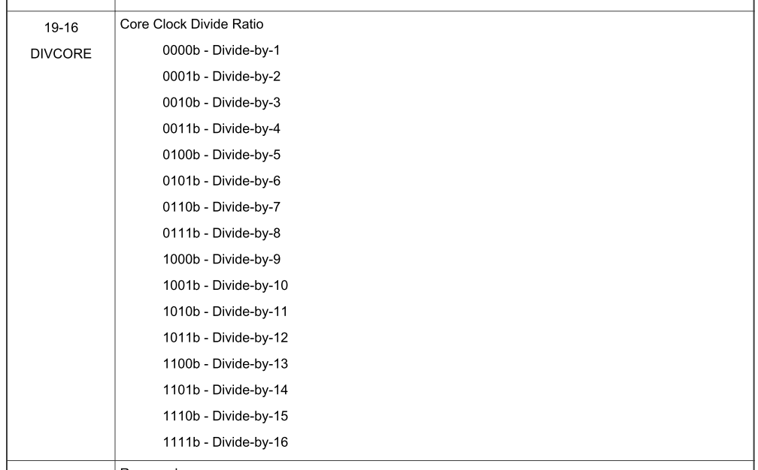

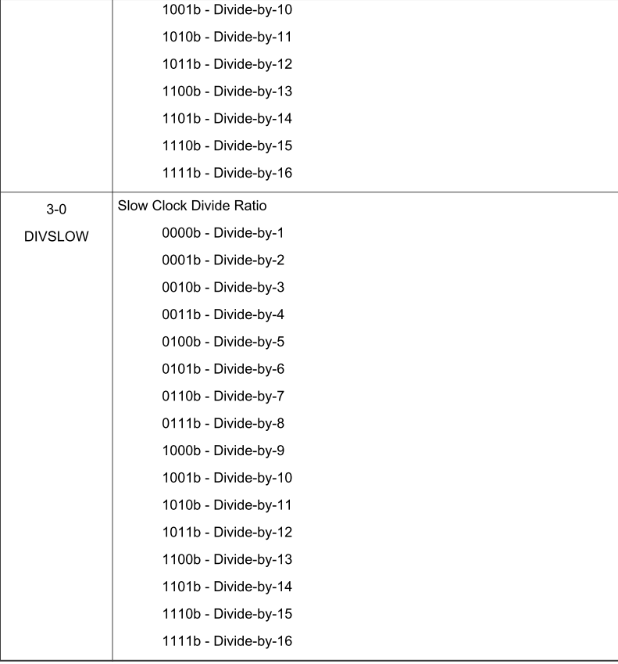

### MRCC 寄存器配置

使能peripheral的clock。

VPLAN中配置的参数如下

Peripheral_clk_cfg不填写，就是force_on

Peripheral_CLK_SRC //function clock source  
peripheral_clk_div //function clock divider

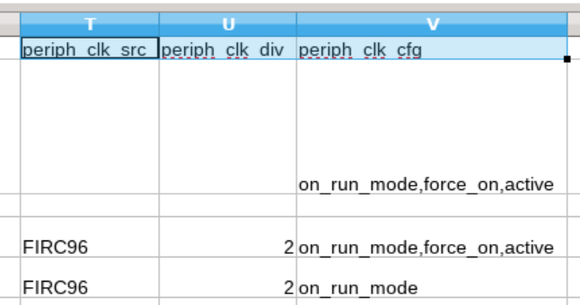

对应生成的arg

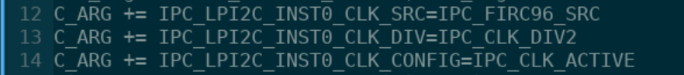

模块进行ip_allocate的时候，时钟使能的函数在Ipc_api.h中，会调用这些参数，进行IPC寄存器的配置。

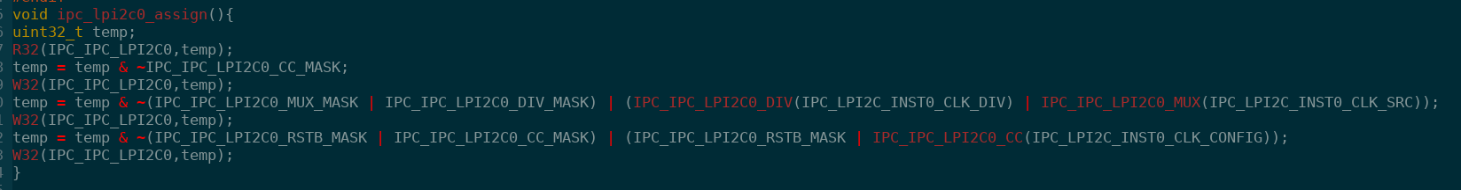

#### Clock configuration

//Macro define for IPC CLOCK CONFIGURATION

// -------------------------------------------

#define IPC_CLK_FORCE_OFF 0

#define IPC_CLK_FORCE_ON 1

#define IPC_CLK_ACTIVE 2 // 时钟会自动gate，当模块处于idle的时候。部分IP支持

#define IPC_CLK_ON_RUN_MODE 3

## DMA-RTL

目前，DMA 的MRCC寄存器跟RM对不上，需要在RTL中找到DMA MRCC的offset。 如下图：

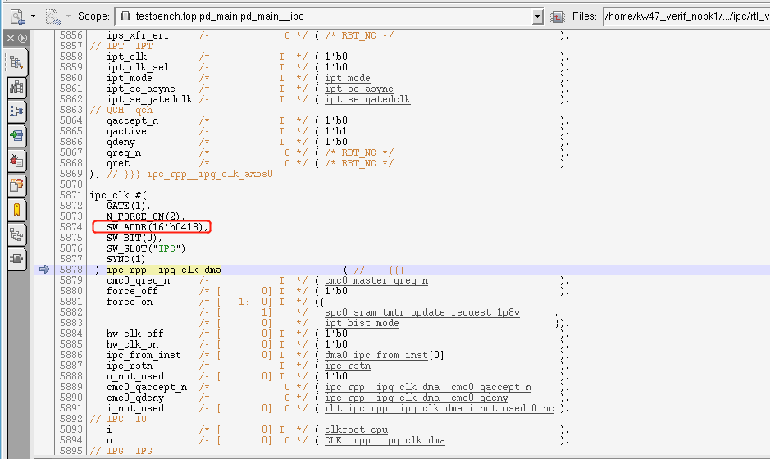

# Lower Power

## Code

### power_wup_configure

power_wup_configure(power_context, NMI_WUP, WUP_WAIT_FOR_LP_ENTRY, 2);

### power_mon_configure

power_mon_configure(power_context, POWER_TEST_TYPE, POWER_MON_IP, POWER_CLK_CONFIG);

### power_configure-> power_dev_configure

power_configure(power_context);

关键字： power_configure

power_wup_api.h: power_wup_setup_nmi

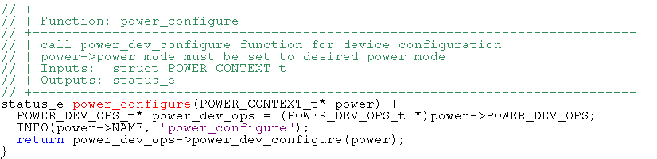

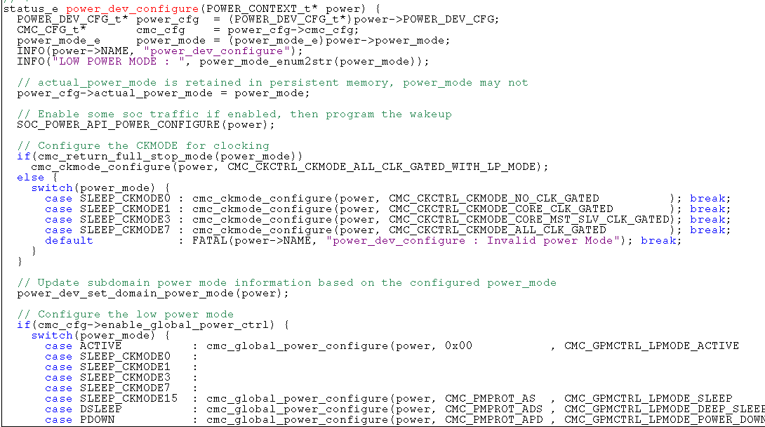

#### SOC_POWER_API_POWER_PROGRAM_WUP ->power_wup_setup

SOC_POWER_API_POWER_CONFIGURE-> SOC_POWER_API_POWER_PROGRAM_WUP ->power_wup_setup

setup wakeup source

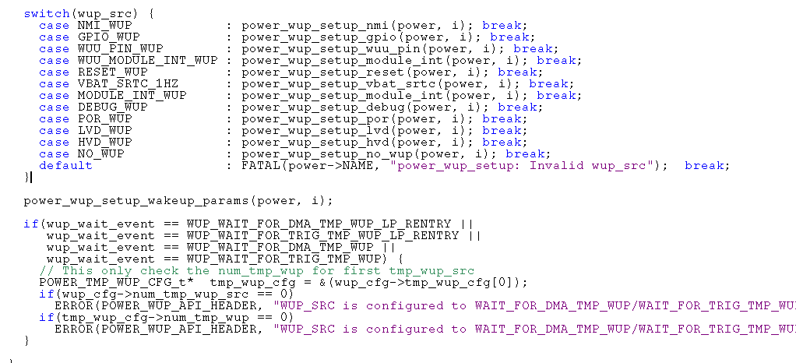

##### power_wup_setup_nmi

log: power_wup_setup_nmi

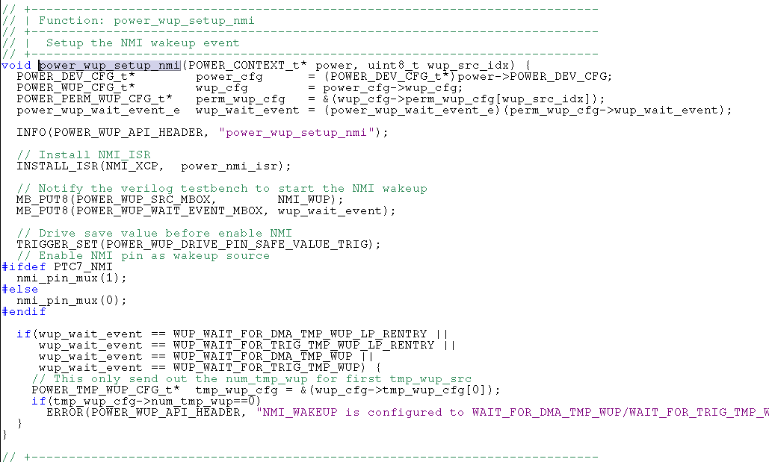

#### cmc_ckmode_configure

配置CKMODE CLOCK CONTROL CKCRTL

Log: cmc_ckmode_configure: Configure Clocking MODE

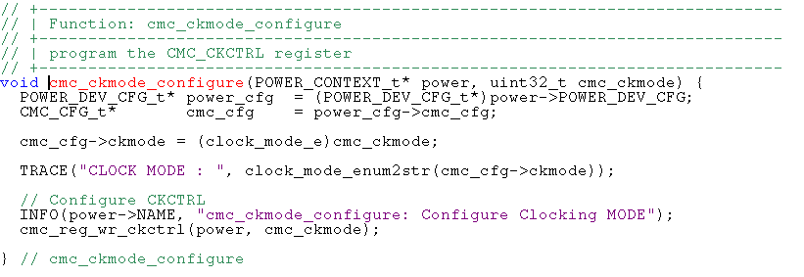

UVM_INFO @ 333188.41 ns: [CORE_A] POWER_INST0: cmc_ckmode_configure: Configure Clocking MODE

UVM_INFO @ 333927.66 ns: [CORE_A] WRE32: A=50001010 W=0000000f R=0000000f E=0000000f

#### power_dev_set_domain_power_mode

Update subdomain power mode information based on the configured power_mode

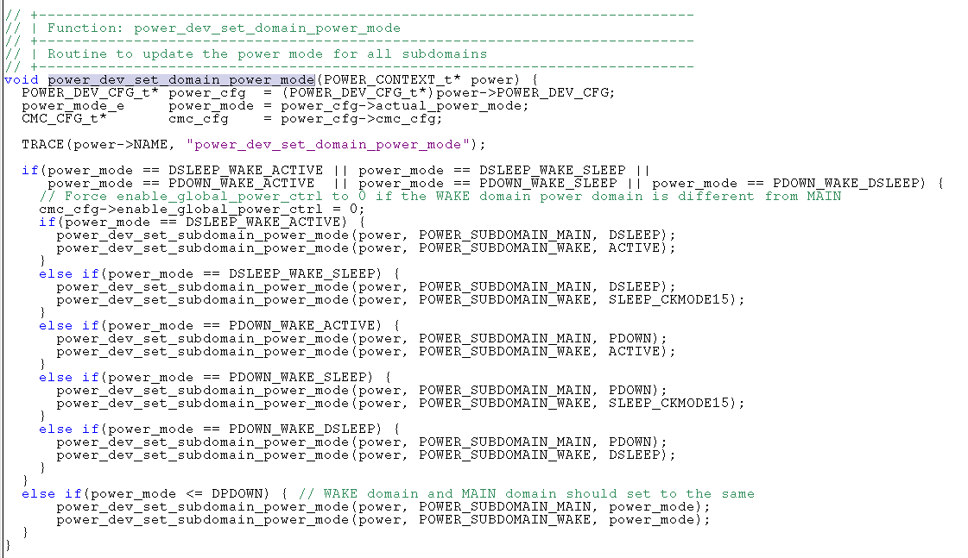

#### cmc_global_power_configure

Power mode protection (PMPROT)

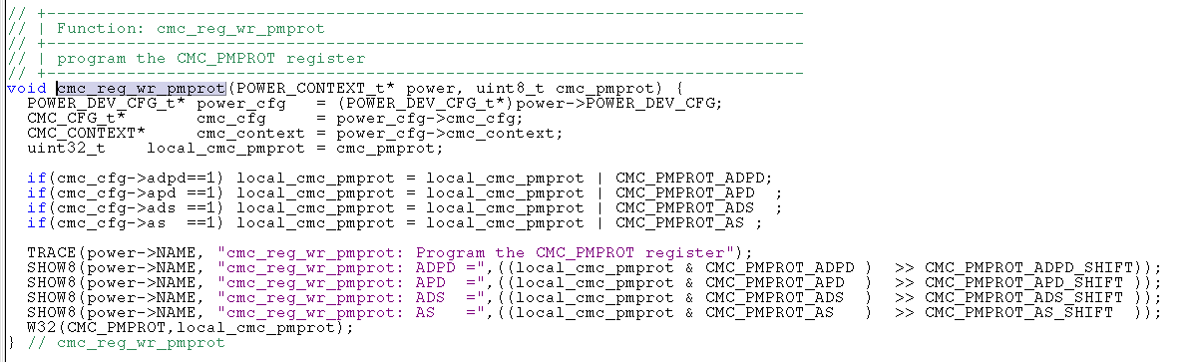

POWER_INST0: cmc_reg_wr_pmprot: ADS =01

UVM_INFO @ 337228.27 ns: [CORE_A] POWER_INST0: cmc_reg_wr_pmprot: AS =00

UVM_INFO @ 337405.27 ns: [CORE_A] W32: A=50001018 W=00000002

#### power_dev_cmc_configure

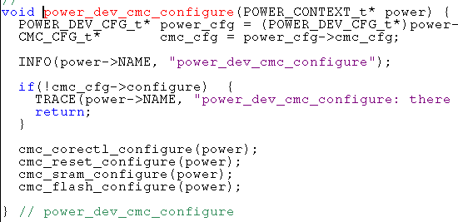

power_dev_cmc_configure

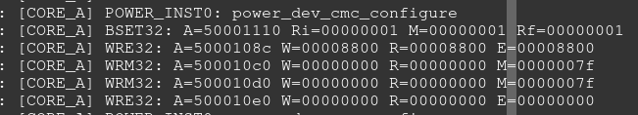

#### power_dev_spc_configure

power_dev_spc_configure

配置 System Power Control (SPC)

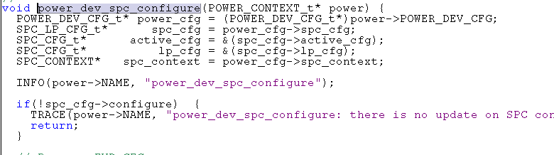

### power_entry

log： power_entry

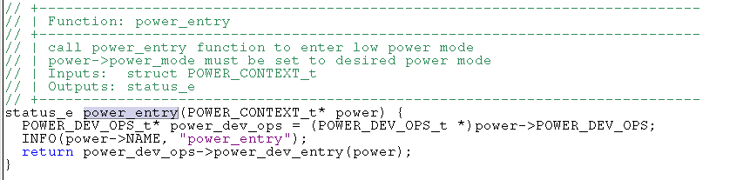

### power_exit

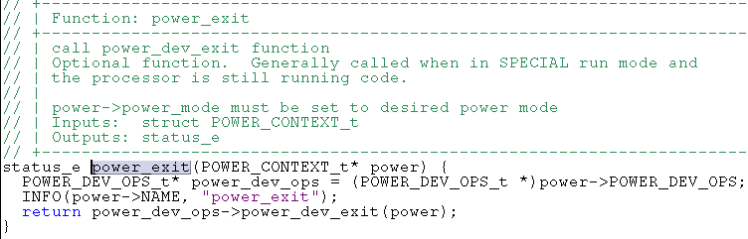

### power_check

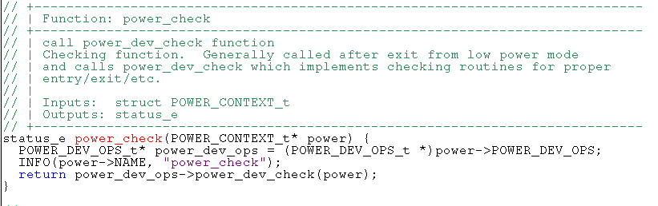

# ROMCP

# POWER

V_SS_KW47_SOC_TB_1.35/testbench/blocks/soc_tb/testbench/instances_v/ power_supply.sv

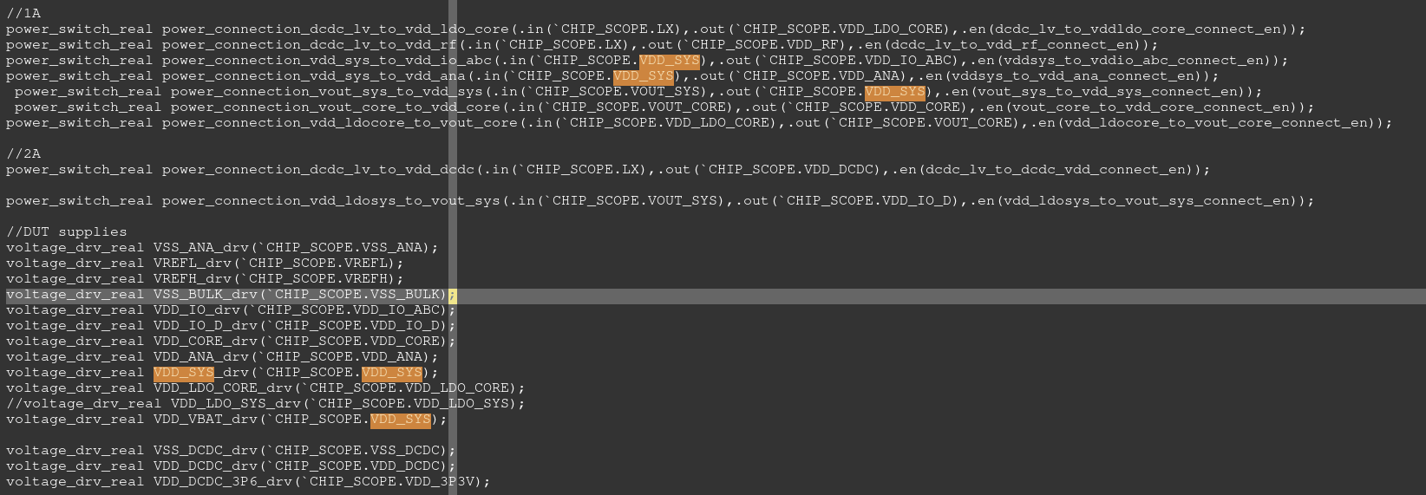

# Fuse

## Timing信号

testbench.top.pd_main.secsubsys.efuse.d_ip_otpc_syn.o_otp_addr[11:0]

testbench.top.pd_main.secsubsys.efuse.efuse_hd.A0

testbench.top.pd_main.secsubsys.efuse.d_ip_otpc_syn.o_otp_strobe //wrapper信号

testbench.top.pd_main.secsubsys.efuse.efuse_hd.STROBE // fuse实体信号

testbench.top.pd_main.secsubsys.efuse.d_ip_otpc_syn.u_otpc_reg_ctrl.o_rf_timing1[31:0]

testbench.top.pd_main.secsubsys.efuse.d_ip_otpc_syn.u_otpc_reg_ctrl.o_rf_timing2[31:0]

## Timing 寄存器配置

测试96M/48M的core clock的时候，fuse的timing需要做不同的配置。

### Timing1寄存器用于配置读相关的timing

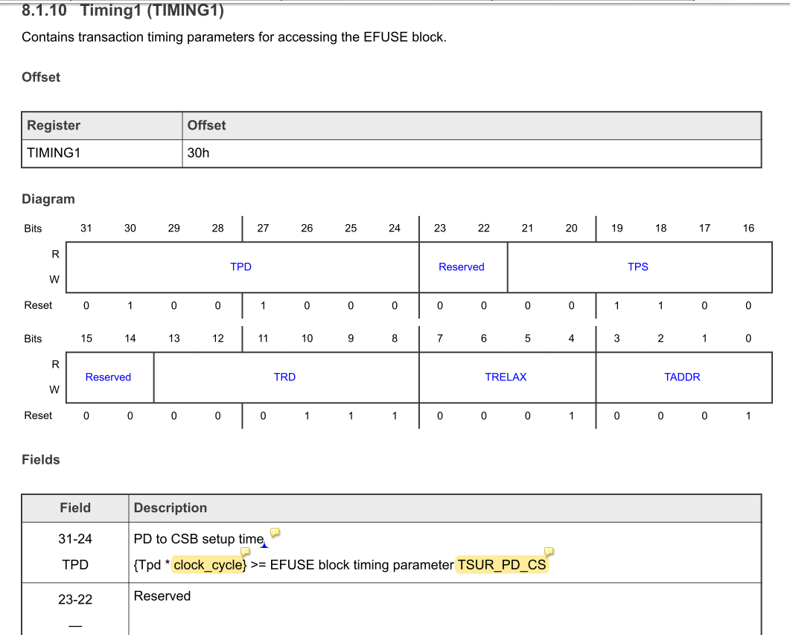

### Timing2寄存器用于配置写相关的timing，用来配置strobe脉冲宽度（高低电平时间差）

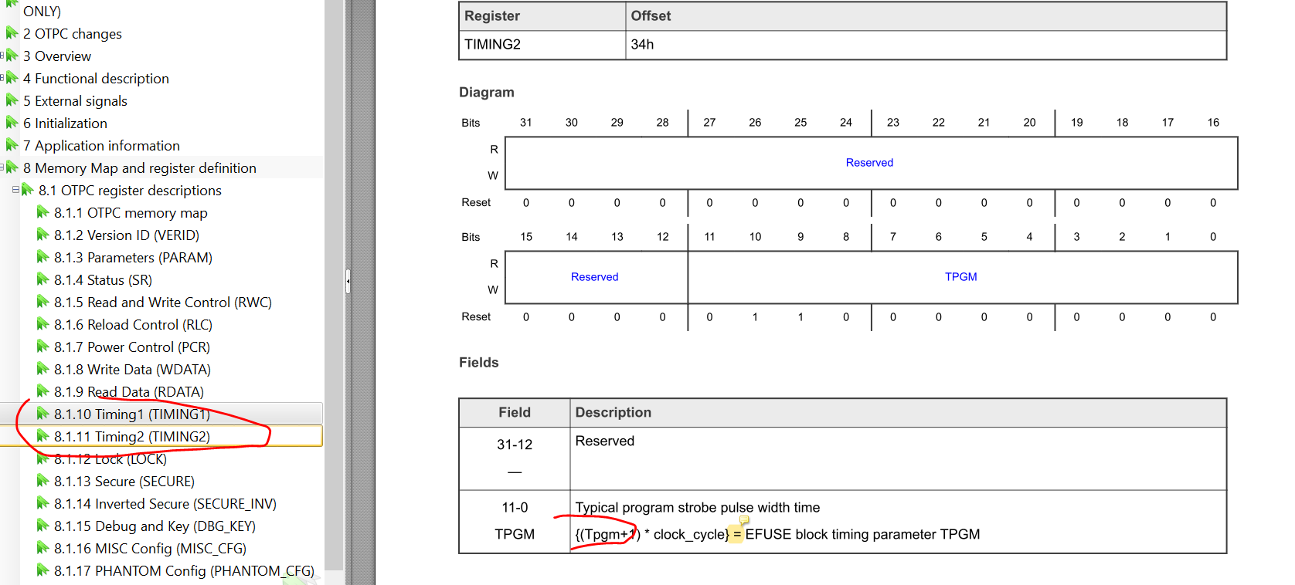

### 推荐配置

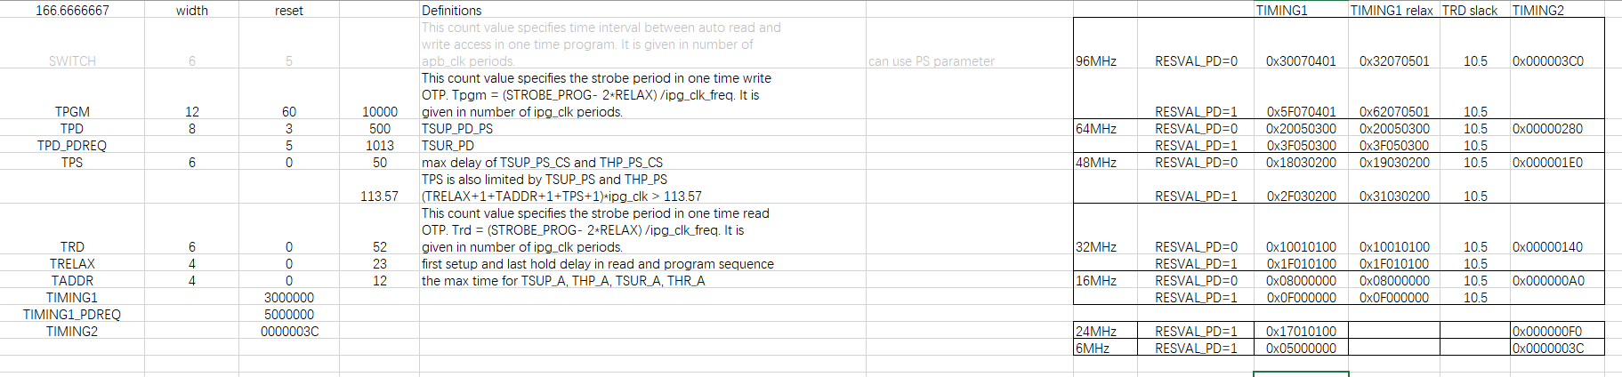

Sentinel ROM 用的配置如下：

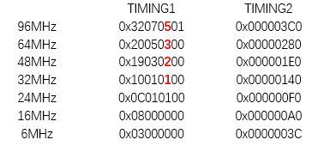

## 48M用96M 的timing配置，错误如下

Strobe信号的高低电平时间差为20000，比标准的9000-11000超过一倍。

导致program失败，

testbench.top.pd_main.secsubsys.efuse.efuse_hd

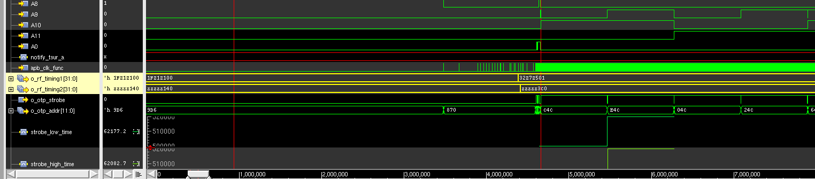

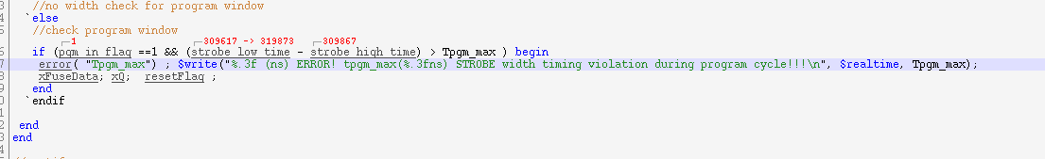

## testbench中case的配置

testbench/common_blocks/v_ss_s200_vip/vectors/s200/stimulus/s200_otpc_timing.h

C_ARG += OTPC_48M

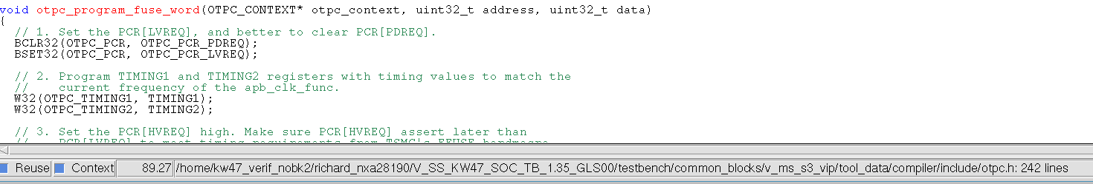

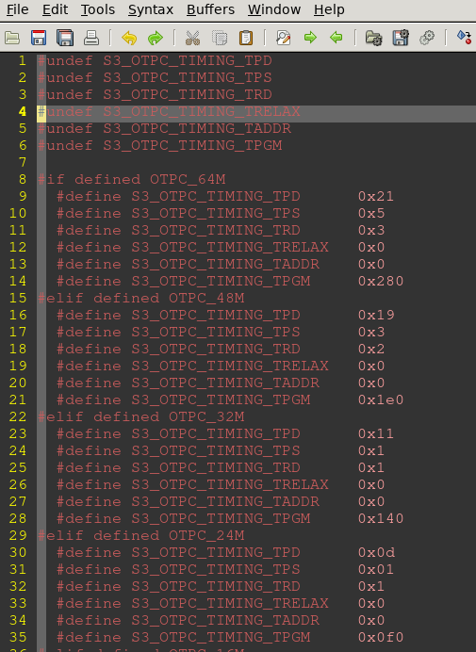

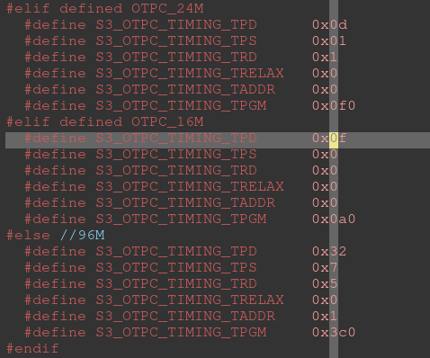

## Issue

### Sentinel ROM 96M下timing1寄存器的配置为0x401，导致fuse program失败

GLS34上可以pass， GLS35/GLS35_01 失败（可能是timing严格导致）。

增加如下的force修改寄存器的配置

always @(posedge testbench.top.pd_main.secsubsys.s3_clk)

begin

if(testbench.top.pd_main.secsubsys.efuse.d_ip_otpc_syn.u_otpc_reg_ctrl.o_rf_timing1[11:0] == 'h401)

begin

$display("force fuse timing register!");

$deposit(testbench.top.pd_main.secsubsys.efuse.d_ip_otpc_syn.u_otpc_reg_ctrl.o_rf_timing1[31:0],'h32070501);

end

end

# Testbench

## Doc

IFR：

/home/kw47_verif_nobk1/richard_nxa28190/V_SS_KW47_SOC_TB_1.18/chip/doc/spec_source/design

Fuse

/home/kw47_verif_nobk1/richard_nxa28190/V_SS_KW47_SOC_TB_1.18/chip/doc/spec_source/systems

## Scope define

Testbench/blocks/soc_tb/tool_data/vcf/fv_iomux_lop/pathes.sv

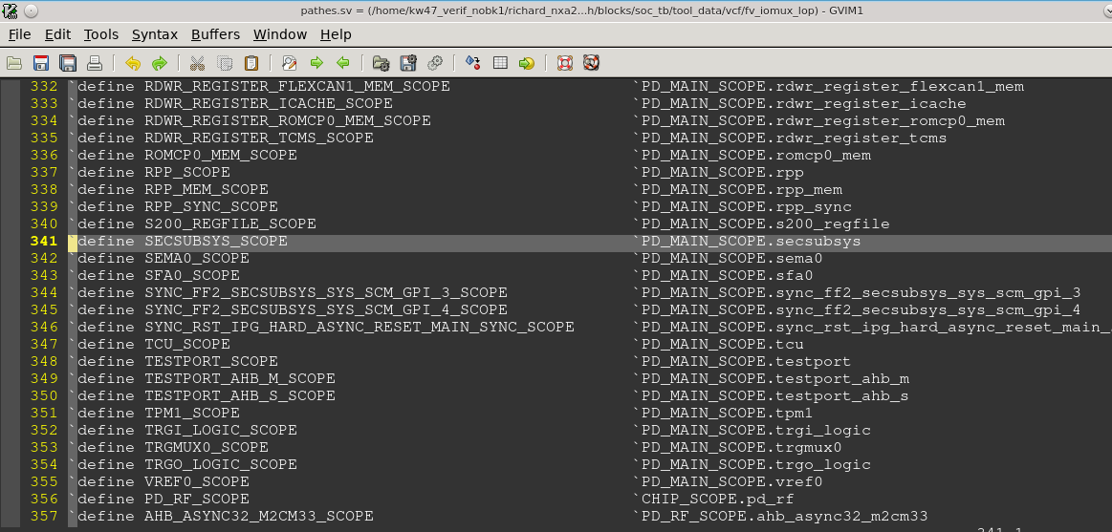

## Top defines

定义信号

/home/kw47_verif_nobk1/richard_nxa28190/V_SS_KW47_SOC_TB_1.6/testbench/blocks/soc_tb/testbench/top_defines_v/ scope_defines.sv

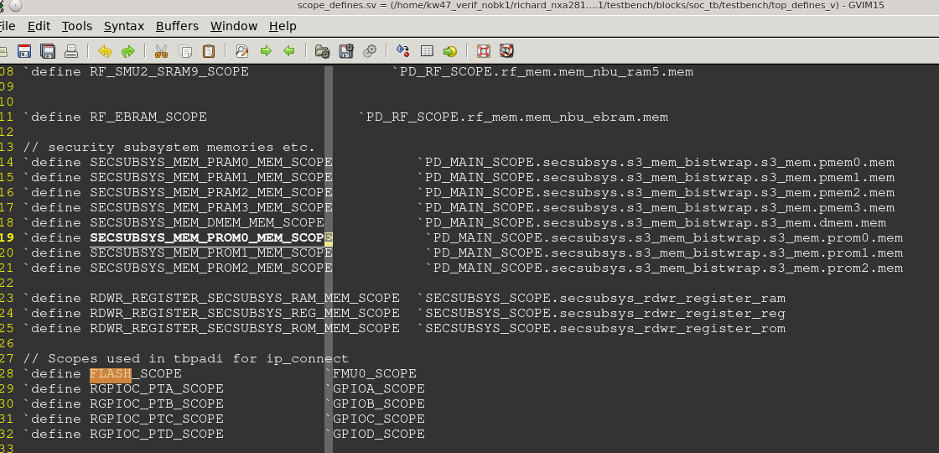

## ARG

/home/kw47_verif_nobk1/richard_nxa28190/V_SS_KW47_SOC_TB_1.28/testbench/blocks/soc_tb/arg/ block.arg

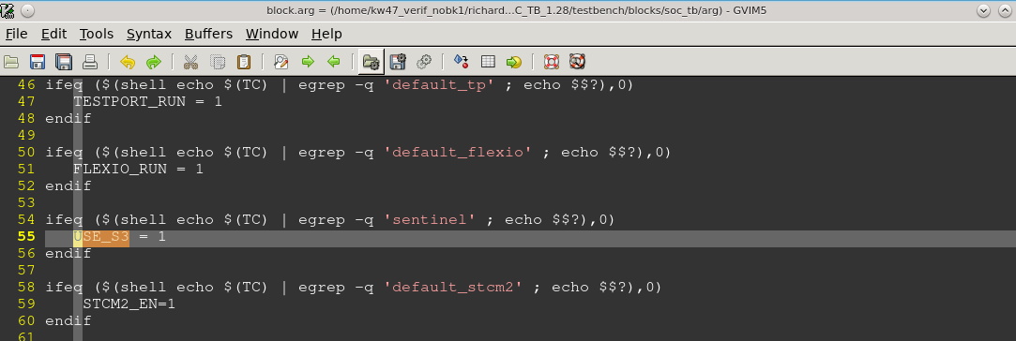

## Load S200 ROM

V code：

common_blocks/v_ss_s200_vip/testbench/instances_v/s3_memory_interface_inst.sv

testbench/common_blocks/v_ss_s200_vip/tool_data/compiler/include/s3.rom.hex

Arg 里面如果没有定义 S3_NO_USM_PROM

v_ss_s200_vip/tool_data/compiler/include/usm_prom.rom.hex

Load USM PROM jump back table - also located in S3 ROM

Arg里面如果有core_s3_rom_image

sim_arg += +core_s3_rom_image

S3 ROM image为：v_ss_s200_vip/tool_data/compiler/include/s3.rom.hex

否则为编译生成的ROM image

Arg 如果有core_s3_custom_rom_image

sim_arg += +core_s3_custom_rom_image

获取用户自定义名字的ROM /v_ss_s200_vip/tool_data/compiler/include/", CMDLINE_GET_STRING("core_s3_custom_rom_image"), ".rom.hex"

默认为 s3_custom.rom.hex

Arg如果有preloader_fill_mems （sim_arg += +preloader_fill_mems）

开启默认load 值， ROM 为0xffffffff， S200 RAM 为0xc0c0c0c0

否则hex以外的空间不load 数据，也就是不做初始化

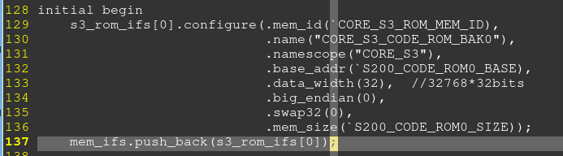

### Memory_interface 类

testbench/common_blocks/v_ip_mem_utils2/testbench/classes_v/memory_interface.sv

#### memory_write

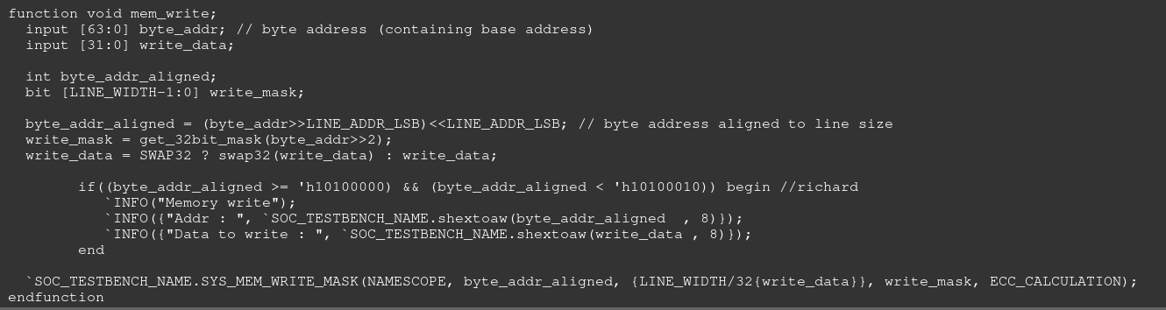

#### configure

获得load address， size等信息。

Log 关键字：

NAME =

BASE_ADDR =

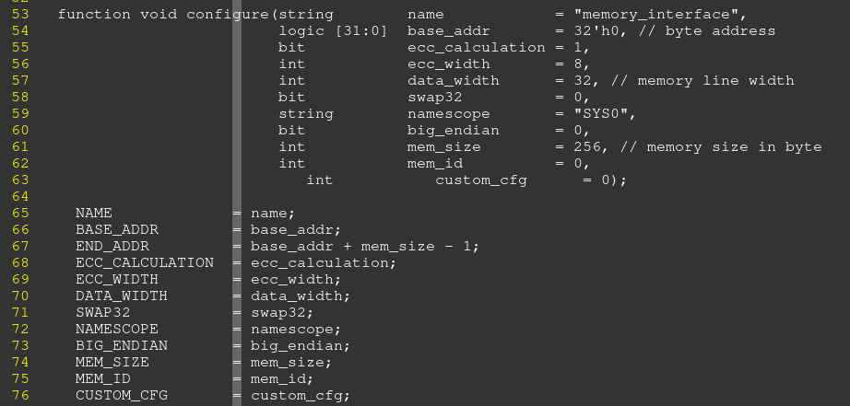

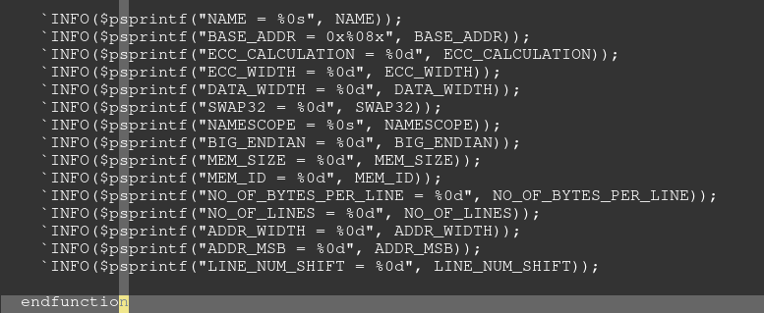

#### Load_mem

如果传入变量init=1， array 中没有的地址，用init_value进行填充。

否则只将array中的数据填写到对应的ROM中

如果load_mem中start addr&end_addr设置为0，则取configure 里面配置的地址。

判断array中地址是否在start addr&end addr范围内，然后将对应数据load 到array里面对应地址

Log：

`INFO({"Initializing ", NAME , " Start Addr : ", `SOC_TESTBENCH_NAME.shextoaw(start_addr, 8)});

`INFO({"Initializing ", NAME , " End Addr : ", `SOC_TESTBENCH_NAME.shextoaw(end_addr , 8)});

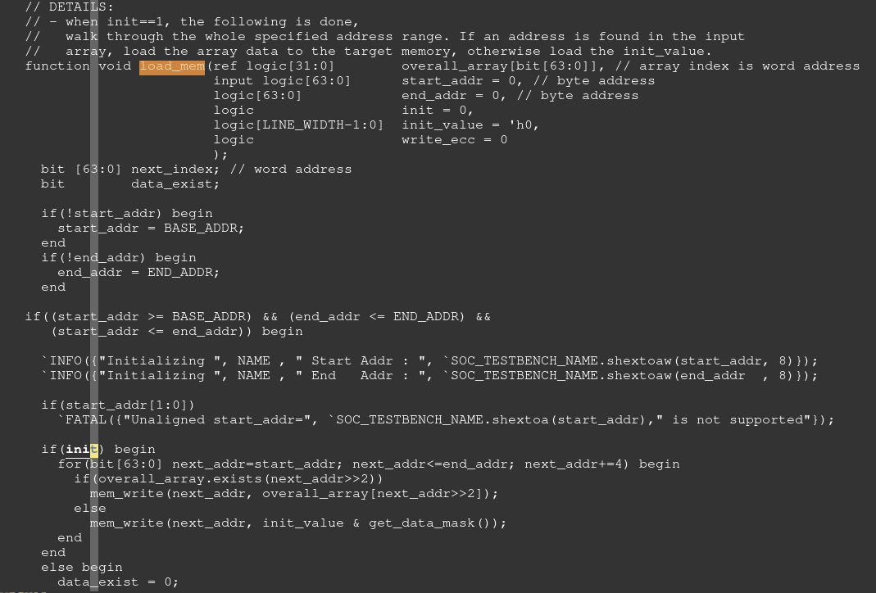

##### mem_write

testbench/common_blocks/v_ip_mem_utils2/testbench/modules_v/memory_interface.sv

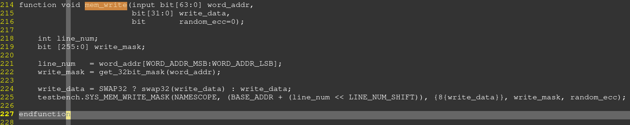

###### SYS_MEM_WRITE_MASK

testbench/blocks/ soc_tb/testbench/tasks_v/sys_mem_access.sv

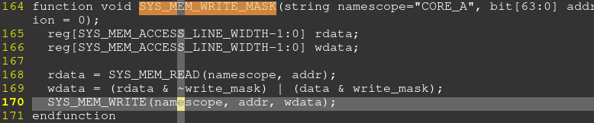



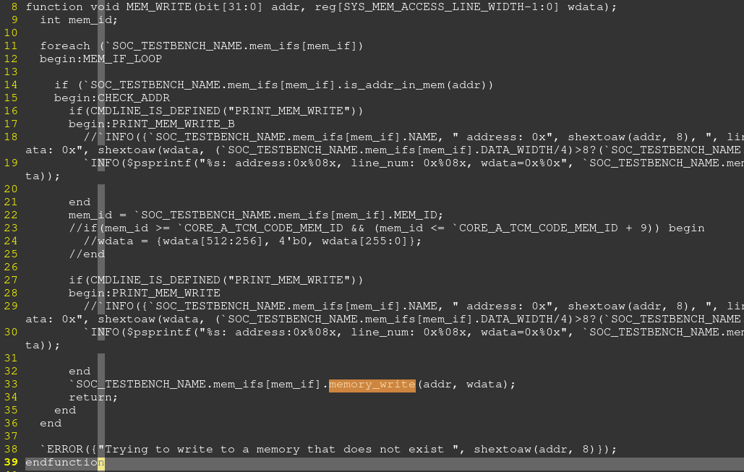

sim_arg += +PRINT_MEM_WRITE=1

arg中加入这个参数，打印write的信息



memory_write

### 如何添加一个loader（ROM loader为例）

#### Mem_map

testbench/common_blocks/v_ss_s200_vip/tool_data/sray/mem_map/s200_soc_resources.mem_map

添加memory信号的定义

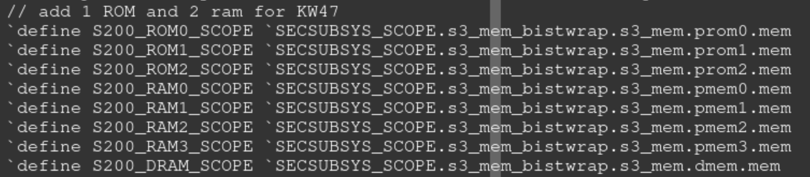

添加memory 地址

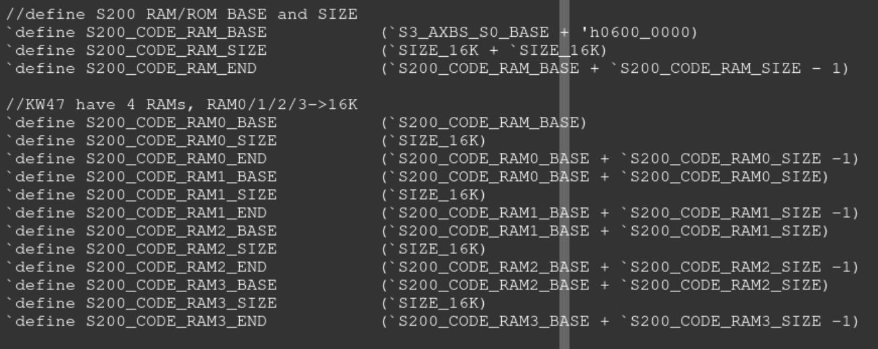

#### s3_rom_ifs 实例的初始化

common_blocks/v_ss_s200_vip/testbench/instances_v/s3_memory_interface_inst.sv

实例化一个 memory_interface类



实例化信号，信号为`S200_ROM2_SCOPE.uut.mem_core_array



Initial begin语句中调用类的configure函数，传入的变量有load数据对应的address， size

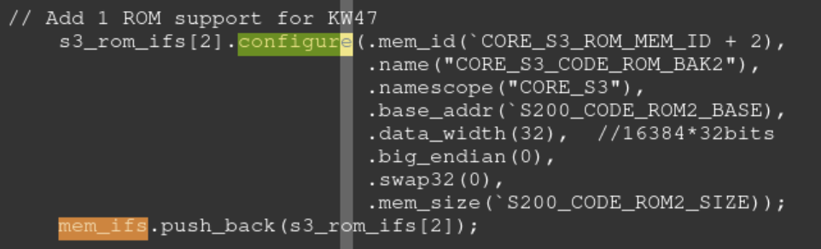

### ROM load过程

common_blocks/v_ss_s200_vip/testbench/instances_v/s3_memory_interface_inst.sv

#### 实例化信号

memory_interface_class_decl

实例化一个类： s3_rom_ifs2_mem_if, 父类为memory_interface

mem_array_deposit 函数用来进行ROM 数据的写入，信号为`S200_ROM2_SCOPE.uut.mem_core_array

mem_array_get 函数用来读取ROM数据

memory_interface_class_init

将上面实例化的类，赋值给数组s3_rom_ifs[2] = s3_rom_ifs2_mem_if



testbench/common_blocks/v_ip_mem_utils2/testbench/defines_v/memory_interface_defines.sv

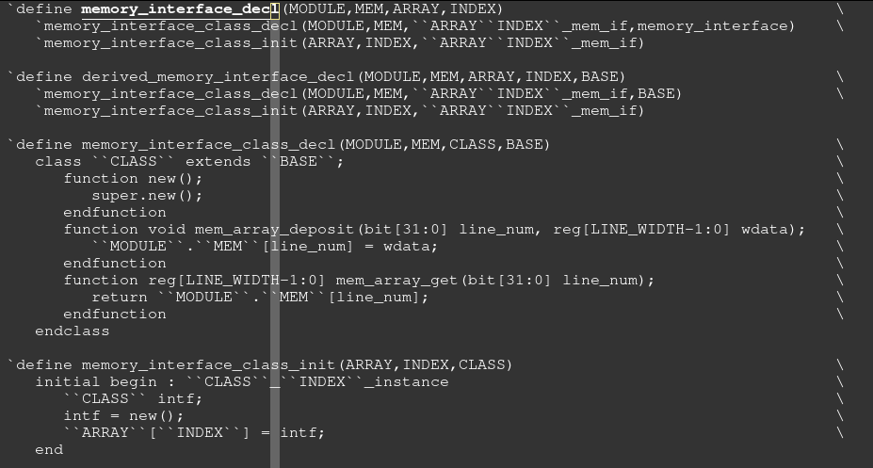

#### Initial

1. Initial 语句中调用memory_interface的configure函数，获取地址信息 s3_rom_ifs 实例的初始化
2. 调用load_hex2mem,将hex文件读取到数组中

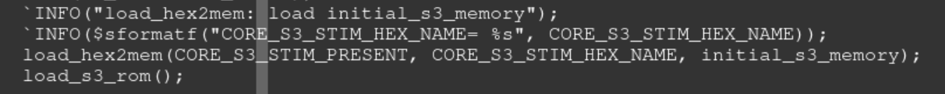

##### load_hex2mem

testbench/common_blocks/v_ip_mem_utils2/testbench/tasks_v/ preload_memories.sv

将编译生成的ROM hex文件读取到数组中，CORE_S3_STIM_HEX_NAME-> initial_s3_memory

load_hex2mem(CORE_S3_STIM_PRESENT, CORE_S3_STIM_HEX_NAME, initial_s3_memory);



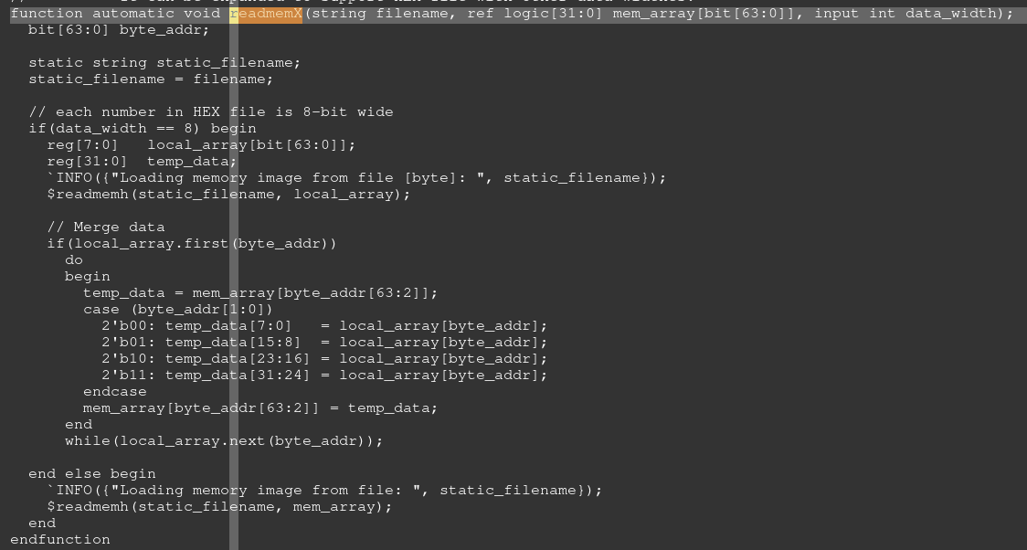

##### Load_s3_rom

选择合适的ROM hex load到数组中

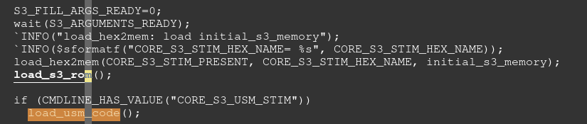

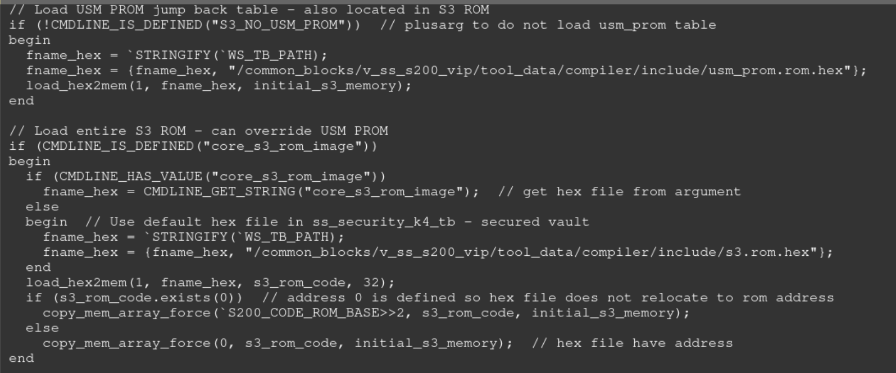

###### Load usm prom

USM PROM 存放在S200 ROM的固定位置（last 2K of ROM）。USM

上电后，USM会执行该处的code，然后释放CM0+，从而可以跑S200的ROM code

如果arg中没有定义S3_NO_USM_PROM， 读取USM PROM到数组中



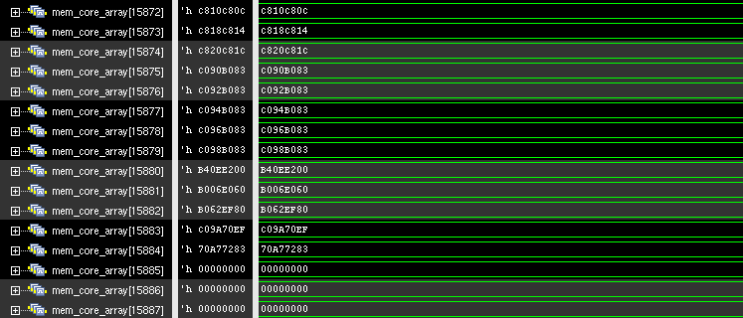



###### Load default ROM

如果arg中定义了core_s3_rom_image， 将load v_ss_s200_vip/tool_data/compiler/include/s3.rom.hex。

否则load的ROM 维持不变，依旧用编译生成的ROM

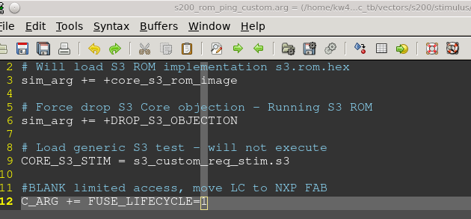

###### Loader customer specific ROM

如果arg中定义了core_s3_custom_rom_image

则load定义的这个参数对应的ROM

##### Load USM code

如果arg里面有CORE_S3_USM_STIM。

则编译testbench/common_blocks/v_ss_s200_vip/vectors/s200/stimulus/s3_message_response.usm.s

这段USM的作用就是控制GPI[2], 以及S3SCM_SR0[12]（MBIST）的置1/清0

USM customer load地址：

USM_EXT_RAM_ADDR=S3_EXT_PERSIST_BASE +S3_EXT_PERSIST_SIZE(4K=0x1000) =0x3001_8000

S3_EXT_PERSIST_BASE = (S3_EXT_RAM_BASE + S3_EXT_RAM_SIZE(64K-4K-16K=0xB000)) = 0x3001_7000

S3_EXT_RAM_BASE= CORE_A_TCM_SYS_BASE（0x3000_0000）+ TCM_SYS_SIZE_FOR_SENTINEL_ONLY(32K+16K=0xc000) = 0x3000_c000

USM customer code会load到 0x3001_8000 这个地址

MBIST S200 C case中，S200 用DMA将USM customer code从SOC RAM中搬运到S200 RAM

0x3001_8800 ->0x06003800

usm_dma_copy(USM_EXT_RAM_ADDR + 0x800, USM_RAM_BASE_ADDR, USM_CODE_SIZE);

DMA搬运完毕后，对数据进行校验（0x220<<2=0x880）。

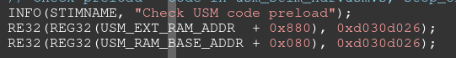



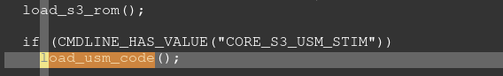

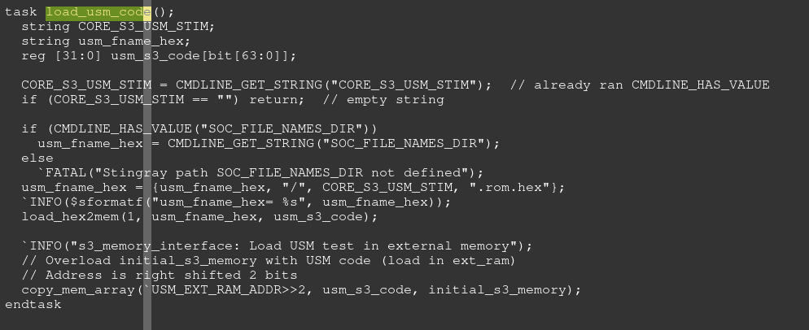

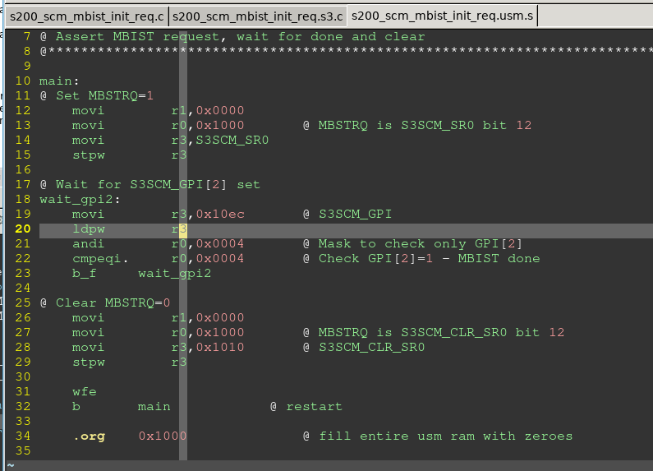

mulus for CORE_S3_USM

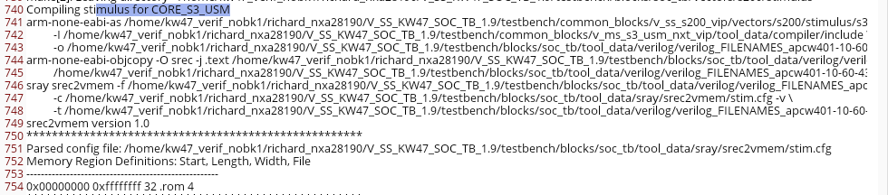

#### 数据load到实体ROM中

Always 语句识别到上电后， 调用memory_interface类中的load_mem 函数Load_mem

将数组中的数据load 到实体ROM 中

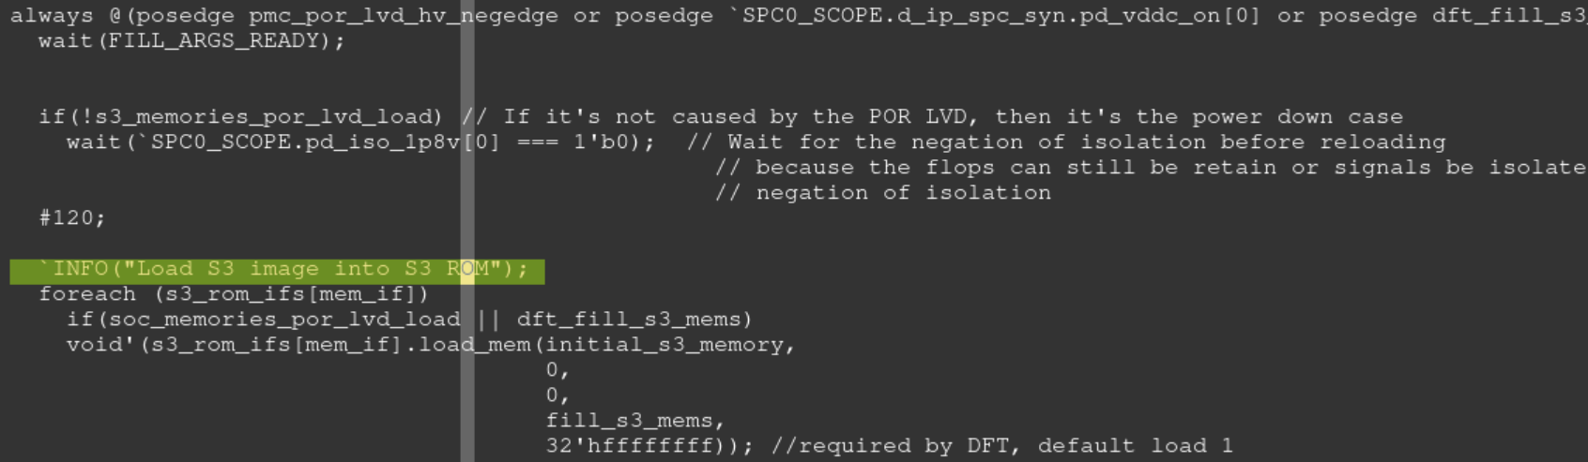

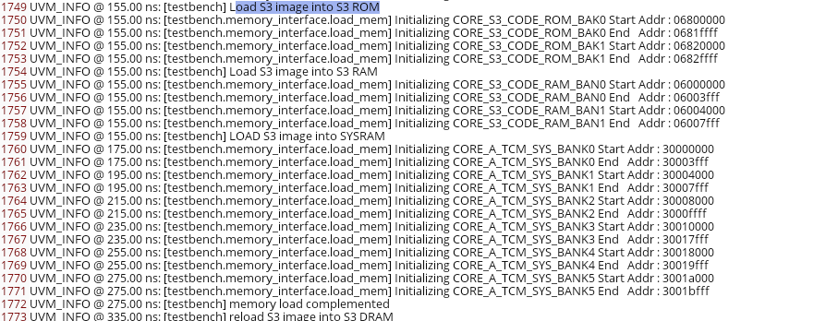

## Load CoreA ROM

testbench.top.pd_main.romcp0_mem.mem_rom0.mem

testbench/blocks/soc_tb/testbench/top_instances_v/ memory_interface_inst.sv

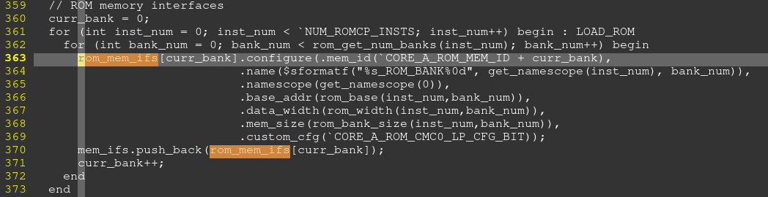

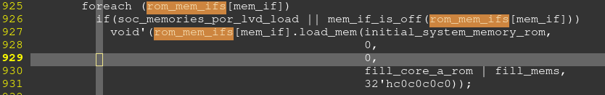

## Load flash

testbench/blocks/soc_tb/testbench/top_instances_v/ memory_interface_inst.sv

类的实例化Fmu_data_mem_ifs的实例化



Config

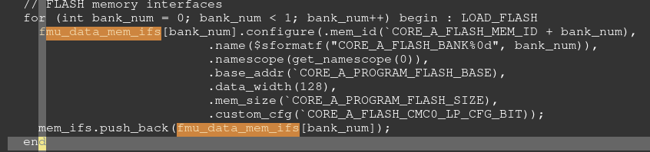

Load

1. Load hex文件到数组中





1. 将hex文件load到实体flash中。Load的地址从hex中提取

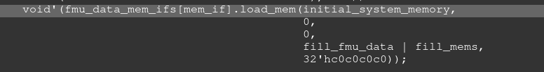

### Fmu_data_mem_ifs的实例化

testbench/common_blocks/v_ip_mem_utils2/testbench/defines_v/memory_interface_defines.sv

实例化一个数组fmu_data_mem_ifs[0], 数组指向的类为fmu_data_memory_interface

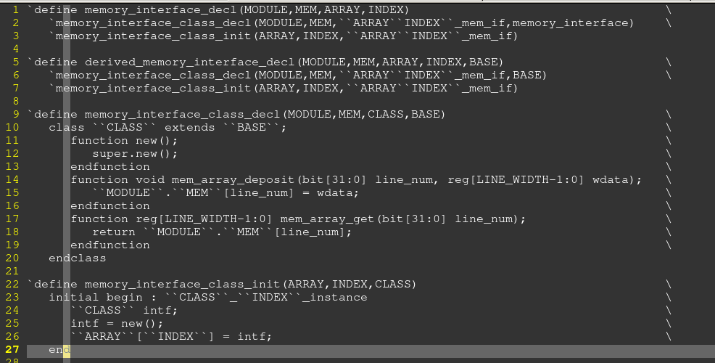

#### fmu_data_memory_interface

tsetbench/blocks/soc_tb/testbench/top_classes_v/soc_memory_interfaces.sv

该文件中集合了，flash/ram数据load的类

这些类的父类为Memory_interface 类

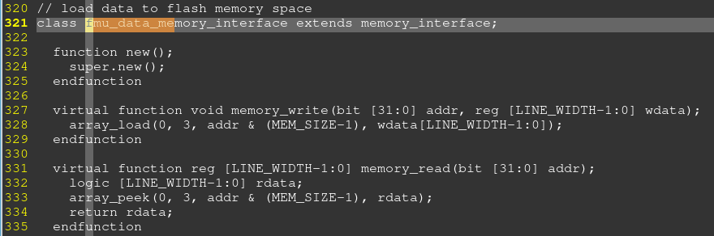

## V S20 check debug statues

testbench/common_blocks/v_ss_s200_vip/testbench/instances_v

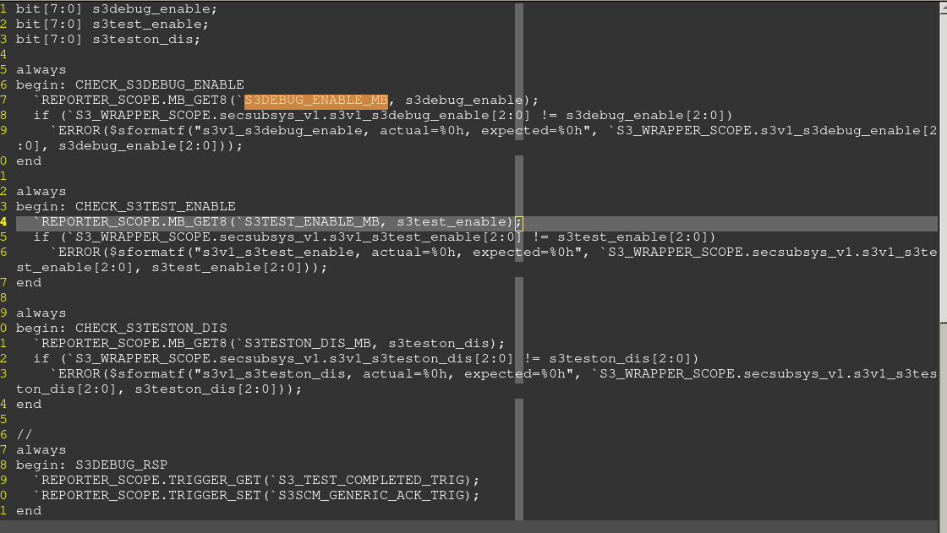



## V S200 memory access

testbench/common_blocks/v_ss_s200_vip/testbench/instances_v/s200_memory_check.sv

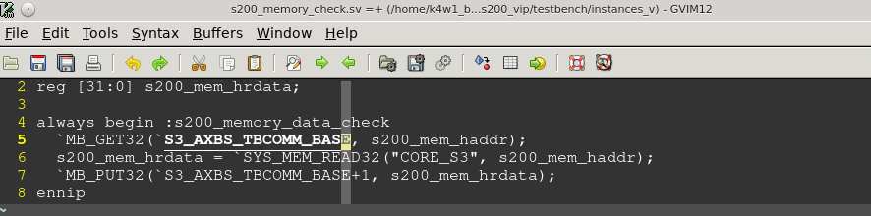

## _mem_fill

testbench/common_blocks/v_ip_mem_utils2/tool_data/compiler/include/mem_utils.h

_mem_fill((uint8_t*)(addr), 64, MEM_FILL_INCREMENT, 0x12345678, 32, MEM_PATH_BACKDOOR);

参数依次为：

起始地址，烧写bytes个数，烧写类型（随机模式/固定数据模式），烧写起始数据，单次烧写数据的bit长度，烧写的方式（backdoor方式为V直接烧写到对应memory中）

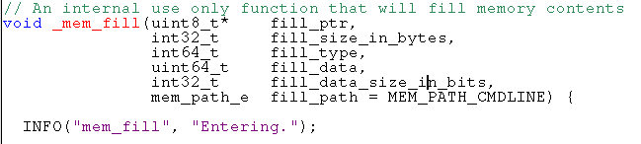

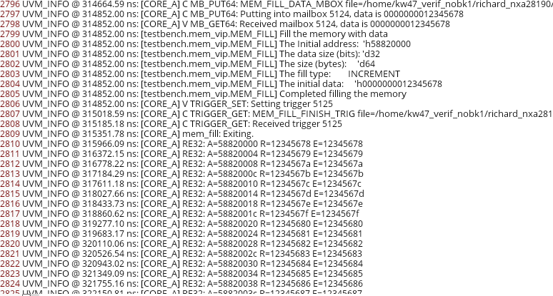

### MEM_FILL

testbench/common_blocks/v_ip_mem_utils2/testbench/modules_v/mem_vip_driver.sv

C 程序调用到的V

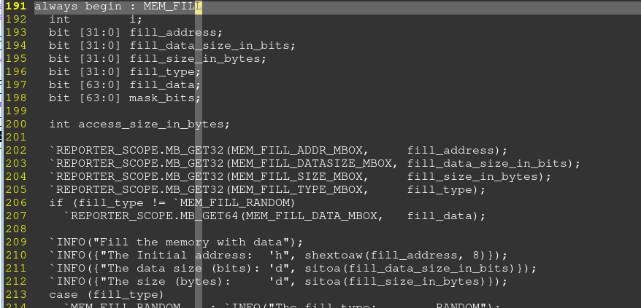

#### mem_vip_memory_write

testbench/blocks/soc_tb/testbench/tasks_v/ sys_mem_access.sv

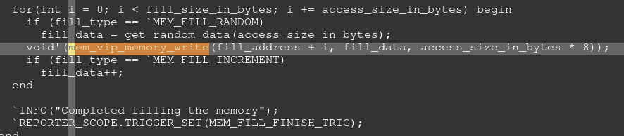



sys_mem_write_partial

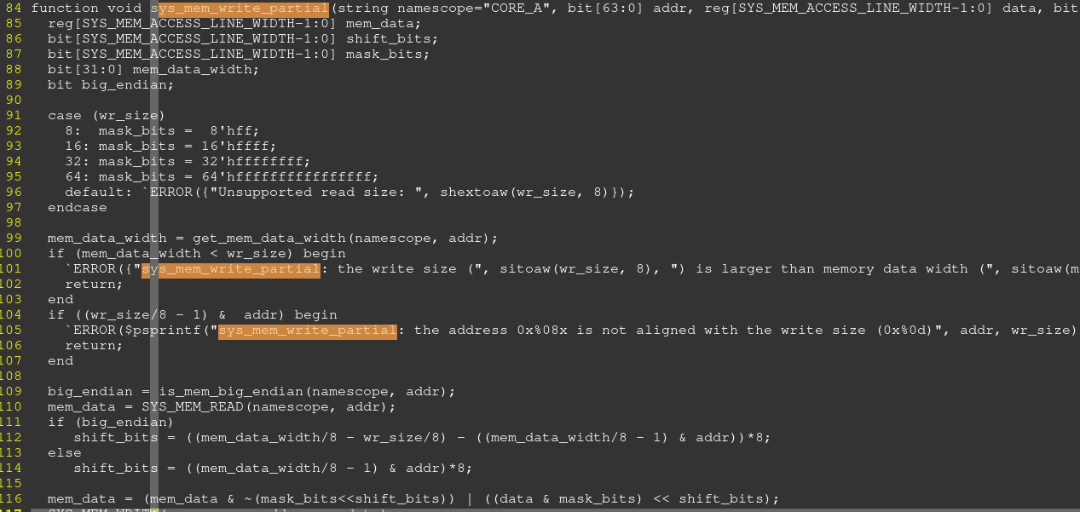



### apapi_WR

debug 方式，通过AP口对memory/register写数据



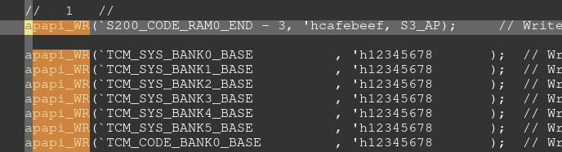

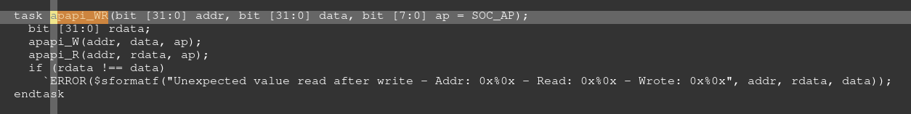

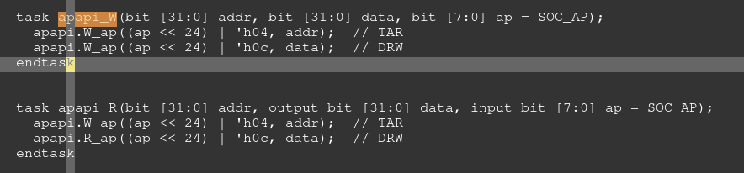

## CAPI

### coreCore A

testbench.core_a_ahb_reporter

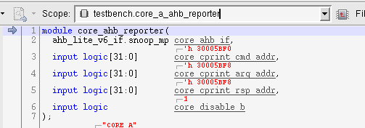

### S200

testbench.core_s3_ahb_reporter

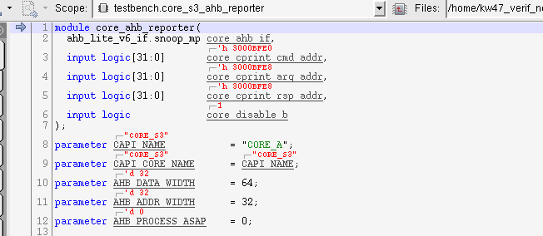

#### CAPI_AHB_REPORTER例化

testbench/common_blocks/v_ms_s3_vip/testbench/instances_v

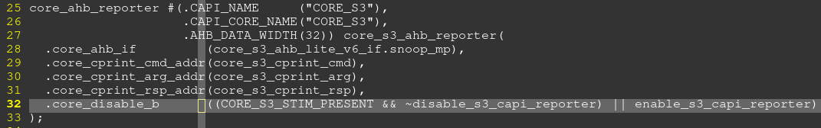

#### Core_ahb_if例化信号

testbench/common_blocks/v_ms_s3_vip/testbench/wires_v/ ahb_lite_v6_if_inst.sv

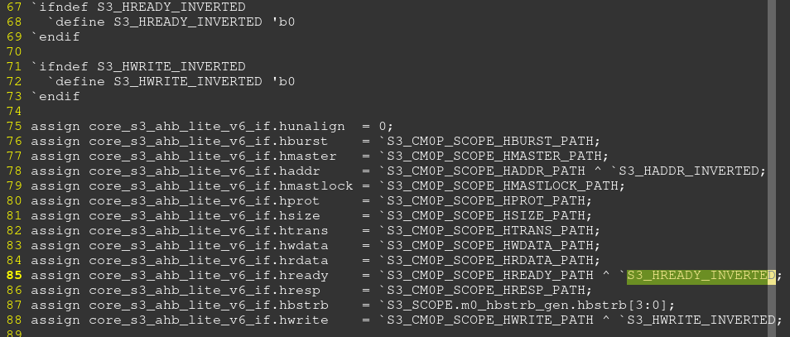

#### Postlayout 信号控制

由于加了delay，传送给CAPI的部分信号可以有位反转。

通过修改这里异或参数，达到送给AHB report的数据需要跟core 一致

testbench/blocks/soc_tb/tool_data/sray/mem_map/s200_postlayout_capi_inverted.mem_map

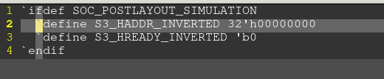

#### CAPI code架构

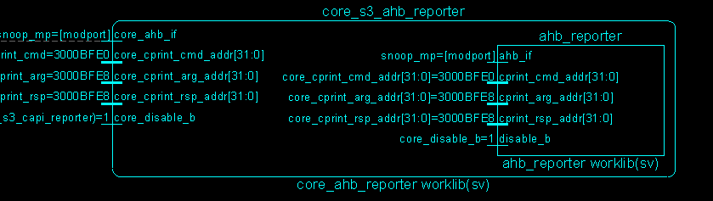

##### 例化Core_s3_ahb_reporter



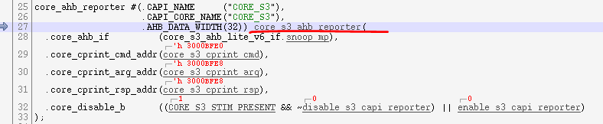

类： core_ahb_reporter



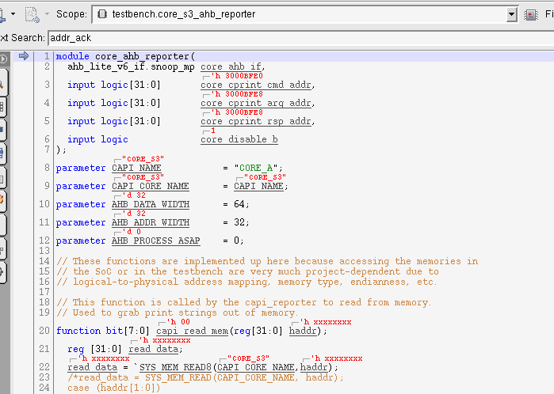

###### 例化ahb_reporter



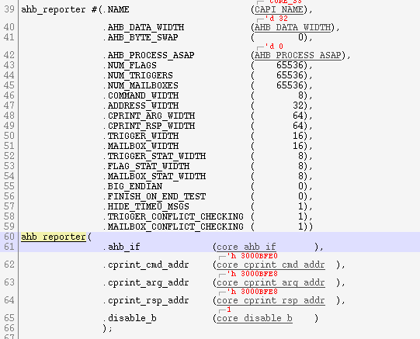

类： ahb_reporter。。 这里面包含了CAPI的arg，command操作函数



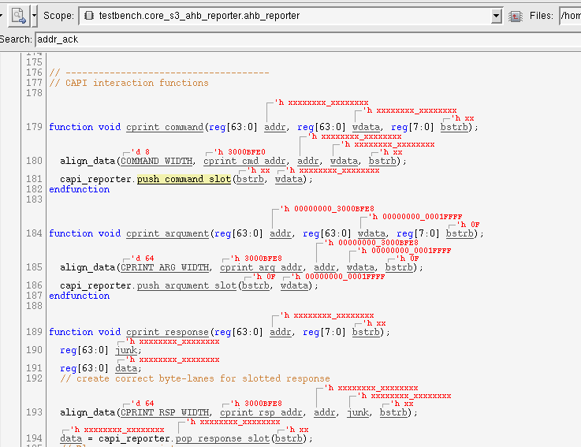

### Command

#### W32

##### C部分操作

[CORE_A] W32: A=5001c418 W=00000000



* CPU先将数据0写入到地址0x5001c418。从如上的波形可以看到地址0x5001c418写入数据0
* 然后将地址，数据，command送给V。先处理地址，然后处理数据，最后处理command

波形可以看到

0x3000fbf8 先写入地址0x5001c418

0x3000fbf8写入数据0

0x3000fbf0写入command 0x58，表示W32

* #define W32(address, write_data) _capi_w32((address), (write_data)



* #define _capi_w32(address, write_data) _capi_wx(32, (address), (write_data))



* #ifndef _capi_wx

#define _capi_wx(x, address, write_data) \

do \

{ VUCAST(x, (address)) = (uint_t(x))(write_data); \

NOTIFY_TE_W##x((address_t)&(address), (uint_t(x))(write_data)); \

NOTIFY_TB_CA##x(CPRINT_W##x, (address_t)&(address), (uint_t(x))(write_data)); \

} while(0)

#endif // _capi_wx



* #if(CAPI_API_32BIT == CAPI_SUPPORTED)

void NOTIFY_TB_CA32(command_t command, address_t address, uint32_t data1)

{ _capi_notify_tb_ca32(command, address, data1);

}



* #ifndef _capi_notify_tb_ca32

#define _capi_notify_tb_ca32(command, address, data1) \

do \

{ CAST_ASSIGN(CPRINT_ARG, address, address_t); \

CAST_ASSIGN(CPRINT_ARG, data1, uint32_t); \

CAST_ASSIGN(CPRINT_CMD, command, command_t); \

} while(0)

#endif // _capi_notify_tb_ca32



#define CAST_ASSIGN(address, data, the_type) \

do \

{ CAST((address), v##the_type) = ((the_type)(data)); \

} while(0)



###### Command定义

common_blocks/v_ip_capi/tool_data/compiler/include/capi_mmp.h

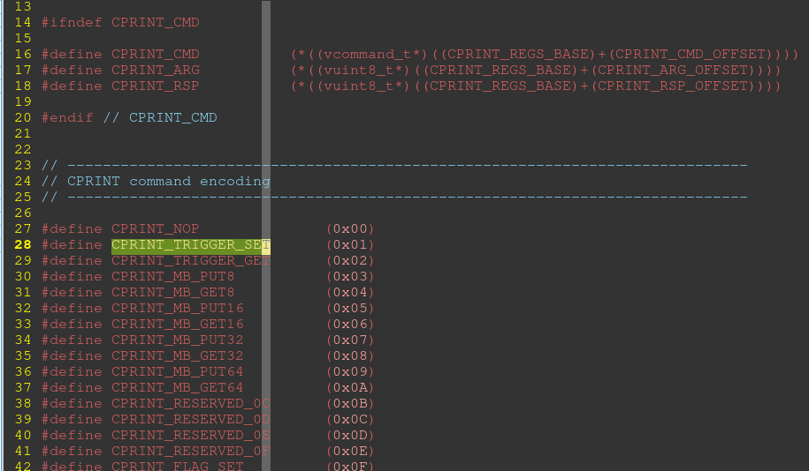

##### V部分操作

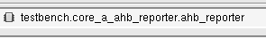

* Cmd_addr, arg_addr

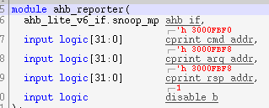

* 检测到AHB地址上的数据后，进行处理

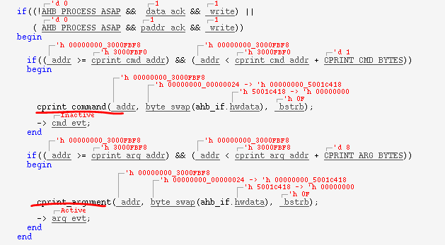

###### Command定义

common_blocks/v_ip_capi/testbench/modules_v/capi_reporter.sv

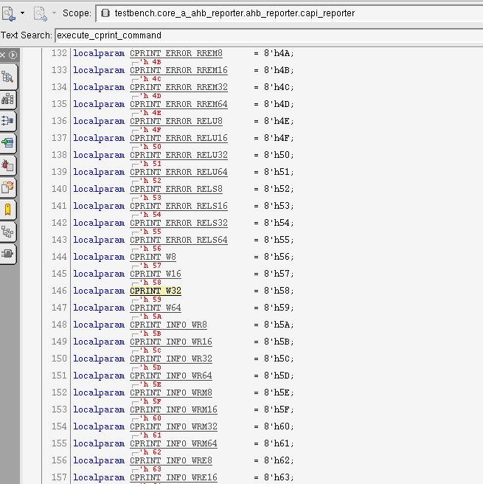

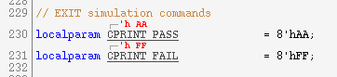

###### Command 处理

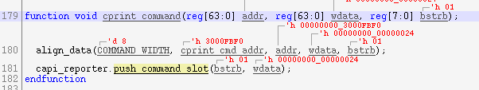

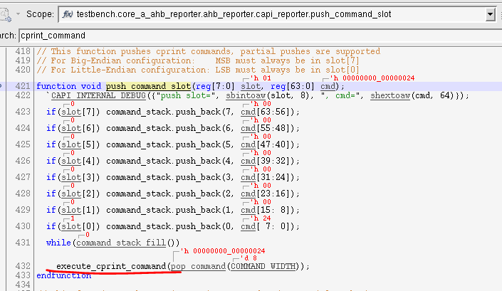

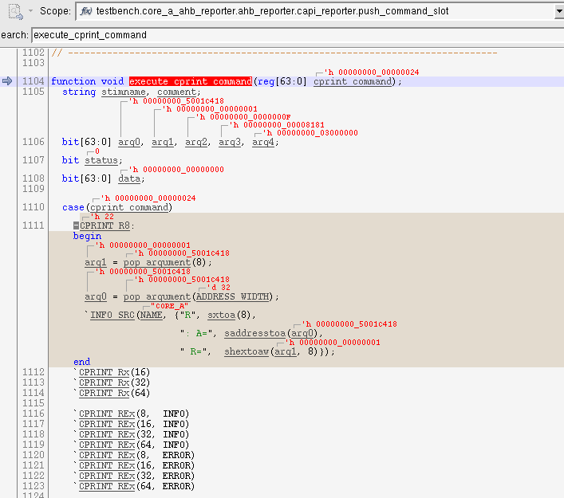

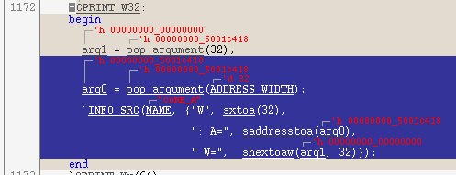

###### Argument 处理

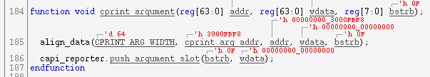

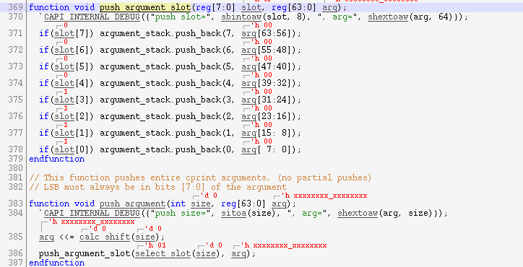

# ARG

增加timeout:

sim_arg := +SIMULATION_TIMEOUT=20000000 $(sim_arg)

# Memory address

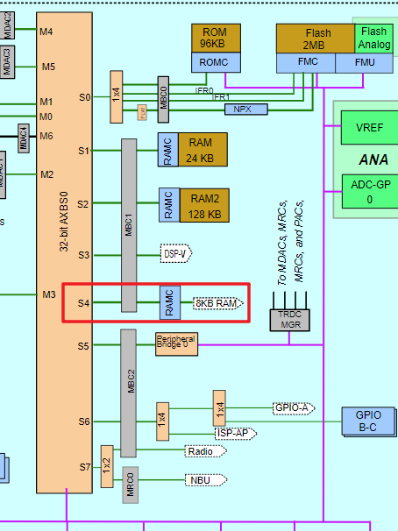

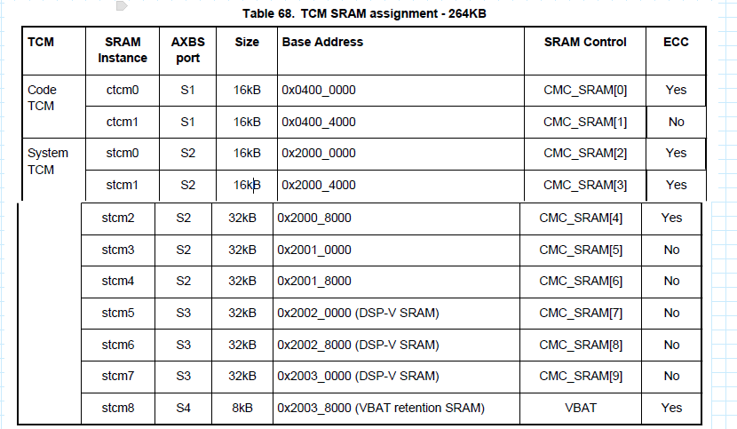

# UVM

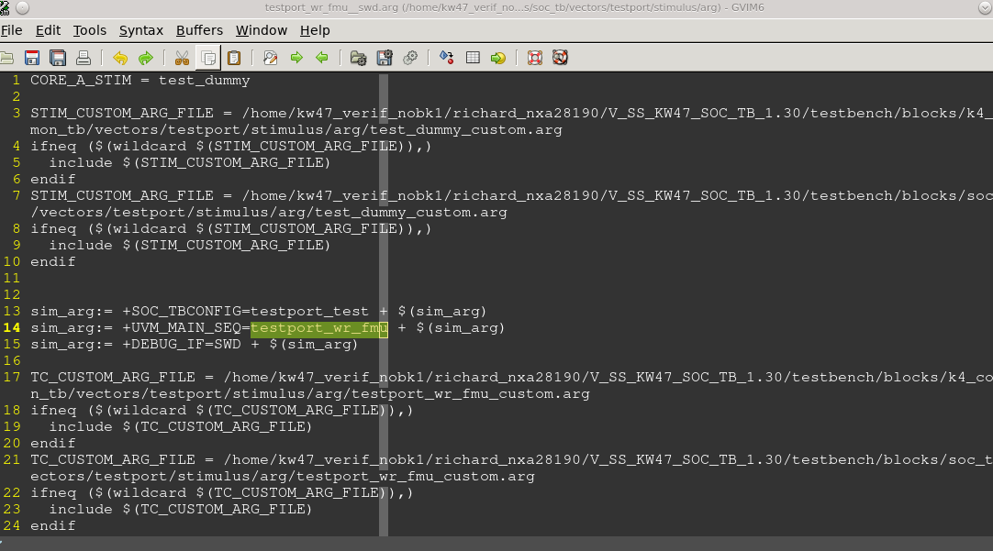

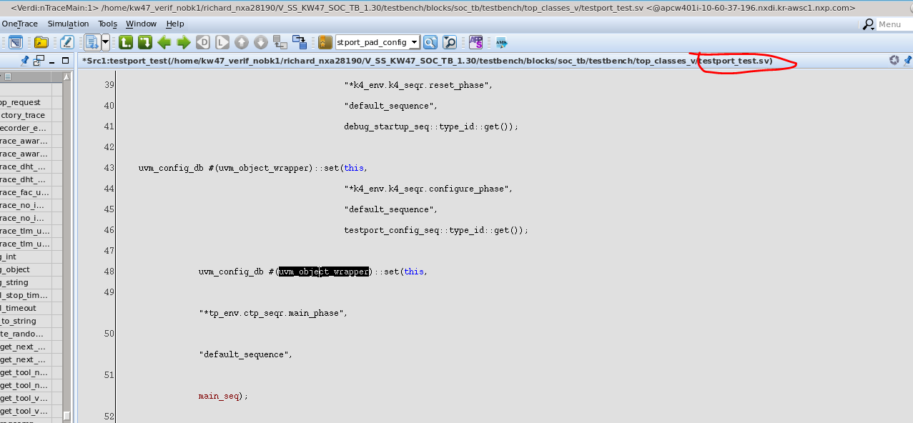



# S200 对其他模块的影响

## SOC DBGEN

SMSCM中的dbgen默认值，受到lifecycle的影响。

ALTEN 为NBU flash访问控制信号，ALTDBGEN为NBU debug 控制信号

NXP的状态下，debug是开启的，其余状态为关闭

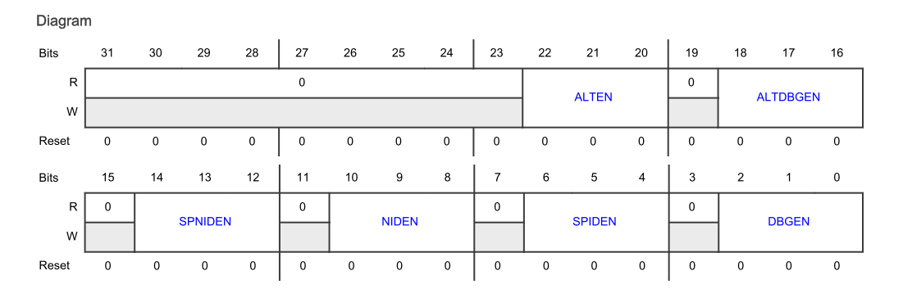

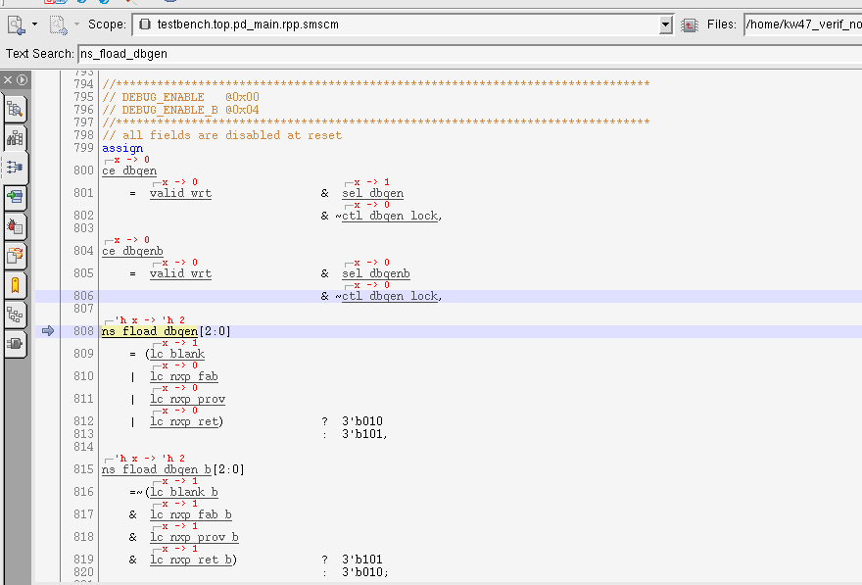

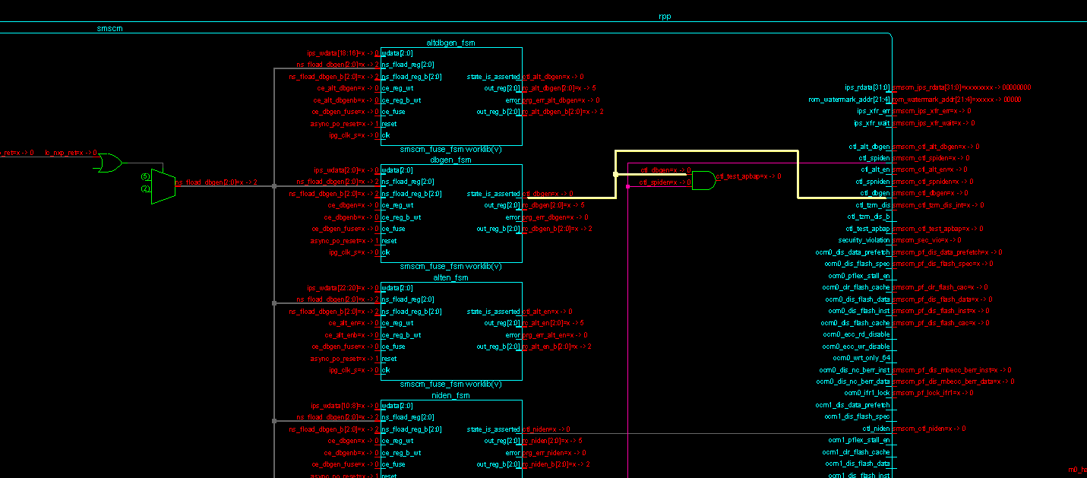

## Test port Enable

assign testport_testport_disable = secsubsys_s3v1_nvm_test_mode_dis;

BLANK/NXP FAB/NXP PRO/NXP RETURN, TOD enabled。

其他lifecycle， TOD disable

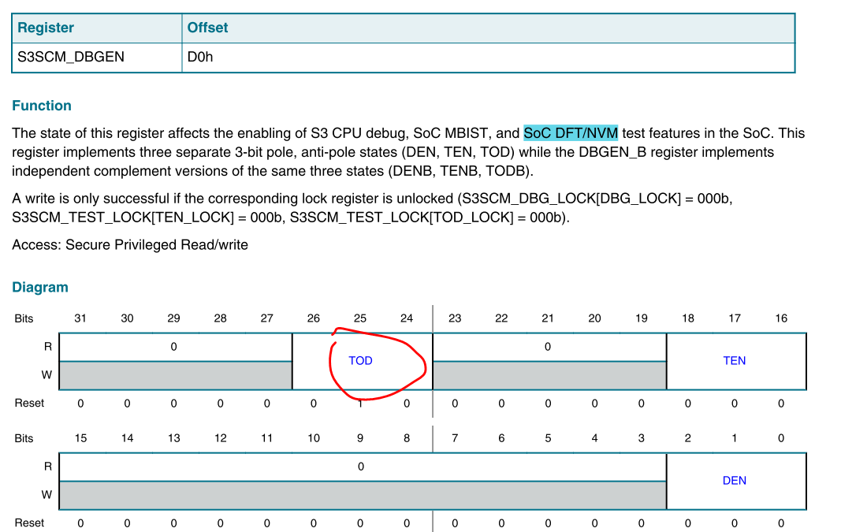

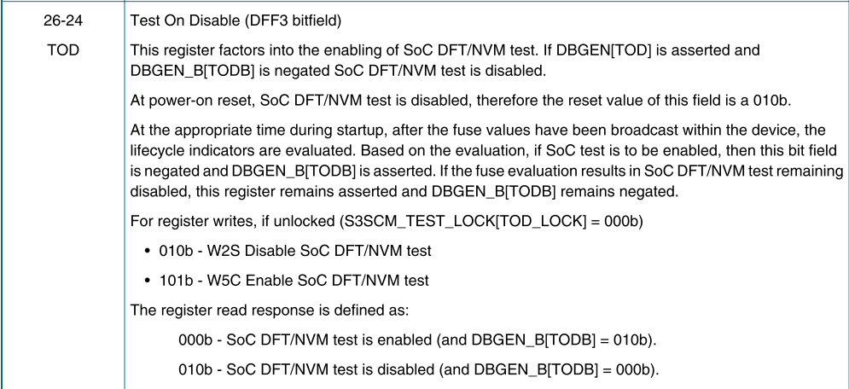

# secure

## secure boot flow

# Bug

## IP SRAM retention失败

|  |  |
| --- | --- |
| **Read/Write S200 RAM address** | **S200 SRAM entity used** |
| **0x0600_0000 – 0x0600_3fff** | SRAM1 |
| **0x0600_4000 - 0x0600_7fff** | SRAM0 |
| **0x0600_8000** | SRAM3 |
| **0X0600_c000** | SRAM2 |

* By default, only PRAM0 can retain data under low power mode. On KW47, the SRAM address 0x0600_0000-0x06003fff mapped chip is PRAM1. It means the SRAM data in address 0x0600_0000-0x06003fff will lose data once wakeup from low power mode

SRAM1(address 0x0600_3800), SRAM2(0x0600_f800), SRAM3(0x0600_b800) can be accessed by default.  
This is not an expected behavior, only the SRAM0(should mapped to 0x0600_3800) can be accessed by default.

* Modify V_SS_KW47_SOC_TB_1.23/blocks/secsubsys_v1_rel/rtl_v/secsubsys_v1.v

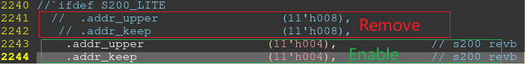

## Lptimer编译出错

Lptimer 的VIP更新后，新增的参数。S200使用到的VIP中没有配置

V_SS_KW47_SOC_TB_1.24/testbench/common_blocks/v_ms_s3_vip/tool_data/sray/mem_map

S200调用的VIP的配置参数，在如下文件中进行设置



## S200 MU 连接到SOC 的线导致MU 寄存器变化

[ CCB_11_S200_MU.pptx](https://nxp1.sharepoint.com/:p:/r/sites/MCUlibrary/kw47/01_Project_Management/04_CCBs%20and%20Waivers/CCB/CCB_11_S200_MU.pptx?d=w1736dabc781a4d8dab3b14a8c9c8ef5c&csf=1&web=1&e=zG6NFQ)

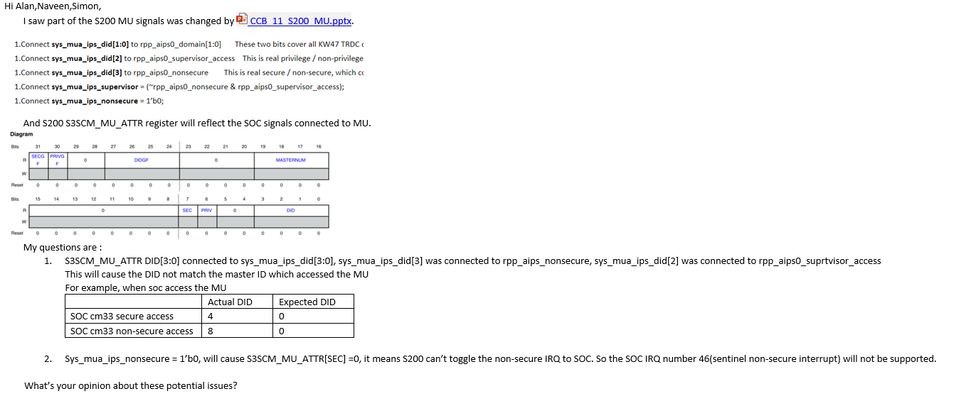

/*************** CCB_11_S200_MU TKT0609941 ********************/

/* This design change is used to fix the MU SEMA issue, signals changes as below

* Connect sys_mua_ips_did[1:0] to rpp_aips0_domain[1:0]

* Connect sys_mua_ips_did[2] to rpp_aips0_supervisor_access

* Connect sys_mua_ips_did[3] to rpp_aips0_nonsecure

* Connect sys_mua_ips_supervisor = (~rpp_aips0_nonsecure & rpp_aips0_supervisor_access);

* Connect sys_mua_ips_nonsecure = 0;

*

* This design change has impact on MU ATTR register, and will cuase MU_ATTR resigter can't got the Non-secure state

* In the S3 RM, S3SCM_MU_ATTR(offset 0x20) register definition should be changed as below

* DID is S3SCM_MU_ATTR[3:0], this should be change to S3SCM_MU_ATTR[1:0]

* S3SCM_MU_ATTR[3] = soc aips secure state

* S3SCM_MU_ATTR[2] = soc aips super access state

* S3SCM_MU_ATTR[7] = 0, always non-secure

* S3SCM_MU_ATTR[6] = (~rpp_aips0_nonsecure & rpp_aips0_supervisor_access). For CM33 secure access, the value is releated to rpp_aips0_nonsecure, while CM33 non-secure access, this value is 0

* The S3SCM_MU_ATTR can't catch secure/non-secure status of CM33.

* If want to generate non-secure done irq, need to set S3SCM_FRC_MU_ATTR

* */

# CR

## TKT0609941[S3_MUA.TR0 error termination for nonsecure access] test failed

Test steps:

1. Configure SAU/IDAU to change CM33 to non secure boot
2. Access MU SEMA4ACQ to get semaphore ownership,  access MU SEMA4STAT to confirm have got the ownership

Log:

[ CORE_A_NS] R32: A=40024998 R=00000055

[CORE_A_NS] R32: A=40024474 R=00000055

1. MU TR0 sent command, still found hardfault occurred.

## TKT0600128 S200 takes too much time to wake up from power down.

### 信号：

testbench.top.pd_main.secsubsys.sys_pkb_prdata[31:0]

testbench.top.pd_main.secsubsys.sys_pkb_pslverr

testbench.top.pd_main.s200_regfile

testbench.top.pd_main.s200_regfile.gp_regfile[0:7]